Chapter 1: Assessment of the Walleye Pollock Stock  in the Eastern Bering Sea

November 04, 2022

# Executive summary

This chapter covers the Eastern Bering Sea (EBS) region—the Aleutian Islands region (Chapter 1A) and the Bogoslof Island area (Chapter 1B) are presented separately. A multi-species stock assessment is provided separately and available [here](https://apps-afsc.fisheries.noaa.gov/Plan_Team/2021/EBSmultispp.pdf).

### Summary of changes in assessment inputs

Relative to last year’s BSAI SAFE report, the following substantive changes have been made in the EBS pollock stock assessment. This includes the 2022 NMFS bottom-trawl survey (BTS) covering the EBS and NBS. As before, these data were treated with a spatio temporal model for index standardization. Age data from this survey effort was compiled and included (also with an extensive spatio-temporal model treatment). The BTS chartered boats also collected acoustic data and the series was updated this year (AVO).

#### Changes in the data

1. Observer data for catch-at-age and average weight-at-age from the 2021 fishery were finalized and included.
2. Total catch as reported by NMFS Alaska Regional office was updated and included through 2022.
3. In summer 2022, the AFSC conducted the bottom trawl survey in the EBS and extended into the NBS. A VAST model evaluation (including the cold-pool extent) was used as the main index.
4. An improved treatment of the weight-at-age data from the BTS was presented to the Plan Team and SSC in September 2022 and these have replaced values used in the past where constant length-weight parameters had been assumed.
5. The bottom trawl survey collected acoustic data opportunistically with the index covering 2006-2022 (except for 2020).
6. The RV Oscar Dyson completed an acoustic-trawl survey (ATS) in 2022. Preliminary age composition data from this survey was included based on the length frequency observed as applied to the age-length key derived from the BTS age composition data.

### Changes in the assessment methods

There were some minor changes to the assessment model to enhance some of the output variables and to accommodate evaluating the posterior distribution via MCMC.

## Summary of EBS pollock results

The concern over low survey abundance estimates in 2021 was alleviated since the three main indices all show an increase over the previous observations. This also coincides with data indicating that the 2018 year class was one of the most abundant on record.

The following table is based on results from Model “20”, as used for last year’s assessment. The ABC recommendation Along with the risk-averse buffer due to uncertainty in the $F_{MSY}$ (about 14% lower because it is based on the harmonic mean) the recommendation results in a buffer of about 24% below $F_{MSY}$. The Tier 3 ABC estimate for 2023 and 2024 would be 1,688,000 and 1,815,000 t, respectively.

## Response to SSC and Plan Team comments

### General comments

From several SSC comments in the past few years related to reviewing the support for retaining the EBS Pollock assessment in Tier 1 versus reclassifying it as Tier 3.

* Consideration of whether the observed sensitivity in the SRR to prior specification should constitute an increased risk level specification within the assessment or population dynamics related considerations. This could provide a clearer justification for the use of the Tier 3 calculation as the basis for harvest specification.
  + We evaluated factors affecting the Tier classification in the 2020 assessment and showed that the priors used reflect the SRR curve were conservative and justified based on residual patterns near the origin (as opposed to alternatives that fit data on the descending slope of the Ricker SRR.
* The SSC recommends that if the assessment is considered in the appropriate Tier, buffers should be based on the use of the Risk Table rather than the continued use of Tier 3 calculations for a Tier 1 stock.
  + We agree.
* The SSC also notes that an alternative approach to consider for a buffer below the maximum permissible would be apply Tier 2 control rule. This tier uses the SR relationship for stock status and OFL, but uses the ratio of SPR rates for adjustments when the stock is below $B_{MSY}$.
  + An examination of Tier 2 as an option resulted in a value of 2,518,000 t (or a hybrid of Tier 1 and 2 of 2,224,000 t) for 2023 ABC values. We note that selecting Tier 2 would require similar reliance on the underlying productivity estimates (via the stock-recruitment relationship) and how that affects the reference fishing rate ($F_{MSY}$).

The SSC had a number of recommendations for additional research supporting this assessment:

From previous requests:

The SSC also looks forward to estimates of movement and abundance along the US-Russia EEZ boundary based on echosounders fixed to moorings in this area.

* The data from the moored sounders is presently underway. Initial results hold promise and should be available in early 2023.

From October 2021 (unless covered above):

# Introduction

## General

Walleye pollock (*Gadus chalcogrammus*; hereafter referred to as pollock) are broadly distributed throughout the North Pacific with the largest concentrations found in the Eastern Bering Sea. Also known as Alaska pollock, this species continues to play important roles ecologically and economically.

## Review of Life History

In the EBS pollock spawn generally in the period March-May and in relatively localized regions during specific periods (Bailey 2000). Generally spawning begins nearshore north of Unimak Island in March and April and later near the Pribilof Islands (Jung et al. 2006, Bacheler et al. 2010). Females are batch spawners with up to 10 batches of eggs per female per year. Eggs and larvae of EBS pollock are planktonic for a period of about 90 days and appear to be sensitive to environmental conditions. These conditions likely affect their dispersal into favorable areas (for subsequent separation from predators) and also affect general food requirements for over-wintering survival (Gann et al. 2015, Heintz et al., 2013, Hunt et al. 2011, Ciannelli et al. 2004). Duffy-Anderson et al. (2015) provide a review of the early life history of EBS pollock.

Throughout their range juvenile pollock feed on a variety of planktonic crustaceans, including calanoid copepods and euphausiids. In the EBS shelf region, one-year-old pollock are found throughout the water column, but also commonly occur in the NMFS bottom trawl survey. Ages 2 and 3 year old pollock are rarely caught in summer bottom trawl survey gear and are more common in the midwater zone as detected by mid-water acoustic trawl surveys. Younger pollock are generally found in the more northern parts of the survey area and appear to move to the southeast as they age (Buckley et al. 2009). Euphausiids, principally *Thysanoessa inermis* and *T. raschii*, are among the most important prey items for pollock in the Bering Sea (Livingston, 1991; Lang et al., 2000; Brodeur et al., 2002; Cianelli et al., 2004; Lang et al., 2005). Pollock diets become more piscivorous with age, and cannibalism has been commonly observed in this region. However, Buckley et al. (2015) showed spatial patterns of pollock foraging by size of predators. For example, the northern part of the shelf region between the 100 and 200 m isobaths (closest to the shelf break) tends to be more piscivorous than counterparts in other areas.

## Stock structure

Stock structure for EBS pollock was evaluated in Ianelli et al. (2015). In that review past work on genetics (e.g., Bailey et al. 1999, Canino et al. 2005) provided insight on genetic differentiation. The investigation also compared synchrony in year-classes and growth patterns. Pollock samples from areas including Zhemchug Canyon, Japan, Prince William Sound, Bogoslof, Shelikof, and the Northern Bering Sea were processed and results presented in 2021. This analysis included 617 walleye pollock from Japan, Bering Sea, Chukchi Sea, Aleutian Islands, Alaska Peninsula, and Gulf of Alaska. Results suggests there is temporally stable stock structure with a latitudinal gradient, i.e., Bering Sea pollock are distinguishable from those in the Gulf of Alaska and Aleutian Islands (I. Spies, personal communication, 2021). Notably, Bogoslof samples appeared genetically distinct from other spawning regions. In addition, there appeared to be genetic connectivity between the eastern Bering Sea and the western Gulf of Alaska spawning samples. Samples from the eastern Gulf of Alaska are currently undergoing sequencing to determine whether eastern Gulf of Alaska pollock are genetically distinct from those in the western Gulf of Alaska. The ongoing goals of the project include investigating the genetic stock structure of walleye pollock, testing if patterns are temporally stable, and evaluating if distributional shifts under climate change can be detected.

For management purposes, the preliminary conclusions from these genetics results are: 1)there is stock structure in pollock that appears to be stable through time and 2) Some aspect of stock structure is latitudinal—Bering Sea pollock appear distinct from fish collected from the Gulf of Alaska and the Aleutian Islands. The results appear strong enough that a GTseq panel could be designed in the future to determine stock of origin of walleye pollock, the scale of which may be relatively large, such as “Bering Sea” or “GOA”. The scope and funding sources for this project will be planned in 2022 with sampling designs developed for implementation as early as 2023.

# Fishery

## Description of the directed fishery

Historically, EBS pollock catches were low until directed foreign fisheries began in 1964. Catches increased rapidly during the late 1960s and reached a peak in 1970–75 when they ranged from 1.3 to 1.9 million t annually. Following the peak catch in 1972, bilateral agreements with Japan and the USSR resulted in reductions. During a 10-year period, catches by foreign vessels operating in the “Donut Hole” region of the Aleutian Basin were substantial totaling nearly 7 million t (Table ). A fishing moratorium for this area was enacted in 1993 and only trace amounts of pollock have been harvested from the Aleutian Basin region since then. Since the late 1970s, the average EBS pollock catch has been about 1.2 million t, ranging from 0.810 million t in 2009 to nearly 1.5 million t during 2003–2006 (Table ). United States vessels began fishing for pollock in 1980 and by 1988 the fishery became fully domestic. The current observer program for the domestic fishery formally began in 1991 and prior to that, observers were deployed aboard the foreign and joint-venture operations since the late 1970s. From the period 1991 to 2011 about 80% of the catch was observed at sea or during dockside offloading. Since 2011, regulations require that all vessels participating in the pollock fishery carry at least one observer so nearly 100% of the pollock fishing operations are monitored by scientifically trained observers. Historical catch estimates used in the assessment, along with management measures (i.e., OFLs, ABCs and TACs) are shown in Table .

### Catch patterns

The “A-season” for directed EBS pollock fishing opens on January 20th and fishing typically extends into early-mid April. During this season the fishery targets pre-spawning pollock and produces pollock roe that, under optimal conditions, can comprise over 4% of the catch in weight. The summer, or “B-season” presently opens on June 10th and fishing extends through noon on November 1st. The A-season fishery concentrates primarily north and west of Unimak Island depending on ice conditions and fish distribution. There has also been effort along the 100m depth contour (and deeper) between Unimak Island and the Pribilof Islands. The general pattern by season (and area) has varied over time with recent B-season catches occurring in the southeast portion of the shelf (east of 170 $​^{∘}$ W longitude; Fig. ). Since 2011, regulations and industry-based measures to reduce Chinook salmon bycatch have affected the spatial distribution of the fishery and to some degree, the way individual vessel operators fish (Stram and Ianelli, 2014). In 2020, the fishing fleet encountered higher than normal bycatch of herring and this has further constrained the fishing grounds due to area closures. Additionally, sablefish appear to be highly abundant in the region and have comprised a significant proportion of the incidental catches in the pollock fishery (proportionally still less than 1% of the total landings). Comparing encounters of bycatch relative to the effort (total duration of all tows) the pollock fleet had a relatively flat trend in the Chinook salmon bycatch while sablefish and herring was down from the relatively high levels last year (Fig. ).

The catch estimates by sex for the seasons indicate that over time, the number of males and females has been fairly equal but in the period 2017-2020 the A-season catch of females has been slightly higher and conversely, in the B-season there has been a slightly higher number of males taken (Fig. ). The 2022 A-season fishery spatial pattern had a higher concentrations of fishing near Unimak and east compared to 2020 and 2021 (Fig. ). The amount of fishing near the Pribilof Islands was much lower than commonly observed in 2022. The 2022 A-season nominal catch rates were lower than the 2020 peak (for the fleet in aggregate) (Fig. ). Beginning in 2017, due to a regulatory change, up to 45% of the TAC could be taken in the A-season (previously only 40% of the TAC could be taken). This conservation measure was made to allow greater flexibility to avoid Chinook salmon in the B-season. To date, it appears that the pollock fleet as a whole took advantage of this added flexibility (Fig. ). However, this figure indicates that in 2021, the proportion of catch in February dropped relative to recent patterns but was made up by the end of April. Pollock roe is an important product coming from the winter fishery. The amount produced in the 2021 A-season was the lowest since 2016 and a considerable drop from the previous two years (Fig. ).

The summer-fall fishing conditions for 2021 improved considerably over 2020 and was about average on nominal catch rates (Fig. ). The number of hours the fleet required to catch the same tonnage of pollock was also improved relative to 2020. In the B-season catches in the northwestern area dropped relative to the previous two years (Fig. ). In addition, we present an approach first shown in 2019 to evaluate how concentrated the fleet was on average. We called this a measure of fleet dispersion: the relative distance or spread of the fishery in space. Briefly, the calculation computes for a given day, the distance between all trawl tows (within and across boats). These distances are then averaged for year and season. Updated to this year, results indicated that in both seasons the fleet was less disperse than last year and was roughly similar to the recent lower concentration levels compared to other years since 2000 (Fig ).

In 2020 we investigated the preponderance of small pollock in the catch. This was pursued further this year. As noted last year, in addition to the extensive NMFS observer collections, a little used component of their data are estimates of observed tow tonnages compared to numbers of pollock. These can provide a direct mean somatic mass (pollock body weight) for pollock within that tow. The data arise from the sampled total weight (e.g., of several baskets of pollock) divided by the enumerated number of fish in that sample. Such records exist for each tow. Summing these by extrapolated weight of the pollock catch within that tow, and binning by weight increments (here by 50 gram intervals), allows us to obtain some additional fine-scale information on the size trends in the pollock fishery. The annual patterns of these data show that overall, the B-season of 2020 was different with the small mode of fish persisting into the 2021 B-season (Fig. ). Compiling the data by week we show that the small fish were a consistent basis of the catch for this B-season (Fig. ).

The catch of EBS pollock has averaged 1.26 million t in the period since 1979. The lowest catches occurred in 2009 and 2010 when the limits were set to 0.81 million t due to stock declines (Table ). The recent 5-year average (2018-2022) catch has been 1.326 million t. Pollock catches that are retained or discarded (based on NMFS observer estimates) in the Eastern Bering Sea and Aleutian Islands for 1991–2022 are shown in Table . Since 1991, estimates of discarded pollock have ranged from a high of 9.1% of total pollock catch in 1992 to recent lows of around 0.6% to 1.1%. These low values reflect the implementation of the NMFS’ Improved Retention /Improved Utilization program. Prior to the implementation of the American Fisheries Act (AFA) in 1999, higher discards may have occurred under the “race for fish” and pollock marketable sizes were caught incidentally. Since implementation of the AFA, the vessel operators have more time to pursue optimal sizes of pollock for market since the quota is allocated to vessels (via cooperative arrangements). In addition, several vessels have made gear modifications to avoid retention of smaller pollock. In all cases, the magnitude of discards counts as part of the total catch for management (to ensure the TAC is not exceeded) and within the assessment. Bycatch of other non-target, target, and prohibited species is presented in the section titled Ecosystem Considerations below. In that section it is noted that the bycatch of pollock in other target fisheries is more than double the bycatch of other target species (e.g., Pacific cod) in the pollock fishery.

## Management measures

The EBS pollock stock is managed by NMFS regulations that provide limits on seasonal catch. The NMFS observer program data provide near real-time statistics during the season and vessels operate within well-defined limits. In most years, the TACs have been set well below the ABC value and catches have stayed within these constraints (Table ). Allocations of the TAC split first with 10% to western Alaska communities as part of the Community Development Quota (CDQ) program and the remainder between at-sea processors and shore-based sectors. For a characterization of the CDQ program see Haynie (2014). Seung and Ianelli (2016) combined a fish population dynamics model with an economic model to evaluate regional impacts.

Due to concerns that groundfish fisheries may impact the rebuilding of the Steller sea lion population, a number of management measures have been implemented over the years. Some measures were designed to reduce the possibility of competitive interactions between fisheries and Steller sea lions. For the pollock fisheries, seasonal fishery catch and pollock biomass distributions (from surveys) indicated that the apparent disproportionately high seasonal harvest rates within Steller sea lion critical habitat could lead to reduced sea lion prey densities. Consequently, management measures redistributed the fishery both temporally and spatially according to pollock biomass distributions. This was intended to disperse fishing so that localized harvest rates were more consistent with estimated annual exploitation rates. The measures include establishing: 1) pollock fishery exclusion zones around sea lion rookery or haulout sites; 2) phased-in reductions in the seasonal proportions of TAC that can be taken from critical habitat; and 3) additional seasonal TAC releases to disperse the fishery in time.

Prior to adoption of the above management measures, the pollock fishery occurred throughout each of the three major NMFS management regions of the North Pacific Ocean: the Aleutian Islands (1,001,780 km $​^{2}$ inside the EEZ), the Eastern Bering Sea (968,600 km $​^{2}$), and the Gulf of Alaska (1,156,100 km $​^{2}$). The marine portion of Steller sea lion critical habitat in Alaska west of 150 $​^{∘}$ W encompasses 386,770 km $​^{2}$ of ocean surface, or 12% of the fishery management regions.

From 1995–1999 84,100 km $​^{2}$, or 22% of the Steller sea lion critical habitat was closed to the pollock fishery. Most of this closure consisted of the 10 and 20 nm radius all-trawl fishery exclusion zones around sea lion rookeries (48,920 km $​^{2}$, or 13% of critical habitat). The remainder was largely management area 518 (35,180 km $​^{2}$, or 9% of critical habitat) that was closed pursuant to an international agreement to protect spawning stocks of central Bering Sea pollock. In 1999, an additional 83,080 km $​^{2}$ (21%) of critical habitat in the Aleutian Islands was closed to pollock fishing along with 43,170 km $​^{2}$ (11%) around sea lion haulouts in the GOA and Eastern Bering Sea. In 1998, over 22,000 t of pollock were caught in the Aleutian Island region, with over 17,000 t taken within critical habitat region. Between 1999 and 2004 a directed fishery for pollock was prohibited in this region. Subsequently, 210,350 km $​^{2}$ (54%) of critical habitat in the Aleutian Islands was closed to the pollock fishery. In 2000 the remaining phased-in reductions in the proportions of seasonal TAC that could be caught within the BSAI Steller sea lion Conservation Area (SCA) were implemented.

On the EBS shelf, an estimate (based on observer at-sea data) of the proportion of pollock caught in the SCA has averaged about 44% annually. During the A-season, the average is also about 44%. Nonetheless, the proportion of pollock caught within the SCA varies considerably, presumably due to temperature regimes and the relative population age structure. The annual proportion of catch has ranged from an annual low of 11% in 2010 to high of 60% in 1998–the 2019 annual value was 58% and quite high again in the A-season (68%; Ianelli et al. 2020). The higher values in recent years were likely due to good fishing conditions close to the main port. The recent transition from at-sea observer sampling of many catcher vessels to a combination of at-sea electronic monitoring and shore-based observer sampling has resulted in a temporary hiatus in the ability to associate catches with specific areas. However, this should once again become possible…“possible when the position information is fully operational and offloads can be easily linked to haul records. Initial investigations on configuring these data for this purpose were promising and should be possible retroactively when the routines for the new database are developed further.

The AFA reduced the capacity of the catcher/processor fleet and permitted the formation of cooperatives in each industry sector by the year 2000. Because of some of its provisions, the AFA gave the industry the ability to respond efficiently to changes mandated for sea lion conservation and salmon bycatch measures. Without such a catch-share program, these additional measures would likely have been less effective and less economical (Strong and Criddle 2014).

An additional strategy to minimize potential adverse effects on sea lion populations is to disperse the fishery throughout more of the pollock range on the Eastern Bering Sea shelf. While the distribution of fishing during the A-season is limited due to ice and weather conditions, there appears to be some dispersion to the northwest area (Fig. ).

The majority (about 56%) of Chinook salmon caught as bycatch in the pollock fishery originate from western Alaskan rivers. An Environmental Impact Statement (EIS) was completed in 2009 in conjunction with the Council’s recommended bycatch management approach. This EIS evaluated the relative impacts of different bycatch management approaches as well as estimated the impact of bycatch levels on adult equivalent salmon (AEQ) returning to river systems (NMFS/NPFMC 2009). As a result, revised Chinook salmon bycatch management measures went into effect in 2011 which imposed new prohibited species catch (PSC) limits. These limits, when reached, close the fishery by sector and season (Amendment 91 to the BSAI Groundfish Fishery Management Plan (FMP) resulting from the NPFMC’s 2009 action). Previously, all measures for salmon bycatch imposed seasonal area closures when PSC levels reached the limit (fishing could continue outside of the closed areas). The current program imposes a dual cap system by fishing sector and season. A goal of this system was to maintain incentives to avoid bycatch at a broad range of relative salmon abundance (and encounter rates). Participants are also required to take part in an incentive program agreement (IPA). These IPAs are approved and reviewed annually by NMFS to ensure individual vessel accountability. The fishery has been operating under rules to implement this program since January 2011.

Further measures to reduce salmon bycatch in the pollock fishery were developed and the Council took action on Amendment 110 to the BSAI Groundfish FMP in April 2015. These additional measures were designed to add protection for Chinook salmon by imposing more restrictive PSC limits in times of low western Alaskan Chinook salmon abundance. This included provisions within the IPAs that reduce fishing in months of higher bycatch encounters and mandate the use of salmon excluders in trawl nets. These provisions were also included to provide more flexible management measures for chum salmon bycatch within the IPAs rather than through regulatory provisions implemented by Amendment 84 to the FMP. The new measure also included additional seasonal flexibility in pollock fishing so that more pollock (proportionally) could be caught during seasons when salmon bycatch rates were low. Specifically, an additional 5% of the pollock can be caught in the A-season (effectively changing the seasonal allocation from 40% to 45% (as noted above in the discussion assosciated with Fig. ). These measures are all part of Amendment 110 and a summary of this and other key management measures is provided in Table .

There are three time/area closures in regulation to minimize herring PSC impacts: *Summer Herring Savings Area 1* an area south of 57 $​^{∘}$ N latitude and between 162 $​^{∘}$ W and 164 $​^{∘}$ W longitude from June 15 through July 1st. *Summer Herring Savings Area 2* an area south of 56 $​^{∘}$ 30’ N latitude and between 164 $​^{∘}$ W and 167 $​^{∘}$ W longitude from July 1 through August 15. *Winter Herring Savings Area* an area between 58 $​^{∘}$ and 60 $​^{∘}$ N latitude and between 172 $​^{∘}$ W and 175 $​^{∘}$ W longitude from September 1st through March 1st of the next fishing year.

The pollock fishery exceeded the herring PSC limit late in the 2020 A season which invoked three directed pollock fishing closures: the Summer Herring Savings Area 1, the Summer Herring Savings Area 2, and the Winter Herring Savings Area (closed since September 1, 2020 through March 1, 2021). NMFS opened directed fishing for pollock for the American Fisheries Act (AFA) inshore sector, AFA mothership sector, and the Community Development Quota (CDQ) program in the Summer Herring Savings Area 2 of the BSAI from July 1, 2020 through August 15, 2020. This opening was necessary to prevent the underharvest of the 2020 pollock total allowable catch and facilitate pollock harvest by the AFA inshore sector, AFA mothership sector, and CDQ program in the Bering Sea subarea of the BSAI. Additionally, voluntary closure areas were announced throughout the B-season 2020 that were intended to minimize herring bycatch.

# Data

The following lists the data used in this assessment:

Note the 2020 acoustic survey data based on unmanned surface vessel (USV) transects

## Fishery

### Catch

Biological sampling by scientifically trained observers form the basis of a major data component of this assessment (as evaluated in Barbeaux et al. 2005). The catch-at-age composition was estimated using the methods described by Kimura (1989) and modified by Dorn (1992). Length-stratified age data are used to construct age-length keys for each stratum and sex. These keys are then applied to randomly sampled catch length frequency data. The stratum-specific age composition estimates are then weighted by the catch biomass within each stratum to arrive at an overall age composition for each year. Data were collected through shore-side sampling and at-sea observers. The three strata for the EBS were: i) January–June (all areas, but mainly east of 170 $​^{∘}$ W); ii) INPFC area 51 (east of 170 $​^{∘}$ W) from July–December; and iii) INPFC area 52 (west of 170 $​^{∘}$ W) from July–December. This method was used to derive the age compositions from 1991–2021 (the period for which all the necessary information is readily available). Prior to 1991, we used the same catch-at-age composition estimates as presented in Wespestad et al. (1996).

The catch-at-age estimation method uses a two-stage bootstrap re-sampling of the data. Observed tows were first selected with replacement, followed by re- sampling actual lengths and age specimens given that set of tows. This method allows an objective way to specify the effective sample size for fitting fishery age composition data within the assessment model. In addition, estimates of stratum-specific fishery mean weights-at-age (and variances) are provided which are useful for evaluating general patterns in growth and growth variability. For example, Ianelli et al. (2007) showed that seasonal aspects of pollock condition factor could affect estimates of mean weight-at-age. They showed that within a year, the condition factor for pollock varies by more than 15%, with the heaviest pollock caught late in the year from October- December (although most fishing occurs during other times of the year) and the thinnest fish at length tending to occur in late winter. They also showed that spatial patterns in the fishery affect mean weights, particularly when the fishery is shifted more towards the northwest where pollock tend to be smaller at age. In 2011 the winter fishery catch consisted primarily of age 5 pollock (the 2006 year class) and later in that year age 3 pollock (the 2008 year class) were present. In 2012–2016 the 2008 year class was prominent in the catches with 2015 showing the first signs of the 2012 year-class as three year-olds in the catch (Fig. ; Table ). However, by 2017 the 2013 year-class began to be also evident, and surpassed the 2012 year-class in dominance and continued through to 2020. In 2020, an unusual presence of age-2 pollock appeared in the catch, along with some from the 2014 year-class while the 2012 year-class was a small part of the catch (Fig. ). The unusual pattern of switching adjacent year-classes was examined more closely to see if there was a pattern of spatial differences.

The sampling effort for age determinations, weight-length measurements, and length frequencies is shown in Tables , , and . Sampling for pollock lengths and ages by area has been shown to be relatively proportional to catches (e.g., Fig. 1.8 in Ianelli et al. 2004). The precision of total pollock catch biomass is considered high with estimated CVs to be on the order of 1% (Miller 2005).

Scientific research catches are reported to fulfill requirements of the Magnuson-Stevens Fisheries Conservation and Management Act. The annual estimated research catches (1963–2020) from NMFS surveys in the Bering Sea and Aleutian Islands Region are given in (Table ). Since these values represent extremely small fractions of the total removals (about 0.02%) they are ignored for assessment purposes.

## Surveys

### Bottom trawl survey (BTS)

Trawl surveys have been conducted annually by the AFSC to assess the abundance of crab and groundfish in the Eastern Bering Sea since 1979 and since 1982 using standardized gear and methods. For pollock, this survey has been instrumental in providing an abundance index and information on the population age structure. This survey is complemented by the acoustic trawl (AT) surveys that sample mid-water components of the pollock stock. Between 1991 and 2022 the BTS biomass estimates ranged from 2.28 to 8.39 million t (Table ; Fig. ). In the mid-1980s and early 1990s several years resulted in above-average biomass estimates. The stock appeared to be at lower levels during 1996–1999 then increased moderately until about 2003 and since then has averaged just over 4 million t (from the standard EBS region using design-based estimators). These surveys also provide consistent measurements of environmental conditions, such as the sea surface and bottom temperatures. Large-scale zoogeographic shifts in the EBS shelf documented during a warming trend in the early 2000s were attributed to temperature changes (e.g., Mueter and Litzow 2008). However, after the period of relatively warm conditions ended in 2005, the next eight years were mainly below average, indicating that the zoogeographic responses may be less temperature-dependent than they initially appeared (Kotwicki and Lauth 2013). Bottom temperatures increased in 2011 to about average from the low value in 2010 but declined again in 2012–2013. However, in the period 2014–2016, bottom temperatures increased and reached a new high in 2016. In 2018 bottom temperatures were nearly as warm (after 2017 was slightly above average) but was highly unusual due to the complete lack of “cold pool” (i.e., a defined area where water near bottom was less than zero degrees. In 2019, the mean bottom temperature was the warmest during the period the survey has occurred (since 1982; Fig. ). In 2022, the temperatures on bottom were more average with a relatively extensive cold pool extent.

The AFSC has expanded the area covered by the bottom trawl survey over time. In 1987 the “standard survey area” comprising 6 main strata was increased farther to the northwest and covered in all subsequent years. These two northern strata have varied in estimated pollock abundance. In 2022 about 9% of the pollock biomass was found in these strata compared to a long term average of 5% (Table ). Importantly, this region is contiguous with the Russian border and the NBS region, and treatment of the extent stock shifts between regions continues (e.g., O’leary et al. 2021).

In 2021 the survey estimate dropped considerably from the above-average 2019 estimate and was at 65% of the mean value and the $8^{th}$ lowest estimate since 1982 (using design-based, area swept estimates). This corresponded with a near-complete lack of cold water on the bottom throughout the survey area (Fig. ). Pollock appeared to be distributed more broadly over the shelf in 2019, and in 2021, only a few stations had higher than average pollock densities compared to mean values. This year, the survey estimated pollock biomass increased to about 90% of the mean (Fig. ).

The BTS abundance-at-age estimates show variability in year-class strengths with substantial consistency over time (Fig. ). Pollock above 40 cm in length generally appear to be fully selected and in some years many 1-year olds occur on or near the bottom (with modal lengths around 10–19 cm). Generally speaking, age 2 or 3 pollock (lengths around 20–29 cm and 30–39 cm, respectively) are relatively rare in this survey because they tend to be more pelagic as juveniles. The relatively high abundance of 4-year old pollock in this years survey indicates that the 2018 year class persisted, despite that group comprising much of the fishery as 3-year olds in 2021.

Observed fluctuations in survey estimates may be attributed to a variety of sources including unaccounted-for variability in natural mortality, survey catchability, and migrations. As an example, some strong year classes appear in the surveys over several ages (e.g., the 1989 year class) while others appear only at older ages (e.g., the 1992 and 2008 year class). Sometimes initially strong year classes appear to wane in successive assessments (e.g., the 1996 year class estimate (at age 1) dropped from 43 billion fish in 2003 to 32 billion in 2007 (Ianelli et al. 2007)). Retrospective analyses (e.g., Parma 1993) have also highlighted these patterns, as presented in Ianelli et al. (2006, 2011). Kotwicki et al. (2013) also found that the catchability of either the BTS or AT survey for pollock is variable in space and time because it depends on environmental variables, and is density-dependent in the case of the BTS survey.

The 2022 survey age compositions were developed from age-structures collected during the survey (June-July) and processed at the AFSC labs within a few weeks after the survey was completed. The level of sampling for lengths and ages in the BTS is shown in Table . The estimated numbers-at- age from the BTS for strata 1–9 (except for 1982–84 and 1986, when only strata \6 were surveyed) are presented in Table (based on the method in Kotwicki et al. 2014 and then using VAST–see appendix for those details). Compared to the previous design-based age composition estimates, those derived from the spatio-temporal model were generally very similar (Fig. .)

In the previous assessments, the BTS mean body mass-at-ages was computed based on the sex-specific mean length-at-age in each year and converted to weight using sex-specific length-weight parameters that were estimated from data prior to 1999. In reconsidering this approach, data on weight-at-age from intervening years have become available and some new methods applied including those corrected by spatio-temporal modeling (J. Indivero, pers. comm). This work was presented to the Plan Team and SSC for the October 2022 Council meeting. As the results from this new study is in review, the Council advised to use the available data in a basic way prior to advancing to the full spatio-temporal approach. As such, the revised survey station-specific density estimates applied to the weight-at-age data resulted in revised estimates. These are compared in Figure and provided in Table . The time series of BTS survey indices is shown in Table .

The NBS survey area was sampled in 2010, 2017, 2018 (limited to 49 stations), in 2019, 2021 and again this year. Given that the pollock abundance was quite high in 2017 and 2018, a method for incorporating this information as part of the standard survey was desired. One approach for constructing a full time series that included the NBS area is to use observed spatial and temporal correlations. We used the vector-autoregressive spatial temporal (VAST) model of Thorson (2018b) together with the density- dependent corrected CPUE values from each station (including stations where pollock were absent; Table ). Please refer to the appendix for further details on the implementation. The appendix also shows results that indicate the VAST model diagnostics are reasonable and provide consistent interpretations relative to the observations. Notably, results indicate increased uncertainty in years and areas when stations were missing. As noted in past assessments, application of this index within the stock assessment model required accounting for the time-series covariance estimate.

### Acoustic trawl surveys

Acoustic trawl surveys are typically conducted every other year and are designed to estimate the off- bottom component of the pollock stock (compared to the BTS which are conducted annually and provide an abundance index of the near-bottom pollock). The number of trawl hauls, lengths, and ages sampled from the AT survey are presented in Table .

Estimated pollock biomass (to 0.5m from bottom) for the EBS shelf has averaged over 3.1 million t since the time-series was re-evaluated starting in 1994 (Table ). The early 2000s (a relatively ‘warm’ period) were characterized by low pollock recruitment, which was subsequently reflected in lower pollock biomass estimates between 2006 and 2012 (a ‘cold’ period; Honkalehto and McCarthy 2015). In 2014 and 2016 (another ‘warm’ period) with the growth of the strong 2012 year class, AT biomass estimates increased to over 4 million t, exceeding levels observed in 1994-2004 (Table ). These surveys have also provided insight on the relative abundance of pollock in the areas considered critical to Steller sea lions (the “SCA”; Table ).

The 2020 AT survey biomass point estimate was computed from acoustic data collected by 3 uncrewed sailing vessels, using a backscatter to biomass conversion based on the entire AT time series (De Robertis et al. 2021; Table 20). The 2020 estimate (3.605 million t) indicated a 44% increase from the 2018 estimate (2.499 million t) and now the 2022 estimate is up 6% from the 2020 estimate.

Relative estimation errors for the total biomass were derived from a one-dimensional (1D) geostatistical method, which accounts for observed spatial structure for sampling along transects (Petitgas 1993, Walline 2007, Williamson and Traynor 1996). As in previous assessments, the other sources of error (e.g., target strength, trawl selectivity) were accounted for by inflating the annual error estimates to have an overall average CV of 20% for application within the assessment model. The age composition data from the ATS sampling are provided in Table ).

## Other time series used in the assessment

### Japanese fishery CPUE index

An available time series relating the abundance of pollock during the period 1965–1976 was included. This series is based on Japanese fishery catch rates which used the same size class of trawl vessels as presented in Low and Ikeda (1980). A coefficient of variation of 20% was applied.

### Biomass index from Acoustic-Vessels-of-Opportunity (AVO)

Acoustic backscatter data (Simrad ES60, 38 kHz) were collected aboard two fishing vessels chartered for the AFSC summer 2021 bottom trawl surveys (F/V Alaska Knight, F/V Vesteraalen). These Acoustic Vessels of Opportunity (AVO) data were processed according to Honkalehto et al. (2011) to provide an index of age-1+ midwater pollock abundance in each year.

The 2022 AVO index of midwater pollock abundance on the eastern Bering Sea shelf increased by 16% from 2021 and is the highest value on record (14% higher than the next highest value recorded in 2015) (Table ; note the AVO data were unavailable in 2020 since the BTS was canceled). Spatially, the total pollock backscatter observed east of the Pribilof Islands during the summers of 2010-2012 ranged from 4-9%. Since 2013 the backscatter from this area ranged between 15% and 25% (Fig. ).

# Analytic approach

## General model structure

A statistical age-structured assessment model conceptually outlined in Fournier and Archibald (1982) and like Methot’s (1990) stock synthesis model was applied over the period 1964–2022. A technical description is presented in the “EBS Pollock Model Description” appendix. The analysis was first introduced in the 1996 SAFE report and compared to the cohort analyses that had been used previously and was later documented in Ianelli and Fournier (1998). The model was written in ADMB—a library for non-linear estimation and statistical applications (Fournier et al. 2012). The data updated from last year’s analyses include:

* The 2021 fishery age composition data were added and downweighted preliminary size and age composition data for 2021 were trialed
* The catch biomass estimates were updated through to the current year
* The AVO backscatter data collected opportunistically from the 2021 bottom trawl survey and post processed into the AVO backscatter index were included.

A simplified version of the assessment (with mainly the same data and likelihood-fitting method) is included as a supplemental multi-species assessment model. As presented since 2016, it allows for trophic interactions among key prey and predator species and for pollock, and it can be used to evaluate age and time-varying natural mortality estimates in addition to alternative catch scenarios and management targets (see this volume: [EBS multi-species model](https://apps-afsc.fisheries.noaa.gov/Plan_Team/2022/EBSmultispp.pdf)).

## Description of alternative models

In the 2019 assessment, the spatio-temporal model fit to BTS CPUE data *including stations from the NBS* was expanded using the VAST methods detailed in Thorson (2018). This data treatment was included as a model alternative and adopted for ABC/OFL specifications by the SSC in 2020 along with other modifications including a spatio-temporal treatment of the age composition data. This year, we used the same model configuration and simply examined the influence of additional data that became available this year. For projections we added the ability to test alternative Tier scenarios. The current base model is Model 20.0a, which was adopted last year by the SSC, and which differed from the previous base model (Model 16.2) in that it included the 2020 USV acoustic biomass estimate as an extension of the standard AT survey biomass time series and excluded the 1978 year class from the estimation of the stock-recruitment relationship. Following from last year the models examined were:

In an effort to test different stock assessment software, we adopted the pollock data and used some of the model software that was simulation tested in Li et al. (2021). While preliminary, the results were consistent with the bespoke model used here. However, the impact of missing features in the more generalized models tested in this paper requires more investigation. Specifically, the bespoke model used here includes an informed fixed-effects model for projecting weight-at-age and uses a covariance matrix for index time series that is unavailable in the models tested in Li et al. (2021).

### Input sample size

Sample sizes for age-composition data were re-evaluated in 2016 against the trade-off with flexibility in time and age varying selectivity. Subsequent assessment years the values have changed significantly from the 4-periods of fishery data from which these weights were applied and calculated. Principally, this work resulted in tuning the recent era (1991-present year) to an average sample sizes of 350 for the fishery and then using estimated values for the period 1978-1990 and as earlier (Table ). We assumed average values of 100 and 50 for the BTS and ATS data, respectively with inter-annual variability reflecting the variability in the number of hauls sampled for ages. This year we re-evaluated one-step tuning as a sensitivity following Francis 2011 (equation TA1.8, hereafter referred to as Francis weights).

## Parameters estimated outside of the assessment model

### Natural mortality and maturity at age

The baseline model specification has been to use constant natural mortality rates at age (M=0.9, 0.45, and 0.3 for ages 1, 2, and 3+ respectively (Wespestad and Terry 1984). When predation was explicitly considered estimates tend to be higher and more variable (Holsman et al. *this volume*; Holsman et al. 2015; Livingston and Methot 1998; Hollowed et al. 2000). Clark (1999) found that specifying a conservative (lower) natural mortality rate may be advisable when natural mortality rates are uncertain. More recent studies confirm this (e.g., Johnson et al. 2015).

In the supplemental multi-species assessment model alternative values of age and time-varying natural mortality are presented. As in past years the estimates indicate higher values than used here. In the 2018 assessment we evaluated natural mortality, and it was noted that the survey age compositions favored lower values of *M* while the fishery age composition favored higher values. This is consistent with the patterns seen in the BTS survey data as they show increased abundances of “fully selected” cohorts. Hence, given the model specification (asymptotic selectivity for the BTS age composition data), lower natural mortality rates would be consistent with those data. Given these trade-offs, structural model assumptions were held to be the same as previous years for consistency (i.e., the mortality schedule presented below).

Maturity-at-age values used for the EBS pollock assessment were originally based on Smith (1981) and were later reevaluated (e.g., Stahl 2004; Stahl and Kruse 2008a; and Ianelli et al. 2005). These studies found inter-annual variability but general consistency with the original schedule of proportion mature at age.

Based on results from a distinct (apparently) but adjacent stock where fishing has been curtailed since 1992 and spawning surveys have taken place with regularity since then (and included age data) we evaluate as a sensitivity estimated natural mortality for pollock age 3-yrs and older. For the “base” model (model 2020) we continue to use assumed natural mortality-at-age and maturity-at-age (for all models; Smith 1981) as in previous assessments:

### Length and weight-at-age

Age determination methods have been validated for pollock (Kimura et al. 1992; Kimura et al. 2006, and Kastelle and Kimura 2006). EBS pollock size-at-age show important differences in growth with differences by area, year, and year class. Pollock in the northwest area are typically smaller at age than pollock in the southeast area. The differences in average weight-at-age are taken into account by stratifying estimates of catch-at-age by year, area, season, and weighting estimates proportional to catch.

The assessment model for EBS pollock accounts for numbers of individuals in the population. As noted above, management recommendations are based on allowable catch levels expressed as tons of fish. While estimates of pollock catch-at-age are based on large data sets, the data are only available up until the most recent completed calendar year of fishing (e.g., 2020 for this year). Consequently, estimates of weight-at-age in the current year are required to map total catch biomass (typically equal to the quota) to numbers of fish caught (in the current year). Therefore, if there are errors (or poorly accounted uncertainty) in the current and future mean weight-at-age, this can translate directly into errors between the expected fishing mortality and what mortality occurs. For example, if the mean weight-at-age is biased high, then an ABC (and OFL) value will result in greater numbers of fish being caught (and fishing mortality being higher due to more fish fitting within the ABC).

As in previous assessments, we explored patterns in size-at-age and fish condition. Using the NMFS fishery observer data on weight given length we:

1. extracted all data where non-zero measurements of pollock length and weight were available between the lengths of 35 and 60 cm for the EBS region
2. computed the mean value of body mass (weight) for each cm length bin over all areas and time
3. divided each weight measurement by that mean cm-specific value (the “standardization” step)
4. plotted these standardized values by different areas, years, months etc. to evaluate condition differences (pooling over ages is effective as there were no size-specific biases apparent)

In the first instance, the overarching seasonal pattern in body mass relative to the mean shows that as the winter progresses prior to peak spawning, pollock are generally skinnier than average whereas in July, the median is about average (Fig. ). As the summer/fall progresses, fish were at their heaviest given length (Fig. ). This is also apparent when the data are aggregated by A- and B-seasons (and by east and west of 170 $​^{∘}$ W; referred to as SE and NW respectively) when plotted over time (Fig. , where stratum 1 = A season, stratum 2 = B season SE, and stratum 3 = B season NW). Combining across seasons, the fishery data shows that recent years were below average weight given length (Fig. ; note that the anomalies are based on the period 1991-2022).

Examining the weight-at-age, there are also patterns of variability that vary due to environmental conditions in addition to spatial and temporal patterns of the fishery. Based on the bootstrap distributions and large sample sizes, the within-year sampling variability for pollock is small. However, the between-year variability in mean weights-at-age is relatively high (Table ). The coefficients of variation between years are on the order of 6% to 9% (for the ages that are targeted) whereas the sampling variability is generally around 1% or 2%. The approach to account for the identified mean weight-at-age having clear year and cohort effects was continued (e.g., Fig. ). Details were provided in appendix 1A of Ianelli et al. (2016). The results from this method showed the relative variability between years and cohorts and provide estimates for 2022–2024 (Table ). How these fishery weights-at-age estimates can be supplemented using survey weights-at-age is further illustrated in Fig. .

In the 2020 and 2021 fishery, the average weight-at-age for ages 6-8 (the 2012-2014 year classes) was below the time series average. These cohorts have fluctuated around their means in recent years (Fig. ). To examine this more closely, we split the bootstrap results into area-season strata and were able to get an overall picture of the pattern by strata (Fig. and Fig. ). This showed that the mean weight-at-age is higher in the the B-season in the area east of 170 $​^{∘}$ W compared to the A-season and B-season in the area west of 170 $​^{∘}$ W.

## Parameters estimated within the assessment model

For the selected model, 1106 parameters were estimated conditioned on data and model assumptions. Initial age composition, subsequent recruitment, and stock- recruitment parameters account for 79 parameters. This includes vectors describing the initial age composition (and deviation from the equilibrium expectation) in the first year (as ages 2–15 in 1964) and the recruitment mean and deviations (at age 1) from 1964–2021 and projected recruitment variability (using the variance of past recruitments) for five years (2023–2028). The two- parameter stock-recruitment curve is included in addition to a term that allows the average recruitment before 1964 (that comprises the initial age composition in that year) to have a mean value different from subsequent years. Note that the stock-recruit relationship is fit only to stock and recruitment estimates from 1979 year-class through to the 2020 year-class.

Fishing mortality is parameterized to be semi-separable with year and age (selectivity) components. The age component is allowed to vary over time; changes are allowed in each year. The mean value of the age component is constrained to equal one and the last 5 age groups (ages 11–15) are specified to be equal. This latter specification feature is intended to reduce the number of parameters while acknowledging that pollock in this age-range are likely to exhibit similar life-history characteristics (i.e., unlikely to change their relative availability to the fishery with age). The annual components of fishing mortality result in 59 parameters and the age-time selectivity schedule forms a 10x59 matrix of 590 parameters bringing the total fishing mortality parameters to 649. The rationale for including time- varying selectivity has recently been supported as a means to improve retrospective patterns (Szuwalski et al. 2017) and as best practice (Martell and Stewart, 2013).

For surveys and indices, the treatment of the catchability coefficient, and interactions with age-specific selectivity require consideration. For the BTS index, selectivity-at-age is estimated with a logistic curve in which year specific deviations in the parameters is allowed. Such time-varying survey selectivity is estimated to account for changes in the availability of pollock to the survey gear and is constrained by pre-specified variance terms. Presently, these variance terms have been set based on balancing input data-based variances and are somewhat subjective. For the AT survey, which originally began in 1979 (the current series including data down to 0.5 m from bottom begins in 1994), optional parameters to allow for age and time-varying patterns exist but for this assessment and other recent assessments, ATS selectivity is constant over time. Overall, five catchability coefficients were estimated: one each for the early fishery catch-per-unit effort (CPUE) data (from Low and Ikeda, 1980), the early bottom trawl survey data (where only 6 strata were surveyed), the main bottom trawl survey data (including all strata surveyed), the AT survey data, and the AVO data. An uninformative prior distribution is used for all of the indices. The selectivity parameters for the 2 main indices total 135 (the CPUE and AVO data mirror the fishery and AT survey selectivities, respectively).

Additional fishing mortality rates used for recommending harvest levels are estimated conditionally on other outputs from the model. For example, the values corresponding to the $F_{40\%}$ $F_{35\%}$ and $F_{MSY}$ harvest rates are found by satisfying the constraint that, given age-specific population parameters (e.g., selectivity, maturity, mortality, weight-at-age), unique values exist that correspond to these fishing mortality rates. The likelihood components that are used to fit the model can be categorized as:

* Total catch biomass (log-normal, $σ=0.05$)
* Log-normal indices of pollock biomass; bottom trawl surveys assume annual estimates of sampling error, as represented in Fig. along with the covariance matrices (for the density-dependent and VAST index series); for the AT index the annual errors were specified to have a mean CV of 0.20; while for the AVO data, a value relative to the AT index was estimated and scaled to have a mean CV of 0.3).
* Fishery and survey proportions-at-age estimates (multinomial with effective sample sizes presented Table ).
* Age 1 index from the AT survey (CV set equal to 30% as in prior assessments).
* Selectivity constraints: penalties/priors on age-age variability, time changes, and decreasing (with age) patterns.
* Stock-recruitment: penalties/priors involved with fitting a stochastic stock-recruitment relationship within the integrated model.
* “Fixed effects” terms accounting for cohort and year sources of variability in fishery mean weights-at-age estimated based on available data from 1991-2021 from the fishery (and 1982-2022 for the bottom-trawl survey data) and externally estimated variance terms as described in Appendix 1A of Ianelli et al. (2016; see Fig. ).

Work evaluating temperature and predation-dependent effects on the stock- recruitment estimates continues (Spencer et al. 2016). This approach modified the estimation of the stock-recruitment relationship by including the effect of temperature and predation mortality. A relationship between recruitment residuals and temperature was noted (similar to that found in Mueter et al., 2011) and lower pollock recruitment during warmer conditions might be expected. Similar results relating summer temperature conditions to subsequent pollock recruitment for recent years were also found by Yasumiishi et al. (2015).

# Results

## Model evaluation

A sequential sensitivity of available new data showed that adding the 2021 fishery catch-at-age data and the 2022 catch biomass information increased the spawning biomass estimates (Fig. ). As the new 2022 bottom-trawl survey estimates were added to the model (named Model 20), the biomass estimate increased further but adding the as did adding in this years acoustic-trawl survey data and AVO data (Fig. ). Diagnostics of model fits between the set evaluated are given in Table and comparisons of management quantities are given in Table ).

For setting advice, we selected the same Model 20 from the 2020 assessment. Borrowing an estimate of *M* from the Bogoslof assessment (this volume) as a prior increased the value slightly but results were similar. Additionally, we updated the weighting of composition data (the relative weights had been tuned last in 2016). This model had very little impact on the results (Table ).

In the 2020 assessment, SRR evaluations related to Tier 1 classification showed that dropping the influence of the 1978 year-class in the estimation lowered the steepness of the curve and that when the influence of the prior distribution was removed the residual pattern for estimates near the origin was particularly bad (all below the curve). From those results we conclude that the prior specification was appropriate because we place priority on fitting estimated recruits near the slope at the origin better. Last year’s assessment also showed that conditioning the SRR to fit the condition of having the “actual” $F_{MSY}$ equal some $F_{MSY}$ proxies (e.g., equal $F_{35\%}$) shows that the results were more conservative (shallower initial slopes). A conclusion from these exercises was that the SPR proxy for $F_{MSY}$ implies a reasonable “shape” to the SRR.

The fit to the early Japanese fishery CPUE data (Low and Ikeda 1980) was consistent with the estimated population trends for this period (Fig. ). The model fits the fishery-independent index from the 2006–2021 AVO data well through most of the period but the model predicts lower biomass than the index data indicate in 2021 (Fig. ). The model fits to the bottom-trawl survey biomass (the density-dependent corrected series) were reasonable and within the observation error bounds (Fig. ). The fit to the acoustic-trawl survey biomass series (including the USV data from 2020) was consistent with the specified observation uncertainty (Fig. ).

The estimated parameters and standard errors are provided [online](https://apps-afsc.fisheries.noaa.gov/Plan_Team/2022/EBSPollock_params.pdf). The code for the model (with dimensions and links to parameter names) and input files are available on request.

The input sample size (as tuned in 2016 using “Francis Weights”) can be evaluated visually for consistency with expectations of mean annual age for the different gear types (Fig. ; Francis 2011). The estimated selectivity pattern changes over time and reflects to some degree the extent to which the fishery is focused on particularly prominent year-classes (Fig. ). The model fits the fishery age-composition data quite well under this form of selectivity (Fig. ).

Bottom-trawl survey selectivity estimates are shown in Fig. . The model fit to the BTS biomass index predicts fewer pollock than observed in the 2014 and 2015 survey but then varied in subsequent years (Fig. ). The pattern of bottom trawl survey age composition data in recent years shows a decline in the abundance of age 10+ pollock since 2011. Through the time series of the available data, the model predicted proportions of the 2012 and 2013 year classes varied in terms of under- and over- estimates as the 2013 year-class became more common in the data (Fig. ). The AT age compositions consistently track large year classes through the population and the model fits these patterns reasonably well (Fig. ).

As in past assessments, an evaluation of the multivariate posterior distribution was performed by running a chain of 3 million Monte-Carlo Markov chain (MCMC) simulations and saving every 600th iteration (final posterior draws totaled 5,000). We evaluated how selected parameters relate by doing a pairwise (along with their marginal distributions) figure (Fig. ). This illustrates how key parameters relate to management parameters of interest. For example, the stock recruitment steepness is negatively correlated to the resulting $B_{MSY}$ estimate. We also compare the point estimates (highest posterior density) with the mean of the posterior marginal distribution of the 2022 spawning biomass. This showed that the point estimate was similar to the mean of the marginal posterior distribution (Fig. ). As an additional part of the Tier 1 consideration, we evaluated the posterior density of $F_{MSY}$ and is provided in Fig. for reference.

Relative to improving model selection processes, diagnostics and a method for estimating variance parameters internally, we added code for producing posterior predictive distributions. These are shown as an example for the two acoustic indices in Fig. .

### Retrospective analysis

Running the assessment model over a grid with progressively fewer years included (going back to 10 years, i.e., assuming the data extent ended in 2012) results in a fair amount of variability in spawning biomass (Fig. ). This year with the lower than expected survey biomass estimate, the retrospective pattern degraded considerably with an increased average bias (Mohns $ρ$ equal to 0.18 for the 10 year retrospective).

In response to the SSC’s request to evaluate how selectivity is used for ABC and catch advice, we used the retrospective runs to show how the “projected” selectivity compared with subsequent estimates which had the benefit of more data (Fig. ). To explain this figure, and taking the 2021 panel as an example, the blue line in that panel represents the projected estimate from the 2020 “peel” (the current model projecting to 2021 using only data up until 2020). The dots represent estimates from each “peel” and the dots in the 2021 panel are based on this year’s estimated selectivity. In general, the projected selectivity conformed reasonably well with subsequent estimates. To further summarize these results, we also computed a summary statistic as the mean age of selection (independent of any age-specific stock size):

$$\overset{‾}{a}=\frac{∑S_{a}a}{∑S_{a}}$$

where $S_{a}$ is the selectivity at age (ages 1 to 11). This statistic showed that recently the projection was biased towards younger pollock but earlier on, the bias was toward older fish (Fig. ).

Since selectivity varies over time, and the fact that fishing mortality rates for management advice depend on the assumed future selectivity, we evaluate the pattern of $F_{MSY}$ rates given different selectivity assumptions (i.e., Fig. ). In the 2020 assessment, because of the indications of small pollock being unusually present in the fishery, we chose a selectivity pattern from history that reflected tendency towards younger fish (specifically, that from 2005). Using the statistic on mean selected age, we found that the corresponding $F_{MSY}$ showed a correlation (Fig. ). This figure reveals how shifts in the relative age of fish selected impact $F_{MSY}$ estimates.

## Time series results

The time series of begin-year biomass estimates (ages 3 and older) suggests that the abundance of Eastern Bering Sea pollock remained at a high level from 1982–88, with estimates ranging from 9 to 12 million t (Table ). Historically, biomass levels increased from 1979 to the mid-1980s due to the strong 1978 and relatively strong 1982 and 1984 year classes recruiting to the fishable population. The stock is characterized by peaks in the mid-1980s, the mid-1990s and again appears to be increasing to a peak of nearly 12 million t in 2016 following the low in 2008 of 4.45 million t. The estimate for 2022 is trending downward and at 13.39 million t with 2023 estimated at 12.39 million t.

The level of fishing relative to biomass estimates shows that the spawning exploitation rate (SER, defined as the percent removal of egg production in each spawning year) has been mostly below 20% since 1980 (Fig. ). During 2006 and 2007 the rate averaged more than 20% and the average fishing mortality increased during the period of stock decline. The estimate for 2009 through 2018 was below 20% due to the reductions in TACs relative to the maximum permissible ABC values and increases in the spawning biomass. The fishing mortality has fluctuated since 2010-2015 but has since increased steadily and been above 20% in the last three years. Age specific fishing mortality rates reflect these patterns and show some increases in the oldest ages from 2011–2013 and again in recent years (Fig. ). The estimates of age 3+ pollock biomass show a large drop in this year compared to several of the earlier years (Fig. , Table ).

Estimated numbers-at-age are presented in (Table ) and estimated catch-at-age values are presented in (Table ). Estimated summary biomass (age 3+), female spawning biomass, and age-1 recruitment are given in (Table ).

To evaluate past management and assessment performance it can be useful to examine estimated fishing mortality relative to reference values. For EBS pollock, we computed the reference fishing mortality from Tier 1 (unadjusted) and recalculated the historical values for $F_{MSY}$ (since selectivity has changed over time). Since 1977 the current estimates of fishing mortality suggest that during the early period, harvest rates were above $F_{MSY}$ until about 1980. Since that time, the levels of fishing mortality have averaged about 35% of the $F_{MSY}$ level (Fig. ). Projections of spawning stock biomass given the 2023 estimate of fishing mortality rate given catches equal to the 2022 values shows a decline through 2021 and then an increase after; albeit with considerable uncertainty due to uncertainty in recruitment (Fig. ).

### Recruitment

Model estimates indicate that the 2008, 2012, and 2013 year classes are above average (Fig. ). The stock-recruitment curve as fit within the integrated model shows the variability of the estimated curve (Fig. ). Note that the 2019 and 2020 year classes (as age 1 recruits in 2020 and 2021) were excluded from the stock-recruitment curve estimation. Separate from fitting the stock- recruit relationship within the model, examining the estimated recruits-per-spawning biomass shows variability over time but seems to lack trend and also is consistent with the Ricker stock- recruit relationship used within the model (Fig. ).

Environmental factors affecting recruitment are considered important and contribute to the variability. Previous studies linked strong Bering Sea pollock recruitment to years with warm sea temperatures and northward transport of pollock eggs and larvae (Wespestad et al. 2000; Mueter et al. 2006). As part of the Bering-Aleutian Salmon International Survey (BASIS) project research has also been directed toward the relative density and quality (in terms of condition for survival) of young-of-year pollock. For example, Moss et al. (2009) found age-0 pollock were very abundant and widely distributed to the north and east on the Bering Sea shelf during 2004 and 2005 (warm sea temperature; high water column stratification) indicating high northern transport of pollock eggs and larvae during those years. Mueter et al. (2011) found that warmer conditions tended to result in lower pollock recruitment in the EBS. This is consistent with the hypothesis that when sea temperatures on the eastern Bering Sea shelf are warm and the water column is highly stratified during summer, age-0 pollock appear to allocate more energy to growth than to lipid storage (presumably due to a higher metabolic rate), leading to low energy density prior to winter. This then may result in increased over-winter mortality (Swartzman et al. 2005, Winter et al. 2005). Ianelli et al. (2011) evaluated the consequences of current harvest policies in the face of warmer conditions with the link to potentially lower pollock recruitment and noted that the current management system is likely to face higher chances of ABCs below the historical average catches. Also, as part of the evaluation of stationarity given periods of “regimes”, we revisited estimated mean recruitment during different periods previously identified as being unique (Fig. ). This shows a pattern consistent with the impact of warming on recruits with the average from 2000-present being below the current regime (since 1977) average.

# Harvest recommendations

## Status summary

The estimate of $B_{MSY}$ is 2,674 kt (with a CV of 20%) which is less than the projected 2023 spawning biomass of 4,200 kt; (Table ). For 2023, the estimates put the stock in Tier 1a. The corresponding maximum permissible ABC would thus be 2,987,000 t with a fishable biomass estimated at around 6,889 kt (Table ). For the current year spawning biomass this corresponds to 148% of the $B_{MSY}$ level. A diagnostic (see the EBS Pollock Model Description appendix below) on the impact of fishing shows that the 2022 spawning stock size is about 62% of the predicted value had no fishing occurred since 1978 (Table ).

Noting the relatively high uncertainty in the estimated 2018 year class, we developed an alternative Tier 3 projection. We specified the age 4 numbers at age in 2022 to be equal to the average of the 2012 and 2013 year classes (at age 4). The rationale was that these were recent and well above-average estimates. Although the signs for a large 2018 year class are positive, given the uncertainty in the estimate it seemed prudent to lower the expectation that that year-class is the most abundant ever. Lowering this expection slightly still resulted in optimistic near-term conditions and suggests that the spawning biomass in 2023 will be about 65% of $B_{100\%}$. These values are based on the usual SPR expansion using mean 1978–2020 recruitment. This would put the stock in Tier 3a and above $B_{40\%}$ and result in a 2022 ABC of 1,688,000 t. The Tier 3 run with the 2018 year-class (as age 4-yr olds) from the unadjusted projection configuration increased the ABC to 1,910,000 t; a difference of 222,000 t. This alternative was provided and represents a 12% decline from the unadjusted projection configuration.

The probability that the current stock size is below 20% of $B_{0}$ (a level important for additional management measures related to Steller sea lion recovery) is <0.1% for 2023 and 2024.

In response to a request from the SSC, we added results from projections based on Tier 2. We report the “standard” Tier 2 ABC calculation using the point estimate (the mean of the posterior distribution) of $F_{MSY}$. Therefore, for 2023 the Tier 2a ABC would be 2,518,000 t. Since we have estimates of the harmonic mean (from Tier 1 calculations) an alternative Tier 2 estimate using that in place of the arithmetic mean $F_{MSY}$ results in an ABC of 2,224,000 t.

In summary, the criterion for Tier 1 depends on a reliable estimate of $F_{MSY}$ and the uncertainty (the PDF). Tier 2 also requires a reliable estimate of $F_{MSY}$ (without the PDF requirement). Given the seemingly reasonable posterior marginal density for $F_{MSY}$, it seems if Tier 1 criterion is unmet, then so would the requirement for Tier 2. Adopting Tier 3, while in principle may result in more conservative catch advice, uses less information available about the stock productivity and requires adopting more assumptions (i.e., that $F_{35\%}$ is a reasonable proxy for $F_{MSY}$). As noted below in the section on risk evaluations, there are reasons for increased concerns. However, these seem to be unrelated to overall stock productivity as relates to the SRR and estimates of $F_{MSY}$. Consequently, our overall analysis continues to support the SSC’s classification of this stock to be within Tier 1.

## Amendment 56 Reference Points

Amendment 56 to the BSAI Groundfish Fishery Management Plan (FMP) defines overfishing level (OFL), the fishing mortality rate used to set OFL (FOFL), the maximum permissible ABC, and the fishing mortality rate used to set the maximum permissible ABC. The fishing mortality rate used to set ABC ($F_{ABC}$) may be less than this maximum permissible level, but not greater. Estimates of reference points related to maximum sustainable yield (MSY) are currently available. However, we present both reference points for pollock in the BSAI to retain the option for consideration of either Tier 1, 2, or Tier 3 values from the harvest control rules provided in Amendment 56. These Tiers require reference point estimates for biomass level determinations. Consistent with other groundfish stocks, the following values are based on recruitment estimates from post-1976 spawning events (recognizing the the 1978 year class is excluded from the MSY calculations but included in the SPR calculations):

## Specification of OFL and Maximum Permissible ABC

Under Amendment 56 of the [BSAI Groundfish FMP](https://www.google.com/url?sa=t&rct=j&q=&esrc=s&source=web&cd=&cad=rja&uact=8&ved=2ahUKEwjv3vTxvon0AhV1JTQIHYPrBbUQFnoECAMQAQ&url=https%3A%2F%2Fwww.npfmc.org%2Fwp-content%2FPDFdocuments%2Ffmp%2FBSAI%2FBSAIfmp.pdf&usg=AOvVaw0a9uMI-1r3Ylt4jQf1qImj), the SSC qualified this stock as satisfying the Tier 1 conditions. As such, the harmonic mean value of $F_{MSY}$—here computed as an exploitation rate—is applied to the fishable biomass for computing ABC levels. For details on the risk-averse properties of this approach see Thompson (1996). For a future year, the fishable biomass is defined as the sum over ages of predicted begin-year numbers multiplied by age specific fishery selectivity and estimated mean body mass-at-age. The uncertainty in the average weights-at-age projected for the fishery and “future selectivity” has been demonstrated to affect the buffer between ABC and OFL (computed as 1-ABC/OFL) for Tier 1 maximum permissible ABC (Ianelli et al. 2015). The uncertainty in future mean weights-at-age had a relatively large impact as did the selectivity estimation (see the section above on retrospective behavior and Fig. ).

Since the 2023 female spawning biomass is estimated to be above the $B_{MSY}$ level (2,674 kt) and above the $B_{40\%}$ value (2,424 kt) in 2023 and if the 2022 catch is as specified above, then the OFL and maximum permissible ABC values by the different Tier categorizations would be:

Note that the values presented for 2023 assumed a catch of 1,111,000 t in 2022.

## Standard Harvest Scenarios and Projection Methodology

A standard set of projections is required for each stock managed under Tiers 1, 2, or 3 of Amendment 56 to the FMP. This set of projections encompasses seven harvest scenarios designed to satisfy the requirements of Amendment 56, the National Environmental Policy Act, and the Magnuson-Stevens Fishery Conservation and Management Act (MSFCMA). While EBS pollock is generally considered to fall within Tier 1, the standard projection model requires knowledge of future uncertainty in $F_{MSY}$. Since this would require a number of additional assumptions that presume future knowledge about stock-recruit uncertainty, the projections in this subsection are based on Tier 3.

For each scenario, the projections begin with the vector of 2022 numbers at age estimated in the assessment. This vector is then projected forward to the beginning of 2023 using the schedules of natural mortality and selectivity described in the assessment and the best available estimate of total (year-end) catch assumed for 2022. In each subsequent year, the fishing mortality rate is prescribed on the basis of the spawning biomass in that year and the respective harvest scenario. Annual recruits are simulated from an inverse Gaussian distribution whose parameters consist of maximum likelihood estimates determined from the estimated age-1 recruits. Spawning biomass is computed in each year based on the time of peak spawning and the maturity and weight schedules described in the assessment. Total catch is assumed to equal the catch associated with the respective harvest scenario in all years. This projection scheme is run 1,000 times to obtain distributions of possible future stock sizes and catches under alternative fishing mortality rate scenarios.

Five of the seven standard scenarios will be used in an Environmental Assessment prepared in conjunction with the final SAFE. These five scenarios, which are designed to provide a range of harvest alternatives that are likely to bracket the final TAC for 2023, are as follows (“ $maxFABC$” refers to the maximum permissible value of FABC under Amendment 56):

The latter two scenarios are needed to satisfy the MSFCMA’s requirement to determine whether a stock is currently in an overfished condition or is approaching an overfished condition (for Tier 3 stocks, the MSY level is defined as $B_{35\%}$).

## Projections and status determination

For the purposes of these projections, we present results based on selecting the $F_{40\%}$ harvest rate as the $F_{ABC}$ value and use $F_{35\%}$ as a proxy for $F_{MSY}$. Scenarios 1 through 7 were projected 14 years from 2022 (Table for Model 20.0–including the 1978 year-class as is convention for Tier 3 estimates). Under catches set to Tier 3 ABC estimates, the expected spawning biomass is well above $B_{35\%}$ and is expected to be drop below $B_{40\%}$ by 2026 (given mean recruitment; Fig. and assuming catches >2 million t in 2025).

Any stock that is below its minimum stock size threshold (MSST) is defined to be overfished. Any stock that is expected to fall below its MSST in the next two years is defined to be approaching an overfished condition. Harvest scenarios 6 and 7 are used in these determinations as follows:

Is the stock overfished? This depends on the stock’s estimated spawning biomass in 2022:

* If spawning biomass for 2022 is estimated to be below 1/2 $B_{35\%}$ the stock is below its MSST.
* If spawning biomass for 2022 is estimated to be above $B_{35\%}$, the stock is above its MSST.
* If spawning biomass for 2022 is estimated to be above 1/2 $B_{35\%}$ but below $B_{35\%}$, the stock’s status relative to MSST is determined by referring to harvest scenario 6 (Tables through ). If the mean spawning biomass for 2032 is below $B_{35\%}$, the stock is below its MSST. Otherwise, the stock is above its MSST.

Is the stock approaching an overfished condition? This is determined by referring to harvest Scenario 7:

* If the mean spawning biomass for 2022 is below 1/2 $B_{35\%}$, the stock is approaching an overfished condition.
* If the mean spawning biomass for 2022 is above $B_{35\%}$, the stock is not approaching an overfished condition.
* If the mean spawning biomass for 2024 is above 1/2 $B_{35\%}$ but below $B_{35\%}$, the determination depends on the mean spawning biomass for 2034. If the mean spawning biomass for 2034 is below $B_{35\%}$, the stock is approaching an overfished condition. Otherwise, the stock is not approaching an overfished condition.

For scenarios 6 and 7, we conclude that pollock is above MSST for the year 2022, and it is expected to be above the “overfished condition” based on Scenario 7 (the mean spawning biomass in 2022 is between the 1/2 $B_{35\%}$ and $B_{35\%}$ estimate but by 2034 the stock is above $B_{35\%}$; (Table ). Based on this, the EBS pollock stock is being fished below the overfishing level and is not approaching an overfished condition.

To fulfill reporting requirements for [NOAA’s Species Information System](https://www.fisheries.noaa.gov/resource/data/species-information-system), we computed the fishing mortality rate corresponding to the specified OFL for the last complete year (2021). This hypothetical 2021 $F_{OFL}$ from this year’s model was estimated to be xxx for EBS pollock (assuming this year’s estimated 2020 selectivity and weight-at-age).

## ABC Recommendation

ABC levels are affected by estimates of $F_{MSY}$ which depend principally on the estimated stock-recruitment steepness parameter, demographic schedules such as selectivity-at-age, maturity, and growth. The current stock size (both spawning and fishable) is estimated to be above average levels and projections indicate the potential for further declines. Updated data and analysis result in an estimate of 2022 spawning biomass (3,950 kt) which is about 148% of $B_{MSY}$ (2,674 kt). This follows a short period of decline from 2017-2020 followed by a previously unexpected increase due to revised estimates of the 2018 year class. Treating all new data the same way as in the past, this estimate suggests that it would be the biggest year-class on record (79,900 age 1 numbers), but with considerable uncertainty.

Given the same estimated aggregate fishing effort as in 2022 and given the estimated stock trend, the constant-F scenario would yield about 1.3 million t. To obtain 2023 catches on the order of 1.45 million t, given the base model estimates, would require about 18% more effort than what was estimated from 2022.

### Should the ABC be reduced below the maximum permissible ABC?

The SSC in its September 2018 minutes recommended that assessment authors and Plan Teams use the risk table below when determining whether to recommend an ABC lower than the maximum permissible. The details of the risk table are provided below. Given the concerns listed there, we recommend reducing the ABC to the value provided under Tier 3 projections.

The table is applied by evaluating the severity of four types of considerations that could be used to support a scientific recommendation to reduce the ABC from the maximum permissible. Examples of the types of concerns that might be relevant include the following (as identified by the work-group):

1. Assessment considerations  
   * *Data-inputs:* biased ages, skipped surveys, lack of fishery-independent trend data
   * *Model fits:* poor fits to fits to fishery or survey data, inability to simultaneously fit multiple data inputs.
   * *Model performance:* poor model convergence, multiple minima in the likelihood surface, parameters hitting bounds.
   * *Estimation uncertainty:* poorly-estimated but influential year classes.
   * Retrospective bias in biomass estimates.
2. Population dynamics considerations—decreasing biomass trend, poor recent recruitment, inability of the stock to rebuild, abrupt increase or decrease in stock abundance.
3. Environmental/ecosystem considerations–trends in environmental/ecosystem indicators, ecosystem model results, decreases in ecosystem productivity, decreases in prey abundance or availability, increases or increases in predator abundance or productivity.
4. Fisheries considerations–fishery CPUE is showing a contrasting pattern from the stock biomass trend, unusual spatial pattern of fishing, changes in the percent of TAC taken, changes in the duration of fishery openings.”

#### Assessment considerations

The EBS pollock assessment model has appeared to track the stock from year-to-year based on retrospective analysis in previous assessments. This year however, there was a substantial increase relative to the lower than expected survey observation from 2021; this affected the retrospective analyses which last year indicated a tendency to over estimate the stock trend. The model tracks the available data reasonably well except for the strong increase in the AVO index relative to the last two years. We also recognize that the stock-recruitment relationship selected for this cannibalistic species requires a relatively informative prior distribution in order to have the residuals of the estimates relative to the curve to be less biased nearer the slope of the origin. This could be interpreted as being undesirable and having undue influence on the underlying stock productivity (noting that it has been demonstrated that the prior leads to increased conservativism). **We therefore rated the assessment-related concern as level 2, substantially increased concern.**

#### Population dynamics considerations

The age structure of EBS pollock has exhibited some peculiarities over time. On the positive side, some strong year-classes appear to have increased in abundance based on the bottom-trawl survey data (e.g., the 1992, 2012, 2013 and 2018 year classes). Conversely, the period from 2000–2007 had relatively poor year-class strengths which resulted in declines in stock below $\it{B\_{msy}}$ and reduced TACs due to lower ABC values. Given the strong year-class strength from 2018, it appears that the mean recruitment since 2000 has been nearly average but with greater variability than earlier years (Fig. ). There also are clear density-dependent effects on growth, in particular, the 2012 year class. The stock is estimated to be below $\it{B\_{msy}}$ at present, and projections indicate a reasonable chance that the stock will decline further given recent catch levels. The extent that the the lack of a cold pool and will impact pollock survival at egg, larval, and juvenile stages is uncertain. Recruitment in the near term is well above average but are hightly uncertain. Additional age-specific aspects of the spawning population indicate that the stock has increased from a low diversity of ages (for both the population and the mean age of the spawning stock weighted by spawning output Fig. ). **We therefore rated the population-dynamics concern as level 2, substantially increased concern.**

#### Environmental/Ecosystem considerations

*Environmental processes* The extended warm phase experienced in the eastern Bering Sea (EBS) that began in approximately 2014 largely relaxed to normal conditions over the past year (August 2021 - August 2022). The North Pacific Index (NPI) was positive during 5 out of the last 6 winters, with the exception being the winter of 2018 - 2019. Positive values mean a weak Aleutian Low Pressure System and generally calmer conditions. Sea surface temperature (SST) was within one standard deviation of the long term average and marine heatwaves were relatively weak and short-lived compared to recent years. Estimates of bottom temperature derived from the ROMS model suggest that bottom temperatures in the northern Bering Sea (NBS) over the past year were within normal ranges while the southeastern Bering Sea (SEBS) was significantly cooler than average. The Bering Sea ice extent was generally higher than average throughout much of the 2021-2022 winter. Ice advanced rapidly in November, though there was an abrupt springtime retreat beginning in mid-April (Hennon et al., 2022).

These cool-to-normal winter conditions were favorable to cold pool formation, though not to the areal extent in the years preceding 2014. The 2022 cold pool was near the historical average and the spatial footprint was similar to the most recent near-average years in 2011 and 2017. North of ~57°C, the cold pool covered nearly the entire middle domain of the survey area between 50-m and 100-m isobaths. The extents of the <= -1°C, <= 0°C, and <= 1°C isotherms were larger than during the three prior surveys and near their time-series averages (Hennon et al., 2022).

Age-0 fish experiencing warm temperatures during late summer followed by relatively cooler temperatures in spring of age-1 are thought to have below average survival. Based on this Temperature Change index, the 2018 year class was predicted to have above-average recruitment to age-4 in 2022 (Yasumiishi, 2019) while the 2021 year class is predicted to have average recruitment to age-4 in 2025 (Yasumiishi, 2022).

The ecosystem ‘red flags’ that occurred in the NBS in 2021, notably the crab population declines (Richar 2021) and salmon run failures in the Arctic-Yukon-Kuskokwim region (Liller 2021), continued into 2022 (Richar 2022; Whitehouse 2022b).

*Prey* Spring bloom peak timing suggests that 2022 was average in the south inner, south middle, and south outer shelf regions. For the south middle shelf region, there was evidence of 2 peaks (Nielsen et al., 2022), while chlorophyll-a biomass varied spatially over the shelf. Persistently low chlorophyll-a biomass within the outer shelf region has occurred since 2015 (Nielsen et al., 2022). Depending on the spatial and temporal overlap of productivity, this can result in a match or mismatch with favorable feeding conditions for larval pollock. Additionally, in 2022, the coccolithophore index for both the inner and middle shelf was among the highest ever observed in the timeseries. The striking milky aquamarine color of the water during a coccolithophore bloom can reduce foraging success for visual predators, such as fish and surface-feeding seabirds (Nielsen and Eisner, 2022). Small copepods form the prey base for larval to early juvenile pollock during spring. Late juvenile pollock feed on a variety of planktonic crustaceans, including calanoid copepods and euphausiids. Pollock diets become more piscivorous with age and cannibalism is commonly observed. The Rapid Zooplankton Assessment (Kimmel et al., 2022) noted reduced overall zooplankton productivity in the EBS in spring and late- summer 2022, though euphausiid abundances were higher than recent years, supporting the hypothesis that increased euphausiid abundances during warm years may compensate for lower large copepod abundances (Duffy-Anderson et al., 2017). The acoustic euphausiid survey documented an increase in euphausiid density from 2018 (last available estimate), but the 2022 value still remains below the time series average (Ressler, 2022). Over the northern shelf in late summer, small copepods declined by nearly an order of magnitude on average compared to prior years, large copepods were higher than those observed over the southern shelf and greater than those observed in 2018 and 2019, and euphausiid abundances were higher compared to prior years and have increased every year since 2018 (Kimmel et al., 2022).

A significant relationship exists between the abundance of large, lipid-rich copepods and the recruitment and survival of juvenile pollock to age-3 (Eisner et al., 2020). Low availability of large copepod prey in 2019 and 2020 may have resulted in reduced overwinter survival and recruitment to age-3 (in 2022 and 2023). That said, in 2018 there was an increase in euphausiids in BASIS age-0 pollock diets (Andrews et al., 2019), which may have mitigated the lack of large copepods, and enhanced overwinter survival and subsequent recruitment of the 2018 year class (Yasumiishi et al., 2022b).

Fish condition, as measured by length-weight residuals, varied between juvenile (100 - 250 mm) and adult (>250 mm) pollock. In the southern Bering Sea, juvenile pollock had above-average condition in 2022, continuing a trend of positive condition anomalies since 2016. Conversely, adult pollock had below-average condition, which has also been the case since 2015 (except 2019 when adult pollock had a positive condition anomaly). In the northern Bering Sea, both juvenile and adult pollock had slightly below-average condition, though the mean for both groups fell within one standard deviation of the historical mean (Rohan et al., 2022).

*Competitors* Jellyfish feed primarily on zooplankton and small fish, and therefore may compete for prey resources for both juvenile and adult life stages of pollock. Trends in jellyfish abundance (Yasumiishi et al., 2022c) track those of forage fish (Yasumiishi et al., 2022d), and specifically age-0 pollock (Andrews et al., 2022). The 2022 Bristol Bay sockeye salmon inshore run was the largest on record since 1963 (Cunningham et al., 2022). Juvenile sockeye salmon feed on zooplankton (competitors with age-0 pollock) and age-0 pollock (competitors with adult pollock) in warm years; adults feed on zooplankton and krill. Western Alaska salmon runs, however, have experienced a precipitous and concurrent decline in recent years, leading to potential reduced competition for prey resources where these stocks overlap (Liller, 2021; Whitehouse, 2022). The biomass of pelagic foragers measured during the standard EBS bottom trawl survey increased sharply from 2021 to 2022, up more than 70%. The guild is largely driven by trends in pollock, although it is worth noting that Pacific herring were up more than 200% from 2021, well above their long-term mean (Whitehouse, 2022). The impacts of recent large year classes of sablefish to the EBS ecosystem (as prey, predators, and competitors) remains largely unknown at this time. The large 2019 year class of sablefish (see Goethel et al. 2021) may compete with pollock for prey resources as juveniles.

*Predators* Pollock are cannibalistic and rates of cannibalism might be expected to increase as the biomass of older, larger fish increases. In 2022, with an average cold pool extent over the shelf, predation pressure from cannibalism may have been mitigated by this thermal barrier as adult pollock tend to avoid the cold bottom waters. In 2021, a small retracted cold pool likely offered no thermal refuge or barrier for juvenile pollock. However, the biomass of pelagic foragers, including adult pollock dropped in 2021 to their second lowest value over the time series (Whitehouse, 2021). Fur seal consumption of adult pollock generally increases in years when juvenile pollock are less abundant (Kuhn et al., 2019). However, Northern fur seal pup production at St. Paul Island in 2021 continued a declining trend since 1998 that may be partially attributed to low pup growth rates (see 2022 Report Card in Siddon, 2022). Other potential predators of juvenile pollock include jellyfish and chum salmon. Jellyfish abundance estimated from surface trawl surveys remained low from 2021 to 2022 (Yasumiishi et al., 2022c); estimates from the bottom trawl survey increased 75% from 2021 to 2022 and have been variable over the past 5 years (Buser, 2022). Chum salmon abundance has been declining in the Arctic-Yukon-Kuskokwim Region since 2017 to their lowest level in the time series in 2021 (Liller, 2021), a trend also reflected in the commercial harvest data (Whitehouse, 2022b).

Summary for Environmental/Ecosystem considerations

* The extended warm phase experienced by the EBS that began in approximately 2014 has largely relaxed to normal conditions over the past year (August 2021 - August 2022).
* The 2022 cold pool spatial extent was near the historical average.
* The 2022 spring bloom peak timing was average over the southern shelf; chlorophyll-a biomass varied spatially over the shelf.
* The 2022 coccolithophore index was among the highest ever observed
* Reduced overall zooplankton productivity in the south in spring and late- summer 2022; euphausiid abundances higher than recent years. In the north, small copepods declined while large copepods and euphausiids were more abundant than in recent years.
* In the south, juvenile pollock had above-average condition in 2022, continuing a trend of positive condition anomalies since 2016, while adult pollock had below-average condition, which has also been the case since 2015 (except 2019). In the north, both juvenile and adult pollock had slightly below-average condition.
* Trends in potential competitors are mixed over the shelf, with record high run size of Bristol Bay sockeye salmon and run failures of across western Alaska salmon stocks. The abundance of Pacific herring and juvenile sablefish increased, but their impact as competitors is not well understood at this time.
* In 2022, with an average cold pool extent over the shelf, predation pressure from cannibalism may have been mitigated as adult pollock avoid the cold pool.
* Northern fur seal pup production at St. Paul Island in 2021 continued a declining trend since 1998.
* Trends in other potential predators are mixed over the shelf, with increased jellyfish abundance and decreased chum salmon abundance.

Together, the most recent data available suggest an ecosystem risk Level 1 – Normal: “No apparent environmental/ecosystem concerns.”

#### Fishery performance

As noted above, the 2022 fishery improved over 2020 and 2021 and the past concerns about small pollock in the fishery is alleviated. The fleet dispersion (the relative distance or spread of the fishery in space) as shown in the past has indicated that the seasonal dispersion levels were low (indicating relatively good fishing; Fig ).

The CPUE of PSC species and other bycatch declined in 2022. Sablefish, herring and Chinook salmon bycatch rates (per hour of fishing) all decreased from 2021 (except for a slight increase in herring CPUE during the B season from low levels; Fig. ).

The way the ABC control rule interacts with actual fishing is worth considering. Specifically, given the 2 million t OY cap for all of groundfish, when the EBS pollock stock is above target levels, the fishing effort is lower (a lower *F*). As it approaches the target ($B_{MSY}$), it increases and then when it drops below, the fishing mortality rate is ratcheted downwards rapidly. This can be exacerbated when there are sudden unanticipated changes in survey estimates (like what was apparently the case in 2021 which caused the retrospective pattern to degrade). The mean weight-at-age for the 2021 B-season was near average, but in general, pollock were skinny given their length. However, concerns over the amount of 2-year old pollock in the 2020 fishery data has been ameliorated with continued positive signs of that year-class which is projected to be an abundant number of 5-year olds in 2023. For this reason, we **conclude that that the fishery performance warrants a score of 1, normal: no apparent fishery performance concerns.**

These results are summarized as:

Having 2 scores at level 2 suggests that adjustments to the ABC may be prudent. In the past, the SSC has considered factors similar to those presented above and selected an ABC based on Tier 3 estimates. Last year the SSC requested examining Tier 2 values as an alternative. Unlike Tier 3, using Tier 2 would have a constant buffer relative to the Tier 1 value (at about 11%). Setting the ABC to Tier 3 levels provides a very large buffer but one that could be warrented given that the impact on subsequent spawning biomass levels will be much more variable and have a high probability of dropping below the target stock size and result in much reduced future ABCs under the current FMP. It is worth noting that fishing at the full Tier 1 ABC would imply a more than doubling of effort and well exceed the 2 million t groundfish catch limit. Even fishing at a full Tier 3 ABC shows there is a relatively high probability of falling below $B_{MSY}$ values or proxies thereof. Under our standard scenarios, Alternative 3 shows trajectories if fishing effort is held equal to the recent 5-year average. It is noteworthy that this provides stock sizes that have a good probability of being above targets and avoiding drastic reductions in yeild (lower overall variability in ABC/yields; Fig. ).

The SSC has requested “an explicit set of concerns that explain the ABC adjustment.” In response, we direct attention to the decision table ) and the fact that the biological basis for the continued stock productivity has most to do with the OY constraint which has effectively maintained fishery production at around 1.3 million t since 1990. Demonstrations that would allow fishing to near $F_{MSY}$ catch quantities would show that catch variability would be extremely high (and unrealistic given current capacity and OY limits for combined BSAI groundfish; Ianelli 2005). Furthermore, the frequency of being at much lower spawning stock sizes would be much higher, and would likely be riskier and fishing effort would need to be much higher. While the biological basis for ABC setting is founded in sound conservation of spawning biomass, the history of the current fishery productivity should inform desirable biomass. In only 6 of the 41 years since 1981 has the stock been below the $B_{MSY}$ level (15% of the years). The mean spawning biomass over this period has averaged about 6% higher than the estimated $B_{MSY}$. In terms of an actual “management target”, Punt et al. (2013) developed some robust estimators for $B_{MEY}$ (Maximum Economic Yield) noting that a typical target would be 1.2 $×B_{MSY}$ or about -11% lower than the mean value or a target female spawning biomass at 3.209 million t. It therefore seems worth considering developing an explicit harvest control rule that achieves the level of productivity observed over the past 30 years.

In recent years when the pollock biomass was estimated to be well above average, the catch was constrained by other factors. Specifically, the 2 million t BSAI groundfish catch limit and bycatch avoidance measures has an impact on the potential for large increases in catch. As the stock is presently estimated to be below $B_{MSY}$, the maximum permissible ABC under the FMP can become the limiting factor for TAC specification. Unfortunately, this ABC can ratchet down quickly because as the stock declines further below this target stock size, the ABC fishing mortality rate is adjusted downwards nearly proportionately. This part of the FMP control rule can create high variability in the TAC. Less variability in the catch, accordingly, would also result in less spawning stock variability and reduce risks to the fishery should the period of poor recruitment continue.

To more fully evaluate these considerations performance indicators as modified from Ianelli et al. (2012) were developed to evaluate some near-term risks given alternative 2023 catch values. These indicators and rationale for including them are summarized in Table ). Model 20 (the “base”) results for these indicators are provided in Table . Each column of this table uses a fixed 2023 catch and assumes the same effort for the four additional projection years (2024–2027). Given this specification , there is a low probability that any of the catches shown in the first row would exceed the $F_{MSY}$ level. Also, in the near term it appears unlikely that the spawning stock will be below $B_{MSY}$ (rows 3 and 4). Relative to the historical mean spawning biomass, by 2023 it is more likely than not that the spawning biomass will be lower than the historical mean (fifth row). The range of catches examined have relatively small or no impact on the age diversity indicators. However, for catch to equal the 2021 value, more fishing effort will likely be required and there is a good chance that the proportion of the stock less than age 6 will be greater than the historical average. In terms of catch advice, the results presented in the decision table indicates that catches above 1.0 million t will very likely result in 2024 spawning stock estimates being below the long term mean (but above $B_{MSY}$).

In the past, another approach/rationale for stabilizing effort by setting the fishing mortality equal to the current year. Doing so this year suggests setting the fishing mortality to 2022 levels results in a catch of 1,150,000 kt. Given the revisions to last year’s model results and the positive increases in stock size, maintaining a constant fishing mortality rate seems unnecessary at this time.

# Additional ecosystem considerations

In general, a number of key issues for ecosystem conservation and management can be highlighted. These include:

* Preventing overfishing;
* Avoiding habitat degradation;
* Minimizing incidental bycatch;
* Monitoring bycatch and the level of discards; and
* Considering multi-species trophic interactions relative to harvest policies.

For the case of pollock in the Eastern Bering Sea, the NPFMC and NMFS continue to manage the fishery on the basis of these issues in addition to the single- species harvest approach (Hollowed et al. 2011). The prevention of overfishing is clearly set out as the main guideline for management. Habitat degradation has been minimized in the pollock fishery by converting the industry to pelagic-gear only. Bycatch in the pollock fleet is closely monitored by the NMFS observer program and managed on that basis. Discard rates of many species have been reduced in this fishery and efforts to minimize bycatch continue.

In comparisons of the Western Bering Sea (WBS) with the Eastern Bering Sea using mass-balance food-web models based on 1980–85 summer diet data, Aydin et al. (2002) found that the production in these two systems is quite different. On a per-unit-area measure, the western Bering Sea has higher productivity than the EBS. Also, the pathways of this productivity are different with much of the energy flowing through epifaunal species (e.g., sea urchins and brittlestars) in the WBS whereas for the EBS, crab and flatfish species play a similar role. In both regions, the keystone species in 1980–85 were pollock and Pacific cod. This study showed that the food web estimated for the EBS ecosystem appears to be relatively mature due to the large number of interconnections among species. In a more recent study based on 1990–93 diet data (see Appendix 1 of the Ecosystem Considerations chapter for methods), pollock remain in a central role in the ecosystem. The diet of pollock is similar between adults and juveniles with the exception that adults become more piscivorous (with consumption of pollock by adult pollock representing their third largest prey item).

Regarding specific small-scale ecosystems of the EBS, Ciannelli et al. (2004a, 2004b) presented an application of an ecosystem model scaled to data available around the Pribilof Islands region. They applied bioenergetics and foraging theory to characterize the spatial extent of this ecosystem. They compared energy balance, from a food web model relevant to the foraging range of northern fur seals and found that a range of 100 nautical mile radius encloses the area of highest energy balance representing about 50% of the observed foraging range for lactating fur seals. This has led to a hypothesis that fur seals depend on areas outside the energetic balance region. This study develops a method for evaluating the shape and extent of a key ecosystem in the EBS (i.e., the Pribilof Islands). Furthermore, the overlap of the pollock fishery and northern fur seal foraging habitat has been identified (see Sterling and Ream 2004, Zeppelin and Ream 2006).

A brief summary of these two perspectives (ecosystem effects on pollock stock and pollock fishery effects on ecosystem) is given in (Table ). Unlike the food-web models discussed above, examining predators and prey in isolation may overly simplify relationships. This table serves to highlight the main connections and the status of our understanding or lack thereof.

## Ecosystem effects on the EBS pollock stock

The pollock stock trends appear to be responding to ecosystem conditions in the EBS. The conditions on the shelf during 2008 apparently affected age-0 northern rock sole due to cold conditions and apparently unfavorable currents that retain them into the over- summer nursery areas (Cooper et al. 2014). It may be that such conditions favor pollock recruitment. Hollowed et al. (2012) provided an extensive review of habitat and density for age-0 and age-1 pollock based on survey data. They noted that during cold years, age-0 pollock were distributed primarily in the outer domain in waters greater than 1 $​^{∘}$ C and during warm years, age-0 pollock were distributed mostly in the middle domain. This temperature relationship, along with interactions with available food in early-life stages, appears to have important implications for pollock recruitment success (Coyle et al. 2011).

A separate section presented again this year updates a multispecies model with more recent data and is presented as a supplement to the BSAI SAFE report. This approach incorporates a number of simplifications for the individual species data and fisheries processes (e.g., constant fishery selectivity and the use of design-based survey indices for biomass). However, that model mimics the biomass levels and trends with the single species reasonably well. It also allows specific questions to be addressed regarding pollock TACs. For example, since predation (and cannibalism) is explicitly modeled, the impact of relative stock sizes on subsequent recruitment to the fishery can be now be directly estimated and evaluated (in the model presented here, cannibalism is explicitly accounted for in the assumed Ricker stock-recruit relationship).

## EBS pollock fishery effects on the ecosystem.

Since the pollock fishery is primarily pelagic in nature, the bycatch of non- target species is small relative to the magnitude of the fishery (Table ). Jellyfish represent the largest component of the bycatch of non-target species and had averaged around 5–6 kt per year but more than doubled in 2014, then dropping again in 2015. The 2018 value was high, dropped and then was again high in 2021. The data on non-target species shows a high degree of inter-annual variability, which reflects the spatial variability of the fishery and high observation error. This variability may reduce the ability to detect significant trends for bycatch species.

The catch of other target species in the pollock fishery (defined as any trawl set where the catch represents more than 80% of the catch) represents less than 1% of the total pollock catch. Incidental catch of Pacific cod has varied but after a period of low catch levels it increased to over 9,000 t in 2020 (Table ). There has been a marked increase in the incidental catch of Pacific ocean perch, sablefish, and Atka mackerel and a decrease in flatfish species. Proportionately, the incidental catch decreased since the overall levels of pollock catch have increased since 2008. In fact, the bycatch of pollock in other target fisheries is more than double the bycatch of target species in the pollock fishery (Table ).

The number of non-Chinook salmon (nearly all made up of chum salmon) taken incidentally has steadily increased since 2014 with the 2017 number in excess of 465 thousand fish, then was below 300 thousand, then increased a little and was high in 2021 at over 530 thousand (Table ). Chinook salmon bycatch has varied but has mostly been below 30,000 fish since the high in 2007 (Table ). Ianelli and Stram (2014) provided estimates of the bycatch impact on Chinook salmon runs to the coastal west Alaska region and found that the peak bycatch levels exceeded 7% of the total run return. Since 2011, the impact has been estimated to be below 2%. Updated estimates given new genetic information and these levels of PSC as provided to the Council continue to suggest that the impact is low.

# Data gaps and research priorities

The available data for EBS pollock are extensive yet many processes behind the observed patterns continue to be poorly understood.  
The recent patterns of abundance observed in the northern Bering Sea provide an example. As such, we recommend the following research priorities:

* Support developing a team of analysts to evaluate all aspects of the current model against alternatives (e.g., WHAM, Stock Synthesis, etc.).
* Continue to investigate using spatial processes for estimation purposes (e.g., combining acoustic and bottom trawl survey data). The application of the geostatistical methods seems like a reasonable approach to statistically model disparate data sources for generating better abundance indices. Also, examine the potential to use pelagic samples from the BASIS survey to inform recruitment and subsequent spatial patterns.
* Develop methods to use spatio-temporal models to estimate composition information (specifically, weight-at-age in the survey).
* Study the relationship between climate and recruitment and trophic interactions of pollock within the ecosystem. This would be useful for improving ways to evaluate the current and alternative fishery management systems. In particular, a careful re-evaluation of the current FMP harvest control rule should be undertaken.
* Apply new technologies (e.g., bottom-moored echosounders) to evaluate pollock movement between regions and supplement this work with analytical approaches.
* Expand genetic sample collections for pollock (and process available samples) and apply high resolution genetic tools for stock structure analyses.

# Acknowledgments

We thank the scientifically trained observers and the staff of the Fisheries and Monitoring Division at AFSC for their hard work. The diligence of survey staff who contribute immensely in collecting samples, especially given these times is exceptional. The AFSC age-and-growth department is thanked for their continued excellence in promptly processing the samples used in this assessment. We thank the many colleagues who provided edits and suggestions to improve this document, in particular, the timely review done by Dr. James Thorson.

# References

Alaska Fisheries Science Center (AFSC). 2020. Wholesale market profiles for Alaska groundfish and crab fisheries. 134 p. Alaska Fish. Sci. Cent., NOAA, Natl. Mar. Fish. Serv., 7600 Sand Point Way NE, Seattle WA 98115.

Andrews, A., E. Yasumiishi, A. Spear, J. Murphy, E. Siddon, and A. Dimond. 2022. Trends in the Biomass of Age-0 Walleye Pollock in the South- and Northeastern Bering Sea During the Late-Summer Surface Trawl Survey, 2003-2022. In Siddon, E.C., 2022. Ecosystem Status Report 2022: Eastern Bering Sea, Stock Assessment and Fishery Evaluation Report, North Pacific Fishery Management Council, 1007 West Third, Suite 400, Anchorage, Alaska 99501.

Andrews, A., M.A. Cook, E. Siddon, and A. Dimond. 2022. Prey Quality Provides a Leading Indictor of Energetic Content for Age-0 Walleye Pollock. In Siddon, E.C., 2021. Ecosystem Status Report 2021: Eastern Bering Sea, Stock Assessment and Fishery Evaluation Report, North Pacific Fishery Management Council, 605 W 4th Ave., Anchorage, Alaska 99501.

Aydin, K.Y., V.V. Lapko, V.I. Radchenko, and P.A. Livingston. 2002. A comparison of the Eastern Bering and western Bering Sea shelf and slope ecosystems through the use of mass-balance food web models. U.S. Department of Commerce, Seattle, WA. (NOAA Technical Memorandum NMFS-AFSC-130) 78p.

Bacheler, N.M., L. Ciannelli, K.M. Bailey, and J.T. Duffy-Anderson. 2010. Spatial and temporal patterns of walleye pollock (*Theragra chalcogramma*) spawning in the eastern Bering Sea inferred from egg and larval distributions. Fish. Oceanogr. 19:2. 107-120.

Bailey, K. M. 2000. Shifting control of recruitment of walleye pollock *Theragra chalcogramma* after a major climatic and ecosystem change. Mar. Ecol. Prog. Ser., 198, 215–224. [link](http://doi.org/10.3354/meps198215)

Bailey, K.M., T.J. Quinn, P. Bentzen, and W.S. Grant. 1999. Population structure and dynamics of walleye pollock, *Theragra chalcogramma*. Advances in Mar. Biol. 37:179-255.

Barbeaux, S. J., S. Gaichas, J. N. Ianelli, and M. W. Dorn. 2005. Evaluation of biological sampling protocols for at-sea groundfish observers in Alaska. Alaska Fisheries Research Bulletin 11(2):82-101.

Britt, L. 2021. Jellyfishes - Eastern Bering Sea Shelf. In Siddon, E.C., 2021. Ecosystem Status Report 2021: Eastern Bering Sea, Stock Assessment and Fishery Evaluation Report, North Pacific Fishery Management Council, 1007 West Third, Suite 400, Anchorage, Alaska 99501.

Brodeur, R.D.; Wilson, M.T.; Ciannelli, L.; Doyle, M. and Napp, J.M. (2002). Interannual and regional variability in distribution and ecology of juvenile pollock and their prey in frontal structures of the Bering Sea. Deep-Sea Research II. 49: 6051-6067.

Buckley, T. W., Ortiz, I., Kotwicki, S., & Aydin, K. (2015). Summer diet composition of walleye pollock and predator-prey relationships with copepods and euphausiids in the eastern Bering Sea, 1987-2011. Deep-Sea Research Part II: Topical Studies in Oceanography, 134, 302–311. [link](http://doi.org/10.1016/j.dsr2.2015.10.009).

Buckley, T.W., Greig, A., Boldt, J.L., 2009. Describing summer pelagic habitat over the continental shelf in the eastern Bering Sea, 1982–2006. United States Depart- ment of Commerce, NOAA Technical Memorandum. NMFS-AFSC-196. pp. 49.

Buser, T. 2022. Jellyfish - Eastern Bering Sea Shelf. In Siddon, E.C., 2022. Ecosystem Status Report 2022: Eastern Bering Sea, Stock Assessment and Fishery Evaluation Report, North Pacific Fishery Management Council, 1007 West Third, Suite 400, Anchorage, Alaska 99501.

Butterworth, D.S., J.N. Ianelli, and R. Hilborn. 2003. A statistical model for stock assessment of southern bluefin tuna with temporal changes in selectivity. Afr. J. mar. Sci. 25: 331-361.

Canino, M.F., P.T. O’Reilly, L. Hauser, and P. Bentzen. 2005. Genetic differentiation in walleye pollock (*Theragra chalcogramma*) in response to selection at the pantophysin (Pan I) locus. Can. J. Fish. Aquat. Sci. 62:2519-2529.

Ciannelli, L., B.W. Robson, R.C. Francis, K. Aydin, and R.D. Brodeur 2004a. Boundaries of open marine ecosystems: an application to the Pribilof Archipelago, southeast Bering Sea. Ecological Applications, Volume 14, No. 3. pp. 942-953.

Ciannelli, L.; Brodeur, R.D., and Napp, J.M. 2004b. Foraging impact on zooplankton by age-0 walleye pollock (*Theragra chalcogramma*) around a front in the southeast Bering Sea. Marine Biology. 144: 515-525.

Clark, W.G. 1999. Effects of an erroneous natural mortality rate on a simple age-structured model. Can. J. Fish. Aquat. Sci. 56:1721-1731.

Cooper, D. W., Duffy-Anderson, J. T., Norcross, B. L., Holladay, B. A., & Stabeno, P. J. (2014). Nursery areas of juvenile northern rock sole (*Lepidopsetta polyxystra*) in the eastern Bering Sea in relation to hydrography and thermal regimes. ICES Journal of Marine Science, 71(7), 1683–1695. <doi:10.1093/icesjms/fst210>

Cotter, A. J. R., Mesnil, B., and Piet, G. J. 2007. Estimating stock parameters from trawl cpue-at-age series using year-class curves. – ICES Journal of Marine Science, 64: 234–247.

Cotter, A.J.R., L. Burt, C.G.M Paxton, C. Fernandez, S.T. Buckland, and J.X Pan. 2004. Are stock assessment methods too complicated? Fish and Fisheries, 5:235-254.

Coyle, K. O., Eisner, L. B., Mueter, F. J., Pinchuk, A. I., Janout, M. A., Cieciel, K. D., … Andrews, A. G. (2011). Climate change in the southeastern Bering Sea: impacts on pollock stocks and implications for the oscillating control hypothesis. Fisheries Oceanography, 20(2), 139–156. <doi:10.1111/j.1365-2419.2011.00574.x>

Cunningham, C., S. Vega, and J. Head. 2022. Temporal Trend in the Annual Inshore Run Size of Bristol Bay Sockeye Salmon (Oncorhynchus nerka). In Siddon, E.C., 2022. Ecosystem Status Report 2022: Eastern Bering Sea, Stock Assessment and Fishery Evaluation Report, North Pacific Fishery Management Council, 1007 West Third, Suite 400, Anchorage, Alaska 99501.

Cunningham, C.J., Buck, G., Vega, S., and Head, J. 2021. Temporal Trend in the Annual Inshore Run Size of Bristol Bay Sockeye Salmon (Oncorhynchus nerka). In Siddon, E.C., 2021. Ecosystem Status Report 2021: Eastern Bering Sea, Stock Assessment and Fishery Evaluation Report, North Pacific Fishery Management Council, 1007 West Third, Suite 400, Anchorage, Alaska 99501.

De Robertis, A., and K. Williams. 2008. Weight-length relationships in fisheries studies: the standard allometric model should be applied with caution. Trans. Am. Fish. Soc. 137:707-719.

De Robertis, A., Levine, M., Lauffenberger, N., Honkalehto, T., Ianelli, J., Monnahan, C., Towler, R., et al. 2021. Uncrewed surface vehicle (USV) survey of walleye pollock, Gadus chalcogrammus, in response to the cancellation of ship-based surveys. ICES Journal of Marine Science, 78: 2797-2808.

De Robertis, A., McKelvey, D. R., and Ressler, P. H. 2010. Development and application of an empirical multifrequency method for backscatter classification. Canadian Journal of Fisheries and Aquatic Sciences, 67: 1459-1474.

De Robertis, A., N. Lawrence-Slavas, R. Jenkins, I. Wangen, C.W. Mordy, C. Meinig, M. Levine, D. Peacock, H. Tabisola, and O. Rune Godø. 2019. “Long-Term Measurements of Fish Backscatter from Saildrone Unmanned Surface Vehicles and Comparison with Observations from a Noise-Reduced Research Vessel.” ICES Journal of Marine Science 76 (7): 2459–70. <https://doi.org/10.1093/icesjms/fsz124>.

De Robertis, A., Taylor, K., Wilson, C., and Farley, E. 2017. Abundance and Distribution of Arctic cod (Boreogadus saida) and other Pelagic Fishes over the U.S. Continental Shelf of the Northern Bering and Chukchi Seas Deep-Sea Research II, 135: 51-65.

Dorn, M.W. 1992. Detecting environmental covariates of Pacific whiting Merluccius productus growth using a growth-increment regression model. Fish. Bull. 90:260-275.

Duffy-Anderson, J. T., Barbeaux, S. J., Farley, E., Heintz, R., Horne, J. K., Parker-Stetter, S. L., … Smart, T. I. (2016). The critical first year of life of walleye pollock (Gadus chalcogrammus) in the eastern Bering Sea: Implications for recruitment and future research. Deep-Sea Research Part II: Topical Studies in Oceanography, 134, 283–301. [link](http://doi.org/10.1016/j.dsr2.2015.02.001).

Duffy-Anderson, J.T., P.J. Stabeno, E.C. Siddon, A.G. Andrews, D.W. Cooper, L.B. Eisner, E.V. Farley, C.E. Harpold, R.A. Heintz, D.G. Kimmel, and F.F. Sewall. 2017. Return of warm conditions in the southeastern Bering Sea: Phytoplankton-Fish. PLoS One, 12(6), p.e0178955.

Eisner, L., J. Gann, K. Cieciel. 2019. “Variations in Temperature and Salinity During Late Summer/ Early Fall 2002-2018 in the Eastern Bering Sea - BASIS.” In Siddon, E., and Zador, S., 2019. Ecosystem Status Report 2019: Eastern Bering Sea, Stock Assessment and Fishery Evaluation Report, North Pacific Fishery Management Council, 605 W 4th Ave, Suite 306, Anchorage, AK 99501.

Eisner, L.B., E.M. Yasumiishi, A.G. Andrews III, and C.A. O’Leary. 2020. Large copepods as leading indicators of walleye pollock recruitment in the southeastern Bering Sea: Sample-Based and spatio-temporal model (VAST) results. Fisheries Research 232:105720.

Fissel, B., M. Dalton, R. Felthoven, B. Garber-Yonts, A. Haynie, A. Himes-Cornell, S. Kasperski, J. Lee, D. Lew, and C. Seung. 2014. Stock assessment and fishery evaluation report for the Groundfish fisheries of the Gulf of Alaska and Bering Sea/Aleutian Islands area: Economic status of the groundfish fisheries off Alaska, 2013.

Fournier, D.A. and C.P. Archibald. 1982. A general theory for analyzing catch-at-age data. Can. J. Fish. Aquat. Sci. 39:1195-1207.

Fournier, D.A., J.R. Sibert, J. Majkowski, and J. Hampton. 1990. MULTIFAN a likelihood-based method for estimating growth parameters and age composition from multiple length frequency samples with an application to southern bluefin tuna (Thunnus maccoyii). Can. J. Fish. Aquat. Sci. 47:301-317.

Francis, R I C C 2011. Data weighting in statistical fisheries stock assessment models. Can. Journ. Fish. Aquat. Sci. 1138: 1124-1138.

Francis, R.I.C.C. 1992. Use of risk analysis to assess fishery management strategies: a case study using orange roughy (Hoplostethus atlanticus) on the Chatham Rise, New Zealand. Can. J. Fish. Aquat. Sci. 49: 922-930.

Francis, R.I.C.C., and Shotton, R. 1997. Risk in fisheries management: a review. Can. J. Fish. Aquat. Sci.54: 1699–1715.

Gann, J. C., Eisner, L. B., Porter, S., Watson, J. T., Cieciel, K. D., Mordy, C. W., Farley, E. V. (2015). Possible mechanism linking ocean conditions to low body weight and poor recruitment of age-0 walleye pollock (*Gadus chalcogrammus*) in the southeast Bering Sea during 2007. Deep Sea Research Part II: Topical Studies in Oceanography, 134, 1–13. [link](http://doi.org/10.1016/j.dsr2.2015.07.010).

Gislason, H., Daan, N., Rice, J. C., & Pope, J. G. (2010). Size, growth, temperature and the natural mortality of marine fish. Fish and Fisheries, 11(2), 149–158. <doi:10.1111/j.1467-2979.2009.00350>.

Goethel, D.R., D.H. Hanselman, C.J. Rodgveller, K.B. Echave, B.C. Williams, S.K. Shotwell, J.Y. Sullivan, P.F. Hulson, P.W. Malecha, K.A. Siwicke, and C.R. Lunsford. 2021. Assessment of the Sablefish Stock in Alaska. Stock Assessment and Fishery Evaluation Report, North Pacific Fishery Management Council, 1007 West Third, Suite 400, Anchorage, Alaska 99501.

Grant, W. S., Spies, I., and Canino, M. F. 2010. Shifting-balance stock structure in North Pacific walleye pollock (*Gadus chalcogrammus*). – ICES Journal of Marine Science, 67:1686-1696.

Greiwank, A., and G.F. Corliss (eds.) 1991. Automatic differentiation of algorithms: theory, implementation and application. Proceedings of the SIAM Workshop on the Automatic Differentiation of Algorithms, held Jan. 6-8, Breckenridge, CO. Soc. Indust. And Applied Mathematics, Philadelphia.

Guenneugues, P., & Ianelli, J. (2013). Surimi Resources and Market. In Surimi and Surimi Seafood, Third Edition (pp. 25–54). CRC Press. [link](http://doi.org/10.1201/b16009-4).

Haynie, A. C. (2014). Changing usage and value in the Western Alaska Community Development Quota (CDQ) program. Fisheries Science, 80(2), 181–191. [link](http://doi.org/10.1007/s12562-014-0723-0).

Heintz, R. a., Siddon, E. C., Farley, E. V., & Napp, J. M. (2013). Correlation between recruitment and fall condition of age-0 pollock (*Theragra chalcogramma*) from the eastern Bering Sea under varying climate conditions. Deep Sea Research Part II: Topical Studies in Oceanography, 94, 150–156. [link](http://doi.org/10.1016/j.dsr2.2013.04.006).

Hennon, T., L. Barnett, N. Bond, M. Callahan, S. Danielson, L. Divine, K. Kearney, E. Lemagie, A. Lestenkof, J. Overland, N. Pelland, S. Rohan, R. Thoman, and M. Wang (authors listed alphabetically after 1st author). 2022. Physical Environment Synthesis. In Siddon, E.C., 2022. Ecosystem Status Report 2022: Eastern Bering Sea, Stock Assessment and Fishery Evaluation Report, North Pacific Fishery Management Council, 1007 West Third, Suite 400, Anchorage, Alaska 99501.

Hinckley, S. 1987. The reproductive biology of walleye pollock, *Theragra chalcogramma*, in the Bering Sea, with reference to spawning stock structure. Fish. Bull. 85:481-498.

Hollowed, A. B., Aydin, K. Y., Essington, T. E., Ianelli, J. N., Megrey, B. a, Punt, A. E., & Smith, A. D. M. (2011). Experience with quantitative ecosystem assessment tools in the northeast Pacific. Fish and Fisheries, 12(2), 189–208. <doi:10.1111/j.1467-2979.2011.00413>.

Hollowed, A. B., Barbeaux, S. J., Cokelet, E. D., Farley, E., Kotwicki, S., Ressler, P. H., … Wilson, C. D. 2012. Effects of climate variations on pelagic ocean habitats and their role in structuring forage fish distributions in the Bering Sea. Deep Sea Research Part II: Topical Studies in Oceanography, 65-70, 230–250. <doi:10.1016/j.dsr2.2012.02.008>

Hollowed, A. B., J. N. Ianelli, and P. A. Livingston. 2000. Including predation mortality in stock assessments: A case study involving Gulf of Alaska walleye pollock. ICES Journal of Marine Science, 57, pp. 279-293.

Honkalehto, T, and A. McCarthy. 2015. Results of the Acoustic-Trawl Survey of Walleye Pollock (*Gaddus chalcogrammus*) on the U.S. and Russian Bering Sea Shelf in June - August 2014. AFSC Processed Rep. 2015-07, 62 p. Alaska Fish. Sci. Cent., NOAA, Natl. Mar. Fish. Serv., 7600 Sand Point Way NE, Seattle WA 98115. [Available](http://www.afsc.noaa.gov/Publications/ProcRpt/%20PR2015-07.pdf)

Honkalehto, T, A. McCarthy, P. Ressler, K. Williams, and D. Jones. 2012. Results of the Acoustic-Trawl Survey of Walleye Pollock (*Theragra chalcogramma*) on the U.S. and Russian Bering Sea Shelf in June - August 2010. AFSC Processed Rep. 2012-01, 57 p. Alaska Fish. Sci. Cent., NOAA, Natl. Mar. Fish. Serv., 7600 Sand Point Way NE, Seattle WA 98115.

Honkalehto, T, P. H. Ressler, S. C. Stienessen, Z. Berkowitz, R. H. Towler, a. L. Mccarthy, and R. R. Lauth. 2014. Acoustic Vessel-of-Opportunity (AVO) index for midwater Bering Sea walleye pollock, 2012-2013. AFSC Processed Rep. 2014-04, 19 p. Alaska Fish. Sci. Cent., NOAA, Natl. Mar. Fish. Serv., 7600 Sand Point Way NE, Seattle WA 98115. [Available](http://www.afsc.noaa.gov/Publications/ProcRpt/PR2013-02.pdf)

Honkalehto, T., A. McCarthy, P. Ressler, and D. Jones, 2013. Results of the acoustic-trawl survey of walleye pollock (*Theragra chalcogramma*) on the U.S., and Russian Bering Sea shelf in June–August 2012 (DY1207). AFSC Processed Rep. 2013-02, 60 p. Alaska Fish. Sci. Cent. NOAA, Natl. Mar. Fish. Serv., 7600 Sand Point Way NE, Seattle WA 98115. [Available](http://www.afsc.noaa.gov/Publications/ProcRpt/PR2013-02.pdf)

Honkalehto, T., D. McKelvey, and N. Williamson. 2005. Results of the echo integration-trawl survey of walleye pollock (*Theragra chalcogramma*) on the U.S. and Russian Bering Sea shelf in June and July 2004. AFSC Processed Rep. 2005-02, 43 p.

Honkalehto, T., Ressler, P. H., Towler, R., and Wilson, C. D. 2011. Using acoustic data from fishing vessels to estimate walleye pollock abundance in the eastern Bering Sea. Can J. Fish. Aquat. Sci., 68: 1231-1242.

<https://doi.org/10.1111/1365-2664.13914>

Hulson, P. F., Quinn, T. J., Hanselman, D. H., Ianelli, J. N. (2013). Spatial modeling of Bering Sea walleye pollock with integrated age-structured assessment models in a changing environment. Canadian Journal of Fisheries & Aquatic Sciences, 70(9), 1402-1416. <doi:10.1139/cjfas-2013-0020>.

Hulson, P.-J.F., Miller, S.E., Ianelli, J.N., and Quinn, T.J., II. 2011. Including mark–recapture data into a spatial age-structured model: walleye pollock (*Theragra chalcogramma*) in the eastern Bering Sea. Can. J. Fish. Aquat. Sci. 68(9): 1625–1634. <doi:10.1139/f2011-060>.

Hunt Jr., G.L., Coyle, K.O., Eisner, L.B., Farley, E.V., Heintz, R.A., Mueter, F., Napp, J.M., Overland, J.E., Ressler, P.H., Salo, S., Stabeno, P.J., 2011. Climate impacts on eastern Bering Sea foodwebs: a synthesis of new data and an assessment of the Oscillating Control Hypothesis. ICES J. Mar. Sci. 68 (6), 1230–1243. link.

Ianelli, J.N. 2005. Assessment and Fisheries Management of Eastern Bering Sea Walleye Pollock: is Sustainability Luck Bulletin of Marine Science, Volume 76, Number 2, April 2005 , pp. 321-336(16)

Ianelli, J.N. and D.A. Fournier. 1998. Alternative age-structured analyses of the NRC simulated stock assessment data. In Restrepo, V.R. [ed.]. Analyses of simulated data sets in support of the NRC study on stock assessment methods. NOAA Tech. Memo. NMFS-F/SPO-30. 96 p.

Ianelli, J.N. and D.L. Stram. 2014. Estimating impacts of the pollock fishery bycatch on western Alaska Chinook salmon. ICES Journal of Marine Science. <doi:10.1093/icesjms/fsu173>

Ianelli, J.N., A.B. Hollowed, A.C. Haynie, F.J. Mueter, and N.A. Bond. 2011. Evaluating management strategies for eastern Bering Sea walleye pollock (*Theragra chalcogramma*) in a changing environment. ICES Journal of Marine Science, <doi:10.1093/icesjms/fsr010>.

Ianelli, J.N., L. Fritz, T. Honkalehto, N. Williamson and G. Walters 1998. Bering Sea-Aleutian Islands Walleye Pollock Assessment for 1999. In: Stock assessment and fishery evaluation report for the groundfish resources of the Bering Sea/Aleutian Islands regions. North Pac. Fish. Mgmt. Council, Anchorage, AK, section 1:1-79.

Ianelli, J.N., S. Barbeaux, T. Honkalehto, N. Williamson and G. Walters. 2003. Bering Sea-Aleutian Islands Walleye Pollock Assessment for 2003. In: Stock assessment and fishery evaluation report for the groundfish resources of the Bering Sea/Aleutian Islands regions. North Pac. Fish. Mgmt. Council, Anchorage, AK, section 1:1-101.

Ianelli, J.N., S. Barbeaux, T. Honkalehto, S. Kotwicki, K. Aydin and N. Williamson. 2011. Assessment of the walleye pollock stock in the Eastern Bering Sea. In Stock assessment and fishery evaluation report for the groundfish resources of the Bering Sea/Aleutian Islands regions. North Pac. Fish. Mgmt. Council, Anchorage, AK, section 1:58-157.

Ianelli, J.N., T. Honkalehto, S. Barbeaux, S. Kotwicki, B. Fissel, and K. Holsman, 2016. Assessment of the walleye pollock stock in the Eastern Bering Sea, pp. 51-156. In Stock assessment and fishery evaluation report for the groundfish resources of the Bering Sea/Aleutian Islands regions for 2017. North Pacific Fishery Management Council, Anchorage, AK. [Available](http://www.afsc.noaa.gov/REFM/docs/2016/EBSpollock.pdf)

Ianelli, J.N., T. Honkalehto, S. Barbeaux, S. Kotwicki, K. Aydin, and N. Williamson, 2013. Assessment of the walleye pollock stock in the Eastern Bering Sea, pp. 51-156. In Stock assessment and fishery evaluation report for the groundfish resources of the Bering Sea/Aleutian Islands regions for 2014. North Pacific Fishery Management Council, Anchorage, AK. [Available](http://www.afsc.noaa.gov/REFM/docs/2013/EBSpollock.pdf)

Jensen, A. 1996. Beverton and Holt life history invariants result from optimal trade-off of reproduction and survival. Canadian Journal of Fisheries and Aquatic Sciences 53, 820–822.

Johnson, K. F., Monnahan, C. C., McGilliard, C. R., Vert-pre, K. A., Anderson, S. C., Cunningham, C. J., … Punt, A. E. (2015). Time-varying natural mortality in fisheries stock assessment models: identifying a default approach. ICES Journal of Marine Science, 72(1), 137–150. [link](http://doi.org/10.1093/icesjms/fsu055).

Jurado-Molina J., P. A. Livingston and J. N. Ianelli. 2005. Incorporating predation interactions to a statistical catch-at-age model for a predator-prey system in the eastern Bering Sea. Canadian Journal of Fisheries and Aquatic Sciences. 62(8): 1865-1873.

Kastelle, C. R., and Kimura, D. K. 2006. Age validation of walleye pollock (*Theragra chalcogramma*) from the Gulf of Alaska using the disequilibrium of Pb-210 and Ra-226. e ICES Journal of Marine Science, 63: 1520e1529.

Kimmel, D., Cormack, B., Crouser, D., Eisner, L., Harpold, C., Murphy, J., Pinchuk, A., Pinger, C., and Suryan, R. 2021. Current and Historical Trends for Zooplankton in the Bering Sea. In Siddon, E.C., 2021. Ecosystem Status Report 2021: Eastern Bering Sea, Stock Assessment and Fishery Evaluation Report, North Pacific Fishery Management Council, 1007 West Third, Suite 400, Anchorage, Alaska 99501.

Kimmel, D., Eisner, L., Harpold, C., and Crouser, D. 2020. Current and Historical Trends for Zooplankton in the Bering Sea. In: E.C. Siddon, 2020. Ecosystem Status Report 2020: Eastern Bering Sea, Stock Assessment and Fishery Evaluation Report, North Pacific Fishery Management Council, 1007 West Third, Suite 400, Anchorage, Alaska 99501.

Kimmel, D., J. Barrett, D. Cooper, D. Crouser, A. Deary, L. Eisner, J. Lamb, J. Murphy, C. Pinger, B. Cormack, S. Porter, W. Strasburger, and R. Suryan. 2022. Current and Historical Trends for Zooplankton in the Bering Sea. In Siddon, E.C., 2022. Ecosystem Status Report 2022: Eastern Bering Sea, Stock Assessment and Fishery Evaluation Report, North Pacific Fishery Management Council, 1007 West Third, Suite 400, Anchorage, Alaska 99501.

Kimura, D.K. 1989. Variability in estimating catch-in-numbers-at-age and its impact on cohort analysis. In R.J. Beamish and G.A. McFarlane (eds.), Effects on ocean variability on recruitment and an evaluation of parameters used in stock assessment models. Can. Spec. Publ. Fish. Aq. Sci. 108:57-66.

Kimura, D.K., C.R. Kastelle , B.J. Goetz, C.M. Gburski, and A.V. Buslov. 2006. Corroborating ages of walleye pollock (*Theragra chalcogramma*), Australian J. of Marine and Freshwater Research 57:323-332.

Kimura, D.K., J.J. Lyons, S.E. MacLellan, and B.J. Goetz. 1992. Effects of year-class strength on age determination. Aust. J. Mar. Freshwater Res. 43:1221-8.

Kotenev, B.N. and A.I. Glubokov. 2007. Walleye pollock *Theregra chalcogramma* from the Navarin Region and adjacent waters of the Bering Sea: ecology, biology, and stock structure. Moscow VNIRO publishing. 180p.

Kotwicki, S. and Lauth R.R. 2013. Detecting temporal trends and environmentally-driven changes in the spatial distribution of groundfishes and crabs on the eastern Bering Sea shelf. Deep-Sea Research Part II: Topical Studies in Oceanography. 94:231-243.

Kotwicki, S., A. DeRobertis, P. vonSzalay, and R. Towler. 2009. The effect of light intensity on the availability of walleye pollock (*Theragra chalcogramma*) to bottom trawl and acoustic surveys. Can. J. Fisheries and Aquatic Science. 66(6): 983–994.

Kotwicki, S., Ianelli, J. N., & Punt, A. E. 2014. Correcting density-dependent effects in abundance estimates from bottom-trawl surveys. ICES Journal of Marine Science, 71(5), 1107–1116.

Kotwicki, S., T.W. Buckley, T. Honkalehto, and G. Walters. 2004. Comparison of walleye pollock data collected on the Eastern Bering Sea shelf by bottom trawl and echo integration trawl surveys. (poster presentation available at: <ftp://ftp.afsc.noaa.gov/posters/pKotwicki01> pollock.pdf).

Kotwicki, S., T.W. Buckley, T. Honkalehto, and G. Walters. 2005. Variation in the distribution of walleye pollock (*Theragra chalcogramma*) with temperature and implications for seasonal migration. Fish. Bull 103:574–587.

Kuhn, C., Sterling, J., and McHuron, E. 2019. Contrasting Trends in Northern Fur Seal Foraging Effort Between St. Paul and Bogoslof Islands: 2019 Preliminary Results. In: Siddon, E., and Zador, S., 2019. Ecosystem Status Report 2019: Eastern Bering Sea, Stock Assessment and Fishery Evaluation Report, North Pacific Fishery Management Council, 605 W 4th Ave, Suite 306, Anchorage, AK 99501.

Laman, N. 2019. “Eastern and Northern Bering Sea Groundfish Condition.” In Siddon, E., and Zador, S., 2019. Ecosystem Status Report 2019: Eastern Bering Sea, Stock Assessment and Fishery Evaluation Report, North Pacific Fishery Management Council, 605 W 4th Ave, Suite 306, Anchorage, AK 99501.

Lang, G.M., Livingston, P.A., Dodd, K.A., 2005. Groundfish food habits and predation on commercially important prey species in the eastern Bering Sea from 1997 through 2001. U.S. Dep. Commer., NOAA Tech. Memo. NMFS-AFSC-158, 230p. [URL](http://www.afsc.noaa.gov/Publications/AFSC-TM/NOAA-TM-AFSC-158.pdf)

Lang, G.M., R.D. Brodeur, J.M. Napp, and R. Schabetsberger. (2000). Variation in groundfish predation on juvenile walleye pollock relative to hydrographic structure near the Pribilof Islands, Alaska. ICES Journal of Marine Science. 57:265-271.

Lauffenberger, N., De Robertis, A., and Kotwicki, S. 2017. Combining bottom trawls and acoustics in a diverse semipelagic environment: What is the contribution of walleye pollock (Gadus chalcogrammus) to near-bottom acoustic backscatter? Can J. Fish. Aquat. Sci., 74: 256-264.

Lauth, R.R., J.N. Ianelli, and W.W. Wakefield. 2004. Estimating the size selectivity and catching efficiency of a survey bottom trawl for thornyheads, Sebastolobus spp. using a towed video camera sled. Fisheries Research. 70:39-48.

Lehodey, P., I. Senina, and R. Murtugudde. 2008. A spatial ecosystem and populations dynamics model (SEAPODYM) – Modeling of tuna and tuna-like populations. Progress in Oceanography 78: 304–318.

Li, Bai, James N. Ianelli, Kyle W. Shertzer, Patrick D. Lynch, Christopher M. Legault, Erik H. Williams, Richard D. Methot, et al. 2021. “A Comparison of 4 Primary Age-Structured Stock Assessment Models Used in the United States.” Fishery Bulletin 119 (2–3): 149–67. <https://doi.org/10.7755/FB.119.2-3.5>.

Liller, Z.W. 2021. Adult Salmon Run Failures Throughout the Arctic-Yukon-Kuskokwim Region. In Siddon, E.C., 2021. Ecosystem Status Report 2021: Eastern Bering Sea, Stock Assessment and Fishery Evaluation Report, North Pacific Fishery Management Council, 1007 West Third, Suite 400, Anchorage, Alaska 99501.

Liller, Z.W. 2021. Adult Salmon Run Failures Throughout the Arctic-Yukon-Kuskokwim Region. In Siddon, E.C., 2021. Ecosystem Status Report 2021: Eastern Bering Sea, Stock Assessment and Fishery Evaluation Report, North Pacific Fishery Management Council, 1007 West Third, Suite 400, Anchorage, Alaska 99501.

Livingston, P. A., and Methot, R. D. (1998). Incorporation of predation into a population assessment model of Eastern Bering Sea walleye pollock. In Fishery Stock Assessment Models. NOAA Technical Report 126, NMFS F/NWC-54, Alaska Sea Grant Program, 304 Eielson Building, University of Alaska Fairbanks, Fairbanks, AK 99775. pp. 663-678.

Livingston, P.A. (1991). Walleye pollock. Pages 9-30 in: P.A. Livingston (ed.). Groundfish food habits and predation on commercially important prey species in the eastern Bering Sea, 1984-1986. U.S. Dep. Commer., NOAA Tech. Memo. NMFS-F/NWC-207, 240 p.

Lorenzen, K. 1996. The relationship between body weight and natural mortality in juvenile and adult fish: a comparison of natural ecosystems and aquaculture. J. Fish. Biol. 49:627-647.

Lorenzen, K. 2000. Allometry of natural mortality as a basis for assessing optimal release size in fish-stocking programmes. Canadian Journal of Fisheries and Aquatic Sciences 57, 2374-2381.

Low, L.L., and Ikeda. 1980. Average density index of walleye pollock in the Bering Sea. NOAA Tech. Memo. SFRF743.

Mace, P., L. Botsford, J. Collie, W. Gabriel, P. Goodyear J. Powers, V. Restrepo, A. Rosenberg, M. Sissenwine, G. Thompson, J. Witzig. 1996. Scientific review of definitions of overfishing in U.S. Fishery Management Plans. NOAA Tech. Memo. NMFS-F/SPO-21. 20 p.

MacLennan, D. N., Fernandes, P. G., and Dalen, J. 2002. A consistent approach to definitions and symbols in fisheries acoustics. ICES J. Mar Sci, 59: 365-369.

Martell, S., & Stewart, I. (2013). Towards defining good practices for modeling time-varying selectivity. Fisheries Research, 1–12. [URL]([link](http://doi.org/10.1016/j.fishres.2013.11.001)

Martinson, E.C., H.H. Stokes and D.L. Scarnecchia. 2012. Use of juvenile salmon growth and temperature change indices to predict groundfish post age-0 yr class strengths in the Gulf of Alaska and eastern Bering Sea. Fisheries Oceanography 21:307-319.

McAllister, M.K. and Ianelli, J.N. 1997. Bayesian stock assessment using catch-age data and the sampling-importance resampling algorithm. Can. J. Fish. Aquat. Sci. 54:284-300.

Meinig, C., Burger, E. F., Cohen, N., Cokelet, E. D., Cronin, M. F., Cross, J. N., de Halleux, S., et al. 2019. Public–Private Partnerships to Advance Regional Ocean-Observing Capabilities: A Saildrone and NOAA-PMEL Case Study and Future Considerations to Expand to Global Scale Observing. Frontiers in Marine Science, 6. doi: 10.3389/fmars.2019.00448.

Merritt, M.F. and T.J. Quinn II. 2000. Using perceptions of data accuracy and empirical weighting of information: assessment of a recreational fish population. Canadian Journal of Fisheries and Aquatic Sciences. 57: 1459-1469.

Methot, R.D. 1990. Synthesis model: an adaptable framework for analysis of diverse stock assessment data. In Proceedings of the symposium on applications of stock assessment techniques to Gadids. L. Low [ed.]. Int. North Pac. Fish. Comm. Bull. 50: 259-277.

Miller, T.J. 2005. Estimation of catch parameters from a fishery observer program with multiple objectives. PhD Dissertation. Univ. of Washington. 419p.

Mohn, R. 1999. The retrospective problem in sequential population analysis: An investigation using cod fishery and simulated data. Ices J. Mar Sci. 56, 473-488.

Moss, J.H., E.V. Farley, Jr., A.M. Feldmann, and J.N. Ianelli. 2009. Spatial distribution, energetic status, and food habits of eastern Bering Sea age-0 walleye pollock. Transactions of the American Fisheries Society.

Mueter, F. J., and M. Litzow. 2008. Sea ice retreat alters the biogeography of the Bering Sea continental shelf. Ecological Applications 18:309–320.

Mueter, F. J., C. Ladd, M. C. Palmer, and B. L. Norcross. 2006. Bottom-up and top-down controls of walleye pollock (*Theragra chalcogramma*) on the Eastern Bering Sea shelf. Progress in Oceanography 68:152-183.

Mueter, F. J., N.A. Bond, J.N. Ianelli, and A.B. Hollowed. 2011. Expected declines in recruitment of walleye pollock (*Theragra chalcogramma*) in the eastern Bering Sea under future climate change. ICES Journal of Marine Science.

Mueter, F., and Britt, L. 2021. Aggregated Catch-Per-Unit-Effort of Fish and Invertebrates in Bottom Trawl Surveys on the Eastern and Northern Bering Sea Shelf, 1982-2021. In Siddon, E.C., 2021. Ecosystem Status Report 2021: Eastern Bering Sea, Stock Assessment and Fishery Evaluation Report, North Pacific Fishery Management Council, 1007 West Third, Suite 400, Anchorage, Alaska 99501.

Nielsen, J., and L. Eisner. 2022. Coccolithophores in the Bering Sea. In: Siddon, E.C., 2022. Ecosystem Status Report 2022: Eastern Bering Sea, Stock Assessment and Fishery Evaluation Report, North Pacific Fishery Management Council, 1007 West Third, Suite 400, Anchorage, Alaska 99501.

Nielsen, J.M., Eisner, L., Watson, J., Gann, J.C., Callahan, M.W., Mordy, C.W., Bell, S.W., and Stabeno, P. 2021. Spring Satellite Chlorophyll-a Concentrations in the Eastern Bering Sea. In Siddon, E.C., 2021. Ecosystem Status Report 2021: Eastern Bering Sea, Stock Assessment and Fishery Evaluation Report, North Pacific Fishery Management Council, 1007 West Third, Suite 400, Anchorage, Alaska 99501.

Nielsen, J.M., L. Eisner, J. Watson, J.C. Gann, M.W. Callahan, C.W. Mordy, S.W. Bell, and P. Stabeno. 2022. Spring Satellite Chlorophyll-a Concentrations in the Eastern Bering Sea. In Siddon, E.C., 2022. Ecosystem Status Report 2022: Eastern Bering Sea, Stock Assessment and Fishery Evaluation Report, North Pacific Fishery Management Council, 1007 West Third, Suite 400, Anchorage, Alaska 99501.

O’Leary, C.A., J.T. Thorson, J.N. Ianelli, and S. Kotwicki. 2020. Adapting to Climate-Driven Distribution Shifts Using Model-Based Indices and Age Composition from Multiple Surveys in the Walleye Pollock (*Gadus Chalcogrammus*) Stock Assessment. Fisheries Oceanography 29 (6): 541–57. <https://doi.org/10.1111/fog.12494>.

O’Leary, C.A., J.T. Thorson, J.N. Ianelli, S. Kotwicki, G.R. Hoff, V.V. Kulik, R.R. Lauth, D.G. Nichol, J. Conner, and A.E. Punt. 2021. Estimating spatiotemporal availability of transboundary fishes to fishery-independent surveys. J Appl Ecol. 2021; 58: 2146– 2157.

O’Reilly, P.T., M.F. Canino, K.M. Bailey and P. Bentzen. 2004. Inverse relationship between FST and microsatellite polymorphism in the marine fish, walleye pollock (*Theragra chalcogramma*): implications for resolving weak population structure. Molecular Ecology (2004) 13, 1799–1814

Park, Joo-myun, Hae-kun Jung, and Chung-il Lee. 2021. Factors Influencing Dietary Changes of Walleye Pollock , *Gadus Chalcogrammus* , Inhabiting the East Sea off the Korean Coast.

Parma, A.M. 1993. Retrospective catch-at-age analysis of Pacfic halibut: implications on assessment of harvesting policies. In Proceedings of the International Symposium on Management Strategies of Exploited Fish Populations. Alaska Sea Grant Rep. No. 93-02. Univ. Alaska Fairbanks.

Petitgas, P. 1993. Geostatistics for fish stock assessments: a review and an acoustic application. ICES J. Mar. Sci. 50: 285-298.

Petrik, C. M., Duffy-Anderson, J. T., Mueter, F., Hedstrom, K., & Curchitser, E. N. 2014. Biophysical transport model suggests climate variability determines distribution of Walleye Pollock early life stages in the eastern Bering Sea through effects on spawning. Progress in Oceanography, 138, 459–474. [link](http://doi.org/10.1016/j.pocean.2014.06.004).

Powers, J. E. 2014. Age-specific natural mortality rates in stock assessments: size-based vs. density-dependent. ICES Journal of Marine Science, 71(7), 1629–1637.

Press, W.H., S.A. Teukolsky, W.T. Vetterling, B.P. Flannery. 1992. Numerical Recipes in C. Second Ed. Cambridge University Press. 994 p.

Punt, A.E., Smith, D.C., KrusicGolub, K. and Robertson, S. 2008. Quantifying age-reading error for use in fisheries stock assessments, with application to species in Australia’s Southern and Eastern Scalefish and Shark Fishery. Can. J. Fish. Aquat. Sci. 65:1991-2005.

Punt, E, Anthony D M Smith, David C Smith, Geoffrey N Tuck, and Neil L Klaer. 2014. Selecting Relative Abundance Proxies for BMSY and BMEY. ICES Journal of Marine Science 71: 469–83. <https://doi.org/10.1093/icesjms/fst162>.

Ressler, P.H., De Robertis, A., Warren, J.D., Smith, J.N., and Kotwicki, S. (2012). Using an acoustic index of euphausiid abundance to understand trophic interactions in the Bering Sea ecosystem. Deep-Sea Res. II. 0967-0645,

Restrepo, V.R., G.G. Thompson, P.M Mace, W.L Gabriel, L.L. Low, A.D. MacCall, R.D. Methot, J.E. Powers, B.L. Taylor, P.R. Wade, and J.F. Witzig. 1998. Technical guidance on the use of precautionary approaches to implementing National Standard 1 of the Magnuson-Stevens Fishery Conservation and Management Act. NOAA Tech. Memo. NMFS-F/SPO-31. 54 p.

Richar, J. 2021. Eastern Bering Sea Commercial Crab Stock Biomass Indices. In Siddon, E.C., 2021. Ecosystem Status Report 2021: Eastern Bering Sea, Stock Assessment and Fishery Evaluation Report, North Pacific Fishery Management Council, 1007 West Third, Suite 400, Anchorage, Alaska 99501.

Richar, J. 2021. Eastern Bering Sea Commercial Crab Stock Biomass Indices. In Siddon, E.C., 2021. Ecosystem Status Report 2021: Eastern Bering Sea, Stock Assessment and Fishery Evaluation Report, North Pacific Fishery Management Council, 1007 West Third, Suite 400, Anchorage, Alaska 99501.

Richar, J. 2022. Eastern Bering Sea Commercial Crab Stock Biomass Indices. In Siddon, E.C., 2022. Ecosystem Status Report 2022: Eastern Bering Sea, Stock Assessment and Fishery Evaluation Report, North Pacific Fishery Management Council, 1007 West Third, Suite 400, Anchorage, Alaska 99501.

Rohan, S., and Barnett, L. 2021a. 2021 Report Card. In Siddon, E.C., 2021. Ecosystem Status Report 2021: Eastern Bering Sea, Stock Assessment and Fishery Evaluation Report, North Pacific Fishery Management Council, 1007 West Third, Suite 400, Anchorage, Alaska 99501.

Rohan, S., and Barnett, L. 2021b. Physical Environment Synthesis: Cold Pool Extent Maps and Index Time Series. In Siddon, E.C., 2021. Ecosystem Status Report 2021: Eastern Bering Sea, Stock Assessment and Fishery Evaluation Report, North Pacific Fishery Management Council, 1007 West Third, Suite 400, Anchorage, Alaska 99501.

Rohan, S., and Prohaska, B. 2021. Eastern and Northern Bering Sea Groundfish Condition. In Siddon, E.C., 2021. Ecosystem Status Report 2021: Eastern Bering Sea, Stock Assessment and Fishery Evaluation Report, North Pacific Fishery Management Council, 1007 West Third, Suite 400, Anchorage, Alaska 99501.

Rohan, S., B. Prohaska, and C. O’Leary. 2022. Eastern and Northern Bering Sea Groundfish Condition. In Siddon, E.C., 2022. Ecosystem Status Report 2022: Eastern Bering Sea, Stock Assessment and Fishery Evaluation Report, North Pacific Fishery Management Council, 1007 West Third, Suite 400, Anchorage, Alaska 99501.

Schnute, J.T. 1994. A general framework for developing sequential fisheries models. Can. J. Fish. Aquat. Sci. 51:1676-1688.

Schnute, J.T. and Richards, L.J. 1995. The influence of error on population estimates from catch-age models. Can. J. Fish. Aquat. Sci. 52:2063-2077.

Seung, C., & Ianelli, J. (2016). Regional economic impacts of climate change: a computable general equilibrium analysis for an Alaskan fishery. Natural Resource Modeling, 29(2), 289–333. [link](http://doi.org/10.1111/nrm.12092).

Sewall, F., K. Cieciel, T. Jarvis, J. Murphy, H. Schultz, J. Watson. 2019. “Total Energy Trends Among Juvenile Fishes in the Northern Bering Sea.” In Siddon, E., and Zador, S., 2019. Ecosystem Status Report 2019: Eastern Bering Sea, Stock Assessment and Fishery Evaluation Report, North Pacific Fishery Management Council, 605 W 4th Ave, Suite 306, Anchorage, AK 99501.

Siddon, E. C., Heintz, R. a., & Mueter, F. J. (2013). Conceptual model of energy allocation in walleye pollock (*Theragra chalcogramma*) from age-0 to age-1 in the southeastern Bering Sea. Deep Sea Research Part II: Topical Studies in Oceanography, 94, 140–149. [link](http://doi.org/10.1016/j.dsr2.2012.12.007).

Siddon, E., and Zador, S., 2019. Ecosystem Status Report 2019: Eastern Bering Sea, Stock Assessment and Fishery Evaluation Report, North Pacific Fishery Management Council, 605 W 4th Ave, Suite 306, Anchorage, AK 99501.

Siddon, E.C., 2020. Ecosystem Status Report 2020: Eastern Bering Sea, Stock Assessment and Fishery Evaluation Report, North Pacific Fishery Management Council, 1007 West Third, Suite 400, Anchorage, Alaska 99501.

Siddon, E.C., 2021. Ecosystem Status Report 2021: Eastern Bering Sea, Stock Assessment and Fishery Evaluation Report, North Pacific Fishery Management Council, 1007 West Third, Suite 400, Anchorage, Alaska 99501.

Siddon, E.C., T. Jarvis, R. Heintz, E. Farley, B. Cormack. 2019. “Condition of Age-0 Walleye Pollock and Pacic Cod.” In Siddon, E., and Zador, S., 2019. Ecosystem Status Report 2019: Eastern Bering Sea, Stock Assessment and Fishery Evaluation Report, North Pacific Fishery Management Council, 605 W 4th Ave, Suite 306, Anchorage, AK 99501.

Smart, T. I., Siddon, E. C., & Duffy-Anderson, J. T. (2013). Vertical distributions of the early life stages of walleye pollock (*Theragra chalcogramma*) in the Southeastern Bering Sea. Deep Sea Research Part II: Topical Studies in Oceanography, 94, 201–210. [link](http://doi.org/10.1016/j.dsr2.2013.03.030).

Smith, G.B. 1981. The biology of walleye pollock. In Hood, D.W. and J.A. Calder, The Eastern Bering Sea Shelf: Oceanography and Resources. Vol. I. U.S. Dep. Comm., NOAA/OMP 527-551.

Stahl, J. 2004. Maturation of walleye pollock, *Theragra chalcogramma*, in the Eastern Bering Sea in relation to temporal and spatial factors. Masters thesis. School of Fisheries and Ocean Sciences, Univ. Alaska Fairbanks, Juneau. 000p.

Stahl, J., and G. Kruse. 2008a. Spatial and temporal variability in size at maturity of walleye pollock in the eastern Bering Sea. Transactions of the American Fisheries Society 137:1543–1557.

Stahl, J., and G. Kruse. 2008b. Classification of Ovarian Stages of Walleye Pollock (*Theragra chalcogramma*). In Resiliency of Gadid Stocks to Fishing and Climate Change. Alaska Sea Grant College Program, AK-SG-08-01.

Sterling, J. T. and R. R. Ream 2004. At-sea behavior of juvenile male northern fur seals (Callorhinus ursinus). Canadian Journal of Zoology 82: 1621-1637.

Stewart, I. J., & Martell, S. J. D. (2015). Reconciling stock assessment paradigms to better inform fisheries management. ICES Journal of Marine Science: Journal Du Conseil, 72(8), 2187–2196. [link](http://doi.org/10.1093/icesjms/fsv061).

Stienessen, S. C., T. Honkalehto, N. E. Lauffenburger, P. H. Ressler, and R. R. Lauth. 2020. Acoustic Vessel-of-Opportunity (AVO) index for midwater Bering Sea walleye pollock, 2018-2019. AFSC Processed Rep. 2020-01, 31 p. Alaska Fish. Sci. Cent., NOAA, Natl. Mar. Fish. Serv., 7600 Sand Point Way NE, Seattle WA 98115.

Stram, D. L., and Ianelli, J. N. 2014. Evaluating the efficacy of salmon bycatch measures using fishery-dependent data. ICES Journal of Marine Science, 3(2). <doi:10.1093/icesjms/fsu168>

Strong, J. W., & Criddle, K. R. (2014). A Market Model of Eastern Bering Sea Alaska Pollock: Sensitivity to Fluctuations in Catch and Some Consequences of the American Fisheries Act. North American Journal of Fisheries Management, 34(6), 1078–1094. [link](http://doi.org/10.1080/02755947.2014.944678).

Swartzman, G.L., A.G. Winter, K.O. Coyle, R.D. Brodeur, T. Buckley, L. Ciannelli, G.L. Hunt, Jr., J. Ianelli, and S.A. Macklin (2005). Relationship of age-0 pollock abundance and distribution around the Pribilof Islands with other shelf regions of the Eastern Bering Sea. Fisheries Research, Vol. 74, pp. 273-287.

Szuwalski, C.S, Ianelli, J.N, and Punt, A.E. 2018. Reducing retrospective patterns in stock assessment and impacts on management performance, ICES Journal of Marine Science, Volume 75, Issue 2, 1 March 2018, Pages 596–609, <https://doi.org/10.1093/icesjms/fsx159>

Takahashi, Y, and Yamaguchi, H. 1972. Stock of the Alaska pollock in the eastern Bering Sea. Bull. Jpn. Soc. Sci. Fish. 38:418-419.

Thoman, R.L. 2019. “Sea Ice Metrics for the Bering Sea.” In Siddon, E., and Zador, S., 2019. Ecosystem Status Report 2019: Eastern Bering Sea, Stock Assessment and Fishery Evaluation Report, North Pacific Fishery Management Council, 605 W 4th Ave, Suite 306, Anchorage, AK 99501.

Thompson, G.G. 1996. Risk-averse optimal harvesting in a biomass dynamic model. Unpubl. Manuscr., 54 p. Alaska Fisheries Science Center, 7600 Sand Pt. Way NE, Seattle WA, 98115. Distributed as Appendix B to the Environmental Analysis Regulatory Impact Review of Ammendments 44/44 to the Fishery Management Plans for the Groundfish Fisheries of the Bering Sea and Aleutian Islands Area and the Gulf of Alaska.

Thorson, J. T., & Taylor, I. G. (2014). A comparison of parametric, semi-parametric, and non-parametric approaches to selectivity in age-structured assessment models. Fisheries Research, 158, 74–83. [link](http://doi.org/10.1016/j.fishres.2013.10.002).

Thorson, J..T. 2018b. Guidance for decisions using the Vector Autoregressive Spatio-Temporal (VAST) package in stock, ecosystem, habitat and climate assessments, Fisheries Research, Volume 210, 2019, Pages 143-161, ISSN 0165-7836, <https://doi.org/10.1016/j.fishres.2018.10.013>.(<http://www.sciencedirect.com/science/article/pii/S0165783618302820>)

Thorson, J.T. 2018a, *In Press*. Predicting recruitment density dependence and intrinsic growth rate for all fishes worldwide using a data-integrated life-history model. Fish and Fisheries.

Thorson, J.T., 2018. Three problems with the conventional delta-model for biomass sampling data, and a computationally efficient alternative. Can. J. Fish. Aquat. Sci. 75, 1369–1382. <https://doi.org/10.1139/cjfas-2017-0266>

Thorson, J.T., 2019. Measuring the impact of oceanographic indices on species distribution shifts: The spatially varying effect of cold-pool extent in the eastern Bering Sea. Limnol. Oceanogr. 64, 2632–2645. <https://doi.org/10.1002/lno.11238>

Thorson, J.T., Ianelli, J.N., Larsen, E., Ries, L., Scheuerell, M.D., Szuwalski, C., and Zipkin, E. 2016. Joint dynamic species distribution models: a tool for community ordination and spatiotemporal monitoring. Glob.Ecol. Biogeogr. 25(9): 1144-1158. <doi:10.1111/geb.12464>. url: <http://onlinelibrary.wiley.com/doi/10.1111/geb.12464/abstract>

Thorson, J.T., Kristensen, K., 2016. Implementing a generic method for bias correction in statistical models using random effects, with spatial and population dynamics examples. Fish. Res. 175, 66–74. <https://doi.org/10.1016/j.fishres.2015.11.016>

Thorson, J.T., Rindorf, A., Gao, J., Hanselman, D.H., and Winker, H. 2016. Density-dependent changes in effective area occupied for sea-bottom-associated marine fishes. Proc R Soc B 283(1840): 20161853.doi:10.1098/rspb.2016.1853. URL: <http://rspb.royalsocietypublishing.org/content/283/1840/20161853.To> see these entries in BibTeX format, use ‘print(, bibtex=TRUE)’, ‘toBibtex(.)’, or set ‘op-tions(citation.bibtex.max=999)’.10

Thorson, J.T., Shelton, A.O., Ward, E.J., Skaug, H.J., 2015. Geostatistical delta-generalized linear mixed models improve precision for estimated abundance indices for West Coast groundfishes. ICES J. Mar. Sci. J.Cons. 72(5), 1297-1310. <doi:10.1093/icesjms/fsu243>. URL: <http://icesjms.oxfordjournals.org/content/72/5/1297>

von Szalay PG, Somerton DA, Kotwicki S. 2007. Correlating trawl and acoustic data in the Eastern Bering Sea: A first step toward improving biomass estimates of walleye pollock (*Theragra chalcogramma*) and Pacific cod (Gadus macrocephalus)? Fisheries Research 86(1) 77-83.

Walline, P. D. 2007. Geostatistical simulations of eastern Bering Sea walleye pollock spatial distributions, to estimate sampling precision. ICES J. Mar. Sci. 64:559-569.

Walters, C. J., and J. F. Kitchell. 2001. Cultivation/depensation effects on juvenile survival and recruitment. Can. J. Fish. Aquat. Sci. 58:39-50.

Wespestad, V. G. and J. M. Terry. 1984. Biological and economic yields for Eastern Bering Sea walleye pollock under differing fishing regimes. N. Amer. J. Fish. Manage., 4:204-215.

Wespestad, V. G., J. Ianelli, L. Fritz, T. Honkalehto, G. Walters. 1996. Bering Sea-Aleutian Islands Walleye Pollock Assessment for 1997. In: Stock assessment and fishery evaluation report for the groundfish resources of the Bering Sea/Aleutian Islands regions. North Pac. Fish. Mgmt. Council, Anchorage, AK, section 1:1-73.

Wespestad, V. G., L. W. Fritz, W. J. Ingraham, and B. A. Megrey. 2000. On relationships between cannibalism, climate variability, physical transport, and recruitment success of Bering Sea walleye pollock (*Theragra chalcogramma*). ICES Journal of Marine Science 57:272-278.

Whitehouse, A., G. Lang. 2019.”Mean Length of the Fish Community.” In Siddon, E., and Zador, S., 2019. Ecosystem Status Report 2019: Eastern Bering Sea, Stock Assessment and Fishery Evaluation Report, North Pacific Fishery Management Council, 605 W 4th Ave, Suite 306, Anchorage, AK 99501.

Whitehouse, G.A. 2022b. Trends in Alaska Commercial Salmon Catch - Bering Sea. In Siddon, E.C., 2022. Ecosystem Status Report 2022: Eastern Bering Sea, Stock Assessment and Fishery Evaluation Report, North Pacific Fishery Management Council, 1007 West Third, Suite 400, Anchorage, Alaska 99501.

Whitehouse, G.A., 2021a. 2021 Report Card. In Siddon, E.C., 2021. Ecosystem Status Report 2021: Eastern Bering Sea, Stock Assessment and Fishery Evaluation Report, North Pacific Fishery Management Council, 1007 West Third, Suite 400, Anchorage, Alaska 99501.

Whitehouse, G.A., 2021b. Trends in Alaska Commercial Salmon Catch - Bering Sea. In Siddon, E.C., 2021. Ecosystem Status Report 2021: Eastern Bering Sea, Stock Assessment and Fishery Evaluation Report, North Pacific Fishery Management Council, 1007 West Third, Suite 400, Anchorage, Alaska 99501.

Whitehouse, G.A., 2022. 2022 Report Card. In Siddon, E.C., 2022. Ecosystem Status Report 2022: Eastern Bering Sea, Stock Assessment and Fishery Evaluation Report, North Pacific Fishery Management Council, 1007 West Third, Suite 400, Anchorage, Alaska 99501.

Williamson, N., and J. Traynor. 1996. Application of a one-dimensional geostatistical procedure to fisheries acoustic surveys of Alaskan pollock. ICES J. Mar. Sci. 53:423-428.

Winter, A.G., G.L. Swartzman, and L. Ciannelli (2005). Early- to late-summer population growth and prey consumption by age-0 pollock (*Theragra chalcogramma*), in two years of contrasting pollock abundance near the Pribilof Islands, Bering Sea. /Fisheries Oceanography/, Vol. 14, No. 4, pp. 307-320.

Yasumiishi, E. 2022. Pre- and Post-Winter Temperature Change Index and the Recruitment of Bering Sea Pollock. In: Siddon, E.C., 2022. Ecosystem Status Report 2022: Eastern Bering Sea, Stock Assessment and Fishery Evaluation Report, North Pacific Fishery Management Council, 1007 West Third, Suite 400, Anchorage, Alaska 99501.

Yasumiishi, E. M., K. R. Criddle, N. Hillgruber, F. J. Mueter, and J. H. Helle. 2015. Chum salmon (*Oncorhynchus keta*) growth and temperature indices as indicators of the year–class strength of age-1 walleye pollock (*Gadus chalcogrammus*) in the eastern Bering Sea. Fish. Oceanogr. 24:242-256.

Yasumiishi, E., 2021. Pre- and Post-Winter Temperature Change Index and the Recruitment of Bering Sea Pollock. In Siddon, E.C., 2021. Ecosystem Status Report 2021: Eastern Bering Sea, Stock Assessment and Fishery Evaluation Report, North Pacific Fishery Management Council, 1007 West Third, Suite 400, Anchorage, Alaska 99501.

Yasumiishi, E., A. Andrews, A. Dimond, and J. Murphy. 2022d. Trends in the Biomass of Forage Fish Species in the South- and Northeastern Bering Sea During the Late-Summer Surface Trawl Survey, 2003-2022. In: Siddon, E.C., 2022. Ecosystem Status Report 2022: Eastern Bering Sea, Stock Assessment and Fishery Evaluation Report, North Pacific Fishery Management Council, 1007 West Third, Suite 400, Anchorage, Alaska 99501.

Yasumiishi, E., A. Andrews, J. Murphy, A. Dimond, E. Farley, and E. Siddon. 2022c. Trends in the Biomass of Jellyfish in the South- and Northeastern Bering Sea During the Late-Summer Surface Trawl Survey, 2003-2022. In: Siddon, E.C., 2022. Ecosystem Status Report 2022: Eastern Bering Sea, Stock Assessment and Fishery Evaluation Report, North Pacific Fishery Management Council, 1007 West Third, Suite 400, Anchorage, Alaska 99501.

Yasumiishi, E., Eisner, L., and Kimmel, D. 2020. Large Copepod Abundance (Sample-Based and Modeled) as an Indicator of Pollock Recruitment to Age-3 in the Southeastern Bering Sea. In: E.C. Siddon, 2020. Ecosystem Status Report 2020: Eastern Bering Sea, Stock Assessment and Fishery Evaluation Report, North Pacific Fishery Management Council, 1007 West Third, Suite 400, Anchorage, Alaska 99501.

Yasumiishi, E., L. Eisner, and D. Kimmel. 2022b. Large Copepod Abundance (Sample-Based and Modeled) as an Indicator of Pollock Recruitment to Age-3 in the Southeastern Bering Sea. 2022. In: Siddon, E.C., 2022. Ecosystem Status Report 2022: Eastern Bering Sea, Stock Assessment and Fishery Evaluation Report, North Pacific Fishery Management Council, 1007 West Third, Suite 400, Anchorage, Alaska 99501.

Zeppelin, T. K. and R.R. Ream. 2006. Foraging habitats based on the diet of female northern fur seals (Callorhinus ursinus) on the Pribilof Islands, Alaska. Journal of Zoology 270(4): 565-576.

# Tables

# Figures

Pollock catch estimates (t) from the Eastern Bering Sea by season and region. The A-season is defined as from Jan-May and B-season from June-October.

Pollock catch estimates (t) from the Eastern Bering Sea by season and region. The A-season is defined as from Jan-May and B-season from June-October.

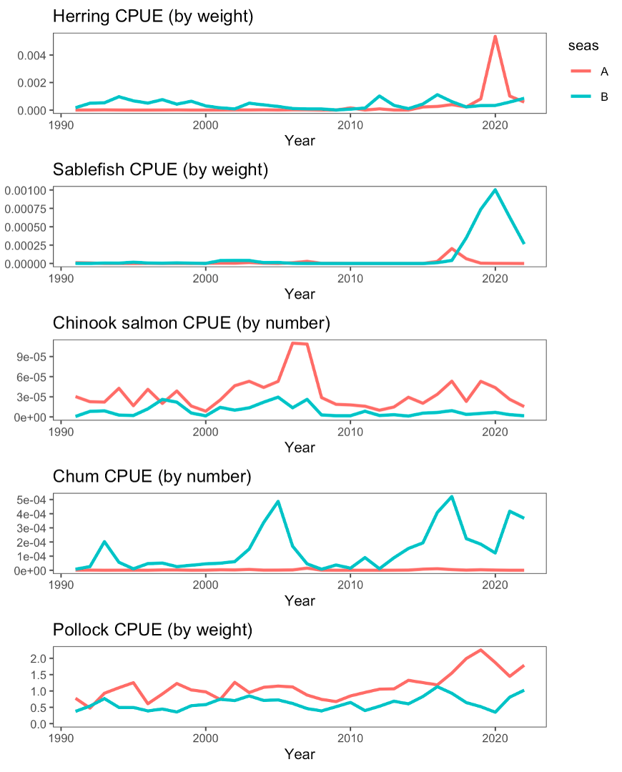

Nominal catch divided by effort (hours towed) for some bycatch species and pollock for the EBS pollock fleet (sectors combined), 2000-2022.

Estimate of EBS pollock catch numbers by sex for the A season (January-May) and B seasons (June-October) and total.

Estimate of EBS pollock catch numbers by sex for the A season (January-May) and B seasons (June-October) and total.

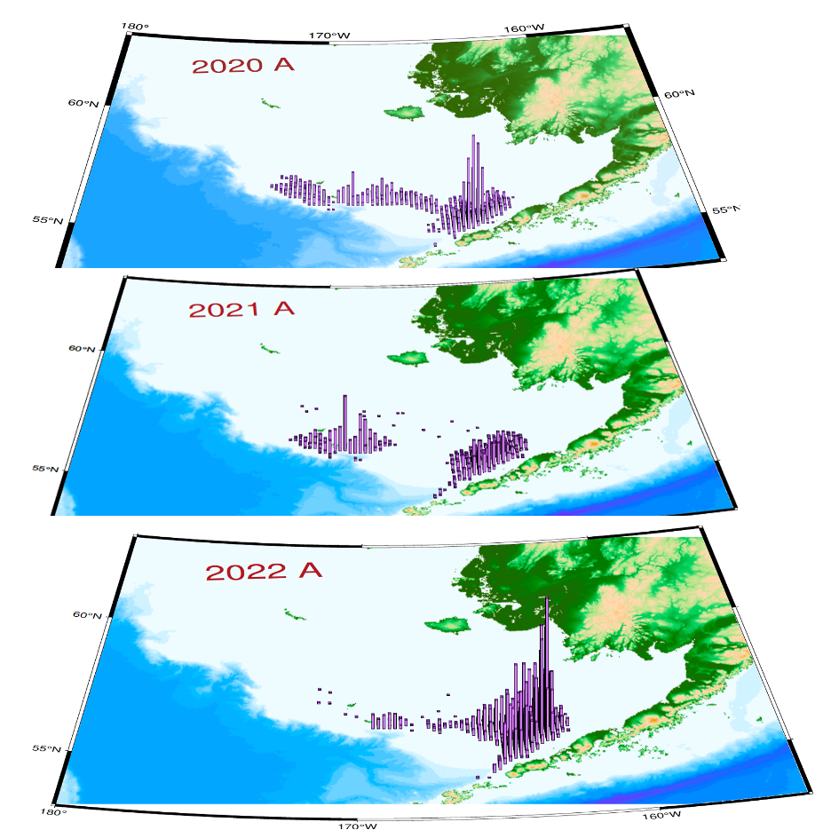

EBS pollock catch distribution during A-season, 2020–2022. Column height is proportional to total catch.

A-season (top) and B-season (bottom) EBS fleet-wide cumulative catch by hours observed fishing and relative pollock catch per hour of fishing (middle). Data were recorded by NMFS scientific observers.

A-season (top) and B-season (bottom) EBS fleet-wide cumulative catch by hours observed fishing and relative pollock catch per hour of fishing (middle). Data were recorded by NMFS scientific observers.

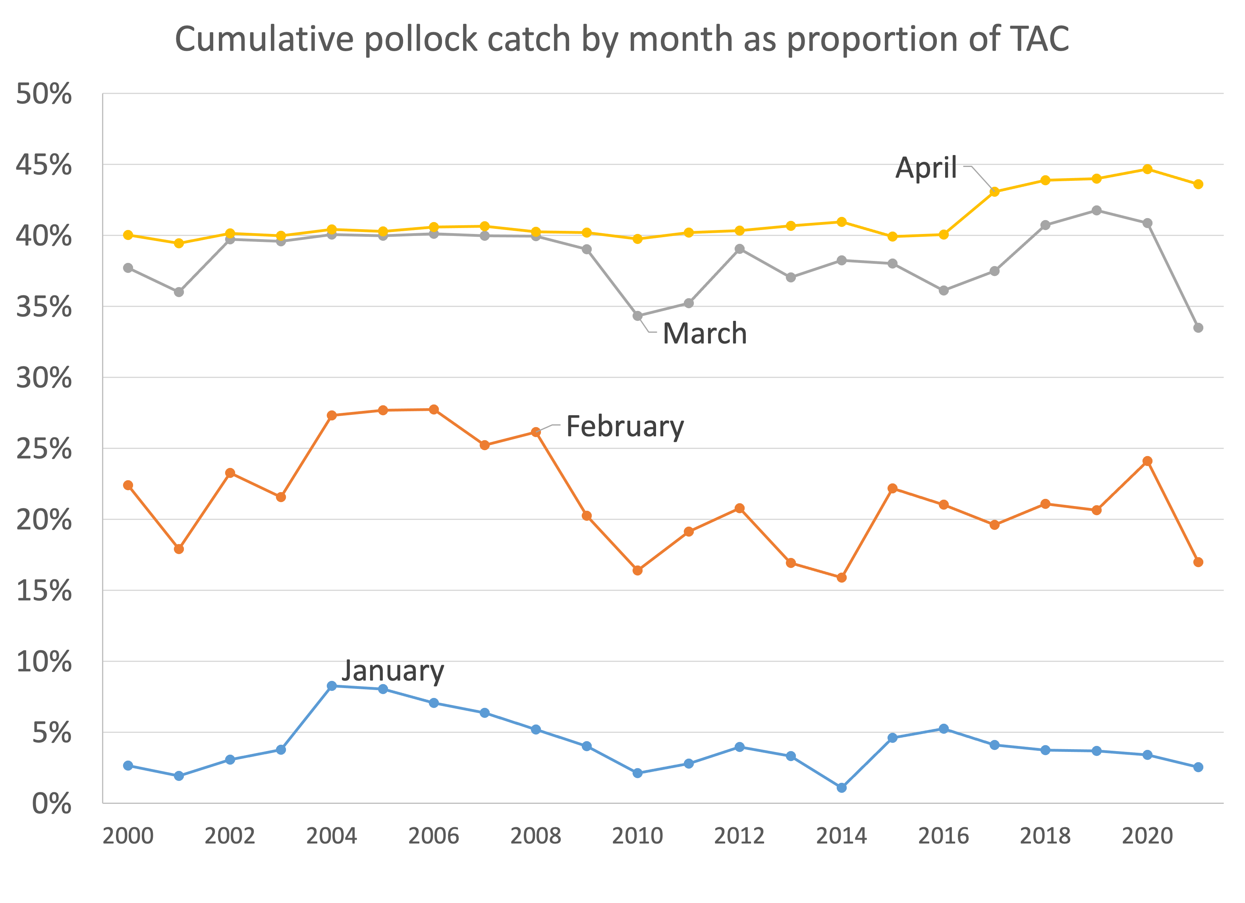

Proportion of the annual EBS pollock TAC by month during the A-season, 2000–2022. The higher value observed since 2017 was due to Amendment 110 of the FMP to allow greater flexibility to avoid Chinook salmon.

EBS pollock roe production in A and B seasons , 2000-2022.

EBS pollock roe production in A and B seasons , 2000-2022.

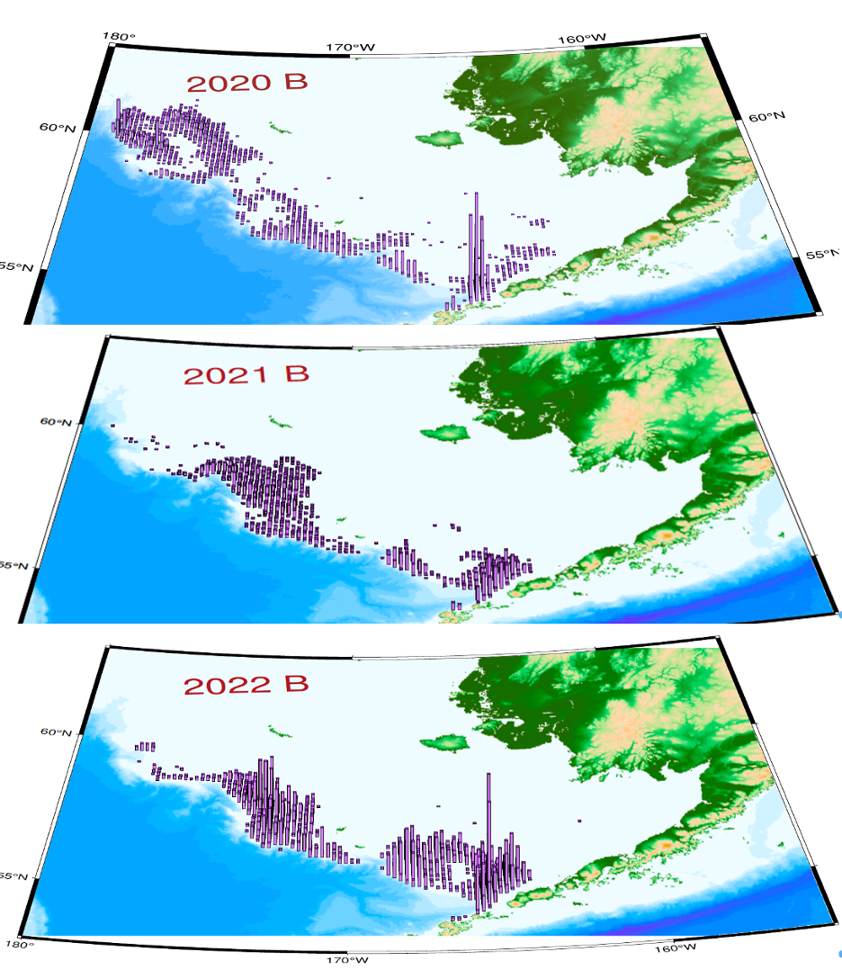

EBS pollock catch distribution during B-season, 2020–2022. Column height is proportional to total catch. Note that directed fishery for pollock generally is finished prior to October; the labels are indicative full-year catches.

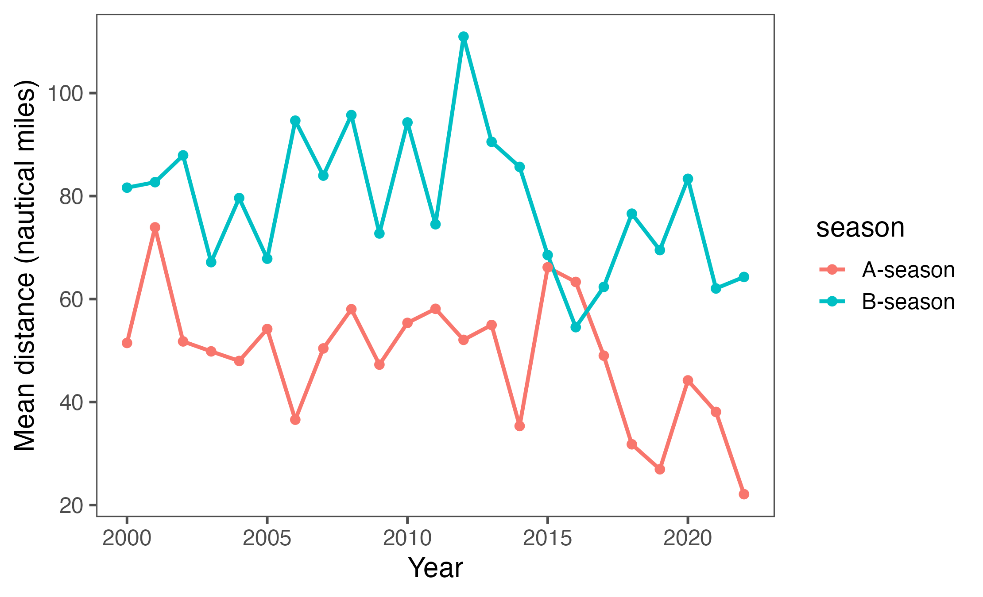

Estimated mean daily distance between operations, 2000-2022.

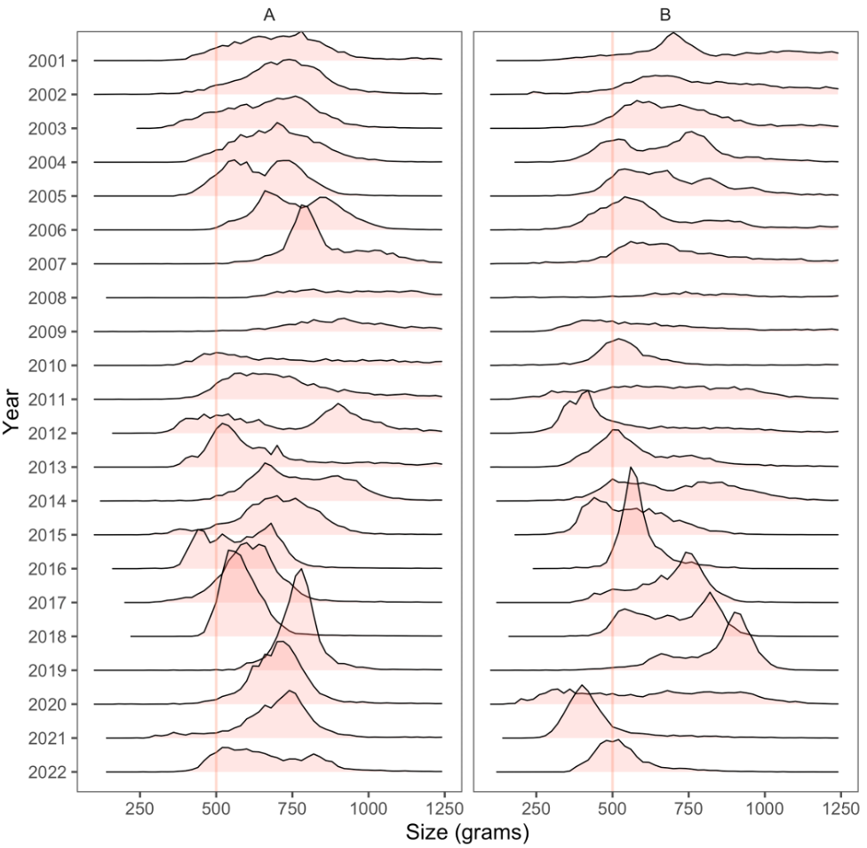

Pollock fishery data showing the frequency of mean pollock weight within a tow (in 50 g increments) by year and season.

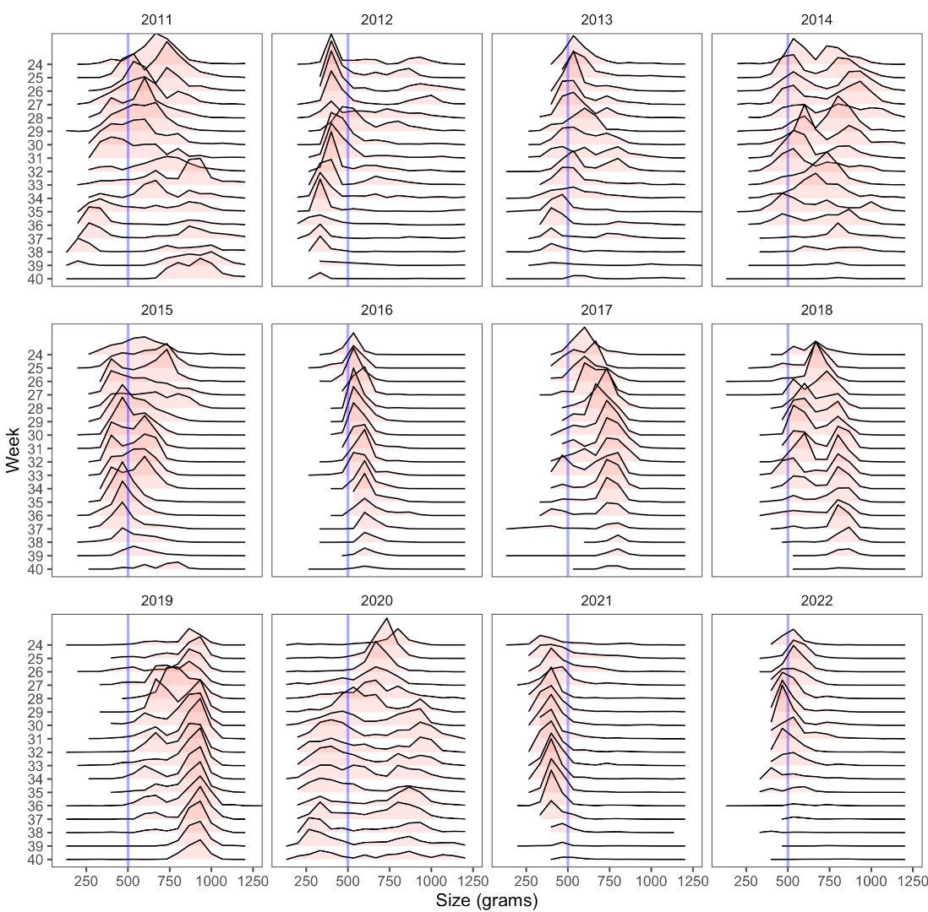

Pollock fishery data showing the frequency of mean pollock weight within a tow (in 50 g increments) by recent years and weeks of the B-season.

Fishery catch-at-length (cm) by the pollock fishery, 1992-2021.

Fishery catch-at-length (cm) by the pollock fishery, 1992-2021.

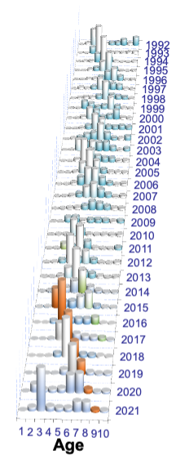

EBS pollock fishery estimated catch-at-age data (in number) for 1992–2021. Age 10 represents pollock age 10 and older. The 2012 year-class is shaded in orange.

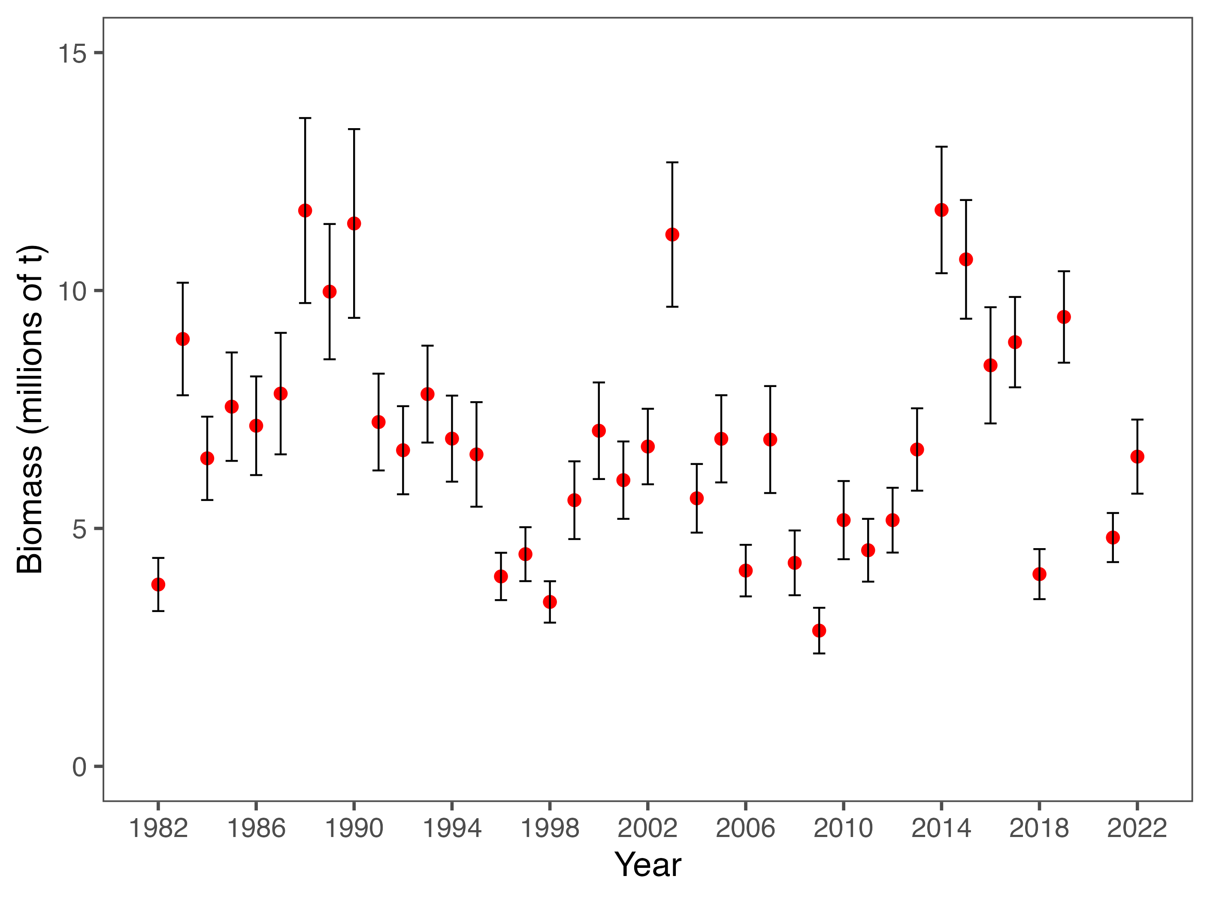

Bottom-trawl survey biomass estimates with error bars representing 95% confidence intervals for the VAST model-based methods for EBS pollock.

Bottom and surface temperatures for the Bering Sea from the NMFS summer bottom-trawl surveys (1982–2019, 2021). Dashed lines represent mean values.

Bottom and surface temperatures for the Bering Sea from the NMFS summer bottom-trawl surveys (1982–2019, 2021). Dashed lines represent mean values.

EBS pollock CPUE (shades = relative kg/hectare) and bottom temperature isotherms in degrees C; from the bottom trawl survey data 2011–2019 and 2021.

EBS pollock CPUE (shades = relative kg/hectare) and bottom temperature isotherms in degrees C; from the bottom trawl survey data 2011–2019 and 2021.

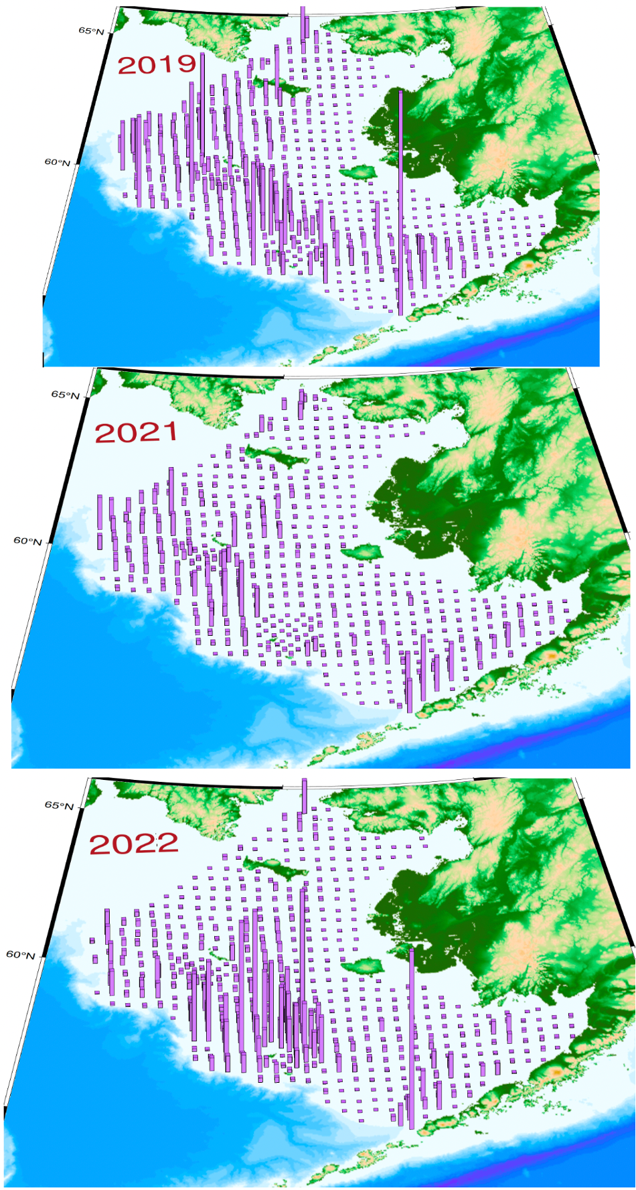

Bottom trawl survey pollock catch in kg per hectare for 2019 and 2021 (top and bottom)compared to the average station density (middle). Height of vertical lines are proportional to station-specific pollock densities by weight (kg per hectare) with constant scales for all years (red stars indicate tows where pollock were absent from the catch).

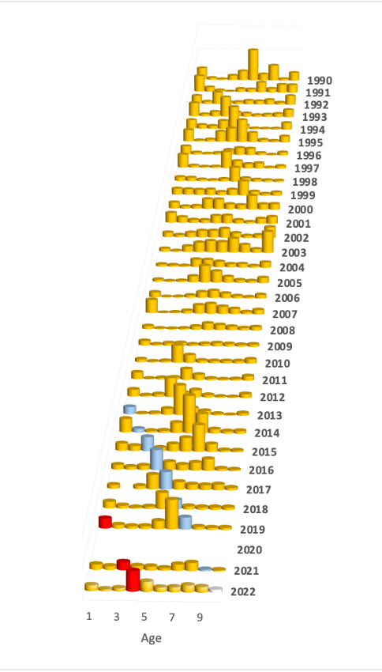

Pollock abundance levels by age and year as estimated directly from the NMFS bottom-trawl surveys (1990–2019,2021-2022). The 2012 year-class is shaded differently.

Comparison of EBS pollock estimated proportions-at-age from the bottom trawl surveys using the standard design-based estimates and those using the VAST spatio-temporal model, 1982-2022 (no data from 2020).

Comparison of EBS pollock estimated proportions-at-age from the bottom trawl surveys using the standard design-based estimates and those using the VAST spatio-temporal model, 1982-2022 (no data from 2020).

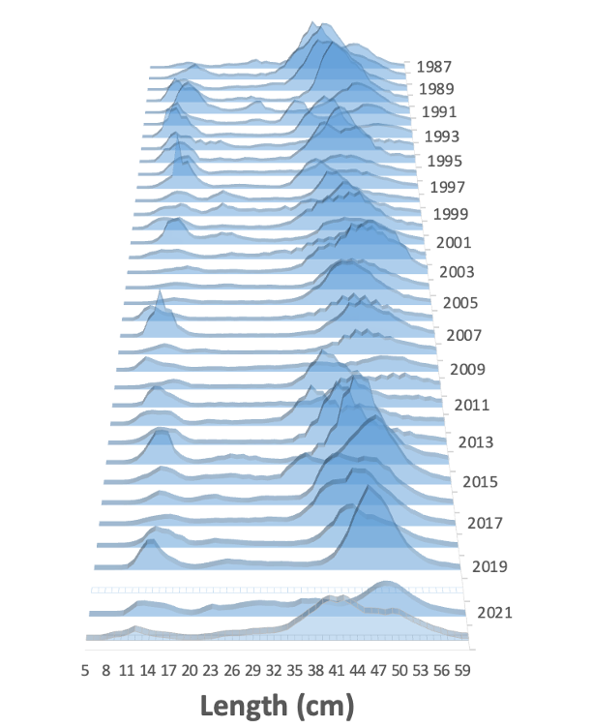

Pollock abundance levels by size and year as estimated from the NMFS bottom-trawl surveys (1990–2019, 2021, and 2022).

Panels showing the values for mean pollock weight-at-age used in the previous assessment (left panel) and the values revised for this assessment as based on more data and appropriate CPUE weighting (right panel). the shadings indicate anomalies over time within ages (columns).

Panels showing the values for mean pollock weight-at-age used in the previous assessment (left panel) and the values revised for this assessment as based on more data and appropriate CPUE weighting (right panel). the shadings indicate anomalies over time within ages (columns).

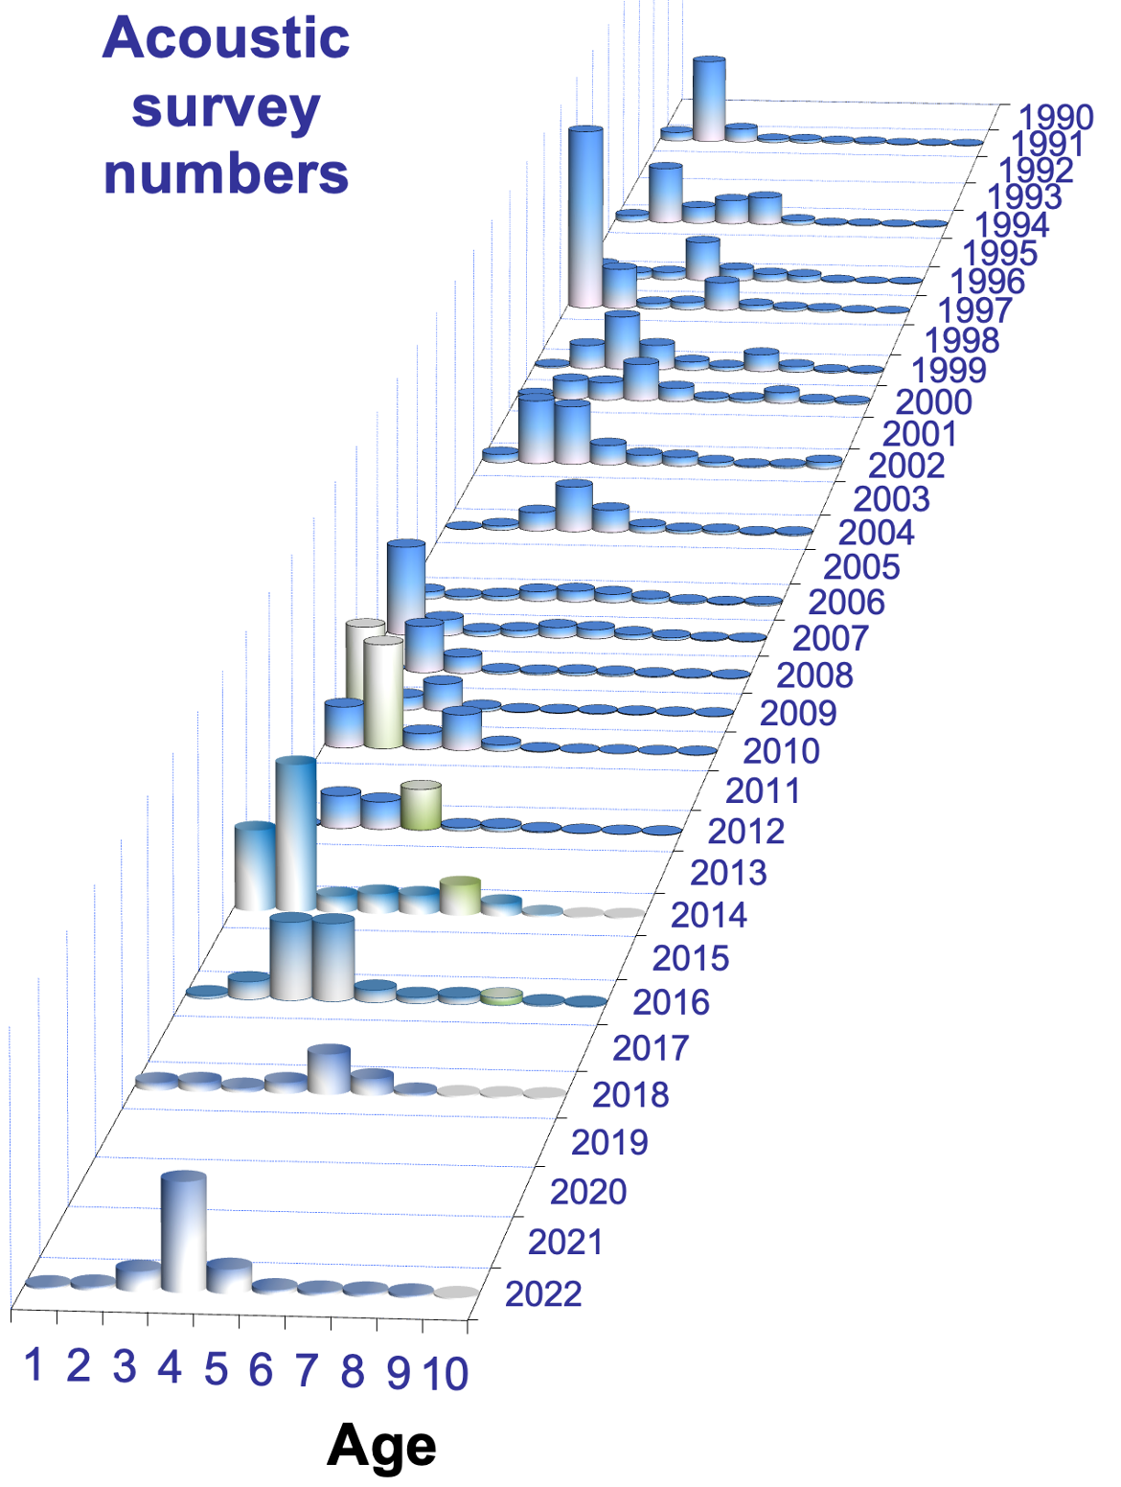

Acoustic-trawl survey pollock numbers-at-age estimates, 1994-2022. Note that data for 2022 are preliminary and based on age-length composition from the bottom trawl survey (plus some supplemental samples from the present survey).

Maps of acoustic vessel-of-opportunity (AVO) index data 2006-2022. Grid cell size and shading is proportional to pollock backscatter.

Maps of acoustic vessel-of-opportunity (AVO) index data 2006-2022. Grid cell size and shading is proportional to pollock backscatter.

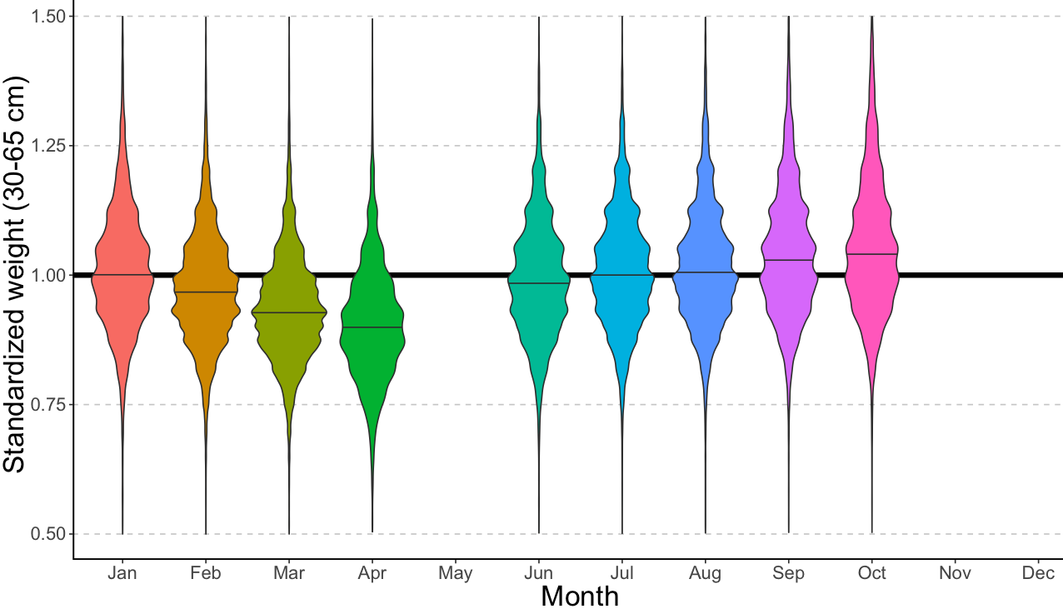

EBS pollock fishery body mass (given length) anomaly (standardized by overall mean body mass at each length) by month based on some over 700 thousand fish measurements from 1991–2022.

EBS pollock fishery body mass (given length) anomaly (standardized by overall mean body mass at each length) by year and season/area strata, 1991–2022.

EBS pollock fishery body mass (given length) anomaly (standardized by overall mean body mass at each length) by year and season/area strata, 1991–2022.

EBS pollock body mass (given length) anomaly (standardized by overall mean body mass at each length) by year, 1991–2022.

EBS pollock body mass (given length) anomaly (standardized by overall mean body mass at each length) by year, 1991–2022.

Recent fishery average weight-at-age anomaly (relative to mean) by strata for ages 3–10, 2017–2021. Vertical shape reflects uncertainty in the data (wider shapes being more precise), colors are consistent with cohorts.

Recent fishery average weight-at-age anomaly (relative to mean) by strata for ages 3–10, 2017–2021. Vertical shape reflects uncertainty in the data (wider shapes being more precise), colors are consistent with cohorts.

Data input and model predictions for the weight-at-age random-effects model fit separately to obtain variance estimates for cohort and year effect contributions to changes in incremental growth from one age to the next. Shadings reflect the anomaly from the mean while the numbers are the weight-at-age in kg.

Data input and model predictions for the weight-at-age random-effects model fit separately to obtain variance estimates for cohort and year effect contributions to changes in incremental growth from one age to the next. Shadings reflect the anomaly from the mean while the numbers are the weight-at-age in kg.

Fishery average weight-at-age anomaly (relative to mean) across strata and combined for all ages (3–10), and available years (1991–2020). Vertical shape reflects uncertainty in the data (wider shapes being more precise), colors are consistent with cohorts.

Fishery average weight-at-age anomaly (relative to mean) across strata and combined for all ages (3–10), and available years (1991–2020). Vertical shape reflects uncertainty in the data (wider shapes being more precise), colors are consistent with cohorts.

Recent fishery average weight-at-age anomaly (relative to mean) by strata for ages 3–10, 2016–2021. Vertical shape reflects uncertainty in the data (wider shapes being more precise), colors are consistent with cohorts.

Recent fishery average weight-at-age anomaly (relative to mean) by strata for ages 3–10, 2016–2021. Vertical shape reflects uncertainty in the data (wider shapes being more precise), colors are consistent with cohorts.

Model runs comparing last year’s assessment with the impact of sequentially adding new data (first 2022 catch and 2021 fishery catch-at-age, then the 2022 bottom trawl survey data point, then the acoustic-trawl and finally the AVO data.

Model runs comparing last year’s assessment with the impact of sequentially adding new data (first 2022 catch and 2021 fishery catch-at-age, then the 2022 bottom trawl survey data point, then the acoustic-trawl and finally the AVO data.

Model results showing the impact of new data available in r this year overall for EBS pollock; recruitment (top) and spawning biomass (bottom).

Model results showing the impact of new data available in r this year overall for EBS pollock; recruitment (top) and spawning biomass (bottom).

EBS pollock model fits to the Japanese fishery CPUE.

EBS pollock model fits to the Japanese fishery CPUE.

Model results of predicted and observed AVO index. Error bars represent assumed 95% confidence bounds of the input series.

Model results of predicted and observed AVO index. Error bars represent assumed 95% confidence bounds of the input series.

EBS pollock model fit to the BTS survey data (VAST estimates based on density dependence-corrected CPUE by station), 1982–2019, 2021-2022. Units are relative biomass.

EBS pollock model fit to the BTS survey data (VAST estimates based on density dependence-corrected CPUE by station), 1982–2019, 2021-2022. Units are relative biomass.

EBS pollock model fit to the ATS biomass index, 1994–2022.

EBS pollock model fit to the ATS biomass index, 1994–2022.

EBS pollock model fits to observed mean age for the Acoustic trawl survey (top), the bottom trawl survey (middle) and fishery (bottom)

EBS pollock model fits to observed mean age for the Acoustic trawl survey (top), the bottom trawl survey (middle) and fishery (bottom)

Selectivity at age estimates for the EBS pollock fishery; note that the values for the terminal year is used for ABC and OFL projections.

Selectivity at age estimates for the EBS pollock fishery; note that the values for the terminal year is used for ABC and OFL projections.

Model fit (dots) to the EBS pollock fishery proportion-at-age data (columns; 1992–2021). The 2021 data are new to this year’s assessment. Colors coincide with cohorts progressing through time.

Model fit (dots) to the EBS pollock fishery proportion-at-age data (columns; 1992–2021). The 2021 data are new to this year’s assessment. Colors coincide with cohorts progressing through time.

Model estimates of bottom-trawl survey selectivity, 1982–2022.

Model estimates of bottom-trawl survey selectivity, 1982–2022.

Model fit (dots) to the bottom trawl survey proportion-at-age composition data (columns) for EBS pollock. Colors correspond to cohorts over time.

Model fit (dots) to the bottom trawl survey proportion-at-age composition data (columns) for EBS pollock. Colors correspond to cohorts over time.

Model fit (dots) to the acoustic-trawl survey proportion-at-age composition data (columns) for EBS pollock. Colors correspond to cohorts over time (for years with consecutive surveys).

Model fit (dots) to the acoustic-trawl survey proportion-at-age composition data (columns) for EBS pollock. Colors correspond to cohorts over time (for years with consecutive surveys).

Pairwise plot of selected EBS pollock parameters and output from 3 million MCMC iterations thinned such that 5 thousand draws were saved as an approximation to the multivariate posterior distribution. Note that the figures on the diagonal represent the marginal posterior distributions. Key: lnR0 is the parameter that scales the stock-recruit relationship, B_Bmsy is estimated B_{2021}/B_{MSY}, DynB0 is the ratio of spawning biomass estimated for in 2022 over the value estimated that would occur if there had been no fishing, B2022 is the spawning biomass in 2022, and B_Bmean is B_{2022}/\bar{B}.

Pairwise plot of selected EBS pollock parameters and output from 3 million MCMC iterations thinned such that 5 thousand draws were saved as an approximation to the multivariate posterior distribution. Note that the figures on the diagonal represent the marginal posterior distributions. Key: lnR0 is the parameter that scales the stock-recruit relationship, B\_Bmsy is estimated $B_{2021}/B_{MSY}$, DynB0 is the ratio of spawning biomass estimated for in 2022 over the value estimated that would occur if there had been no fishing, B2022 is the spawning biomass in 2022, and B\_Bmean is $B_{2022}/\overset{‾}{B}$.

Integrated marginal posterior density (based on MCMC results) for the 2021 EBS pollock female spawning biomass compared to the point estimate (dashed red line).

Integrated marginal posterior density (based on MCMC results) for the 2021 EBS pollock female spawning biomass compared to the point estimate (dashed red line).

Integrated marginal posterior density (based on MCMC results) for the F_{MSY} for EBS pollock and different central tendency values..

Integrated marginal posterior density (based on MCMC results) for the $F_{MSY}$ for EBS pollock and different central tendency values..

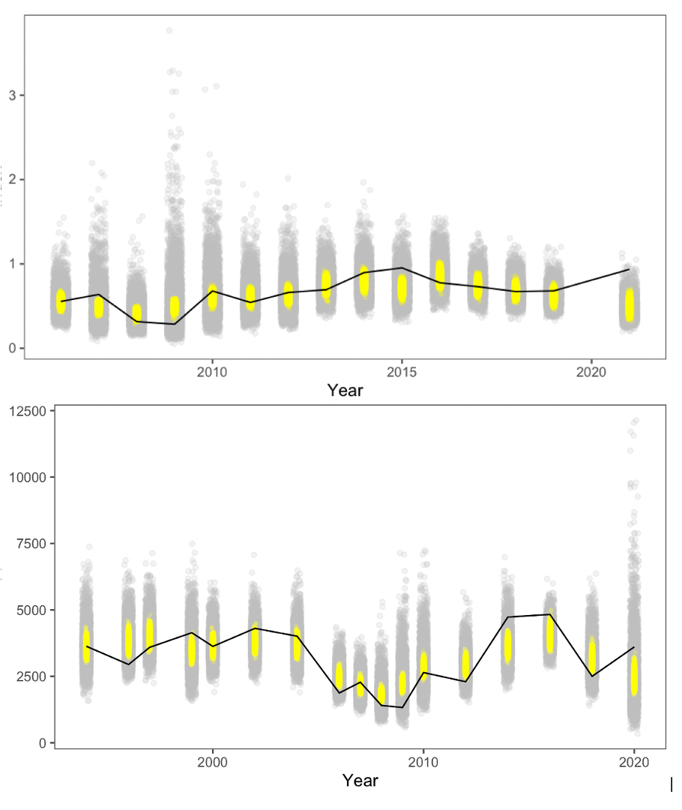

Plot of the model prediction (solid line), the distribution of the expected value (yellow dots) and the posterior predictive distribution (grey points).

Retrospective patterns for EBS pollock spawning biomass showing the point estimates relative to the terminal year (top panel) and approximate confidence bounds on absolute scale (+2 standard deviations).

Retrospective patterns for EBS pollock spawning biomass showing the point estimates relative to the terminal year (top panel) and approximate confidence bounds on absolute scale (+2 standard deviations).

Retrospective pattern for estimated EBS pollock fishery selectivity (dots) compared to the projected selectivity from the year prior (solid line).”

Retrospective pattern for estimated EBS pollock fishery selectivity (dots) compared to the projected selectivity from the year prior (solid line).”

Retrospective pattern for the mean selected age (ages 1-8) based on estimated EBS pollock fishery selectivity compared to the projected selectivity from the year prior.”

Retrospective pattern for the mean selected age (ages 1-8) based on estimated EBS pollock fishery selectivity compared to the projected selectivity from the year prior.”

Comparison of $F_{MSY}$ and mean selected age.” The horizontal axis is a way to summarize if selectivity is tend towards younger or older fish. Labels indicate the year that demographic parameters (weight-at-age

Estimated spawning exploitation rate (defined as the percent removal of egg production in a given spawning year).

Estimated spawning exploitation rate (defined as the percent removal of egg production in a given spawning year).

Estimated instantaneous age-specific fishing mortality rates for EBS pollock.

Estimated instantaneous age-specific fishing mortality rates for EBS pollock.

Comparison of the current assessment results with past assessments of begin-year EBS age-3+ pollock biomass.

Comparison of the current assessment results with past assessments of begin-year EBS age-3+ pollock biomass.

Estimated spawning biomass relative to annually estimated F_{MSY} values and fishing mortality rates for EBS pollock. Two projection years are shaded in yellow

Estimated spawning biomass relative to annually estimated $F_{MSY}$ values and fishing mortality rates for EBS pollock. Two projection years are shaded in yellow

The estimated EBS pollock spawning stock biomass for model 20 last year and this with projections equal to the estimated fishing mortality from 2022.

The estimated EBS pollock spawning stock biomass for model 20 last year and this with projections equal to the estimated fishing mortality from 2022.

Recruitment estimates (age-1 recruits) for EBS pollock for all years since 1964 (1963–2021 year classes) for Model 20. Error bars reflect 90% credible intervals based on model estimates of uncertainty.

Recruitment estimates (age-1 recruits) for EBS pollock for all years since 1964 (1963–2021 year classes) for Model 20. Error bars reflect 90% credible intervals based on model estimates of uncertainty.

Stock-recruitment estimates (shaded represents structural uncertainty) and age-1 EBS pollock estimates labeled by year-classes

Stock-recruitment estimates (shaded represents structural uncertainty) and age-1 EBS pollock estimates labeled by year-classes

EBS pollock productivity as measured by logged recruits per spawning biomass, log(R/S), as a function of spawning biomass with a linear fit (bottom) and over time, 1964–2022 (top).

EBS pollock productivity as measured by logged recruits per spawning biomass, log(R/S), as a function of spawning biomass with a linear fit (bottom) and over time, 1964–2022 (top).

Mean recruitment estimates (age-1) for EBS pollock for different periods with error bars representing 95% credible intervals.

Mean recruitment estimates (age-1) for EBS pollock for different periods with error bars representing 95% credible intervals.

Projected EBS Tier 3 pollock yield (top) and female spawning biomass (bottom) relative to the long-term expected values under F_{35\%} and F_{40\%} (horizontal lines). B_{40\%} is computed from average recruitment from 1978–2020. Future harvest rates follow the guidelines specified under Tier 3 Scenario 1.

Projected EBS Tier 3 pollock yield (top) and female spawning biomass (bottom) relative to the long-term expected values under $F_{35\%}$ and $F_{40\%}$ (horizontal lines). $B_{40\%}$ is computed from average recruitment from 1978–2020. Future harvest rates follow the guidelines specified under Tier 3 Scenario 1.

Projected pollock yield (top) and female spawning biomass (bottom) under Alternative 3—fishing under the recent 5-year average fishing mortality. The long-term expected values under F_{35\%} and F_{40\%} (horizontal lines) B_{40\%} are computed from average recruitment from 1978–2020.

Projected pollock yield (top) and female spawning biomass (bottom) under Alternative 3—*fishing under the recent 5-year average fishing mortality*. The long-term expected values under $F_{35\%}$ and $F_{40\%}$ (horizontal lines) $B_{40\%}$ are computed from average recruitment from 1978–2020.

For the mature component of the EBS pollock stock, time series of estimated average age and diversity of ages (using the Shannon-Wiener H statistic), 1980–2022.

For the mature component of the EBS pollock stock, time series of estimated average age and diversity of ages (using the Shannon-Wiener H statistic), 1980–2022.

# EBS Pollock Model Description

## Dynamics

This assessment is based on a statistical age-structured model with the catch equation and population dynamics model as described in Fournier and Archibald (1982) and elsewhere (e.g., Hilborn and Walters 1992, Schnute and Richards 1995, McAllister and Ianelli 1997). The catch in numbers at age in year $t\left(C_{t,a}\right)$ and total catch biomass $\left(Y_{t}\right)$ can be described as:

$$\begin{matrix}C_{t,a} & =\frac{F_{t,a}}{Z_{t,a}}\left(1-e^{-Z_{t,a}}\right)N_{t,a}, & 1≤t≤T,1≤a≤A \\ N_{t+1,a+1} & =N_{t,a-1}e^{-Z_{t,a-1}} & 1≤t≤T,1≤a<A \\ N_{t+1,A} & =N_{t,A-1}e^{-Z_{t,A-1}}+N_{t,A}e^{-Z_{t,A}}, & 1≤t≤T \\ Z_{t,a} & & =F_{t,a}+M_{t,a} \\ C_{t,.} & & =\sum_{a=1}^{A}{C_{t,a}} \\ p_{t,a} & & =\frac{C_{t,a}}{C_{t,.}} \\ Y_{t} & & =\sum_{a=1}^{A}{w_{t,a}C_{t,a}}\end{matrix}$$

where

Fishing mortality ($F_{t,a}$) is specified as being semi-separable and non-parametric in form with restrictions on the variability following Butterworth et al. (2003):

$$\begin{matrix}F_{t,a} & =s_{t,a} μ^{f}e^{ϵ_{t}}, & ϵ_{t}∼N\left(0, σ_{E}^{2}\right) \\ s_{t+1,a} & =s_{t,a} e^{γ_{t}}, & γ_{t}∼N\left(0, σ_{s}^{2}\right)\end{matrix}$$

where $s_{t,a}$ is the selectivity for age class $a$ in year $t$, and $μ^{f}$ is the median fishing mortality rate over time.

If the selectivities ($s_{t,a}$) are constant over time then fishing mortality rate decomposes into an age component and a year component. A curvature penalty on the selectivity coefficients using the squared second-differences to provide smoothness between ages.

Bottom-trawl survey selectivity was set to be asymptotic yet retain the properties desired for the characteristics of this gear. Namely, that the function should allow flexibility in selecting age 1 pollock over time. The functional form of this selectivity was:

$$\begin{matrix}s_{t,a} & ={\left[1+e^{-α_{t}a-β_{t}}\right]}^{-1}, & a>1 \\ s_{t,a} & =μ_{s}e^{-δ_{t}^{μ}}, & a=1 \\ α_{t} & & =\overset{‾}{α}e^{δ_{t}^{α}}, \\ β_{t} & & =\overset{‾}{β}e^{δ_{t}^{β}},\end{matrix}$$

where the parameters of the selectivity function follow a random walk process as in Dorn et al. (2000):

$$\begin{matrix}δ_{t}^{μ}-δ_{t+1}^{μ} & ∼N\left(0, σ_{δ^{μ}}^{2}\right) \\ & \\ α_{t}^{μ}-α_{t+1}^{μ} & ∼N\left(0, σ_{α^{μ}}^{2}\right) \\ β_{t}^{μ}-β_{t+1}^{μ} & ∼N\left(0, σ_{β^{μ}}^{2}\right)\end{matrix}$$

The parameters to be estimated in this part of the model are thus for t=1982 through to 2022. The variance terms for these process error parameters were specified to be 0.04.

In this assessment, the random-walk deviation penalty was optionally shifted to the changes in log-selectivity. that is, for the BTS estimates, the process error was applied to the logistic parameters as above, but the lognormal penalty was applied to the resulting selectivities-at-age directly. The extent of this variability was evaluated in the context of the impact on age-specific survey catchability/availability and contrasted with an independent estimate of pollock availability to the bottom trawl survey.

$$\begin{matrix}ln\left(s_{t,a}\right)-ln\left(s_{t+1,a}\right) & ∼N\left(0, σ_{sel}^{2}\right)\end{matrix}$$

In 2008 the AT survey selectivity approach was modified. As an option, the age one pollock observed in this trawl can be treated as an index and are not considered part of the age composition (which then ranges from age 2-15). This was done to improve some interaction with the flexible selectivity smoother that is used for this gear and was compared. Additionally, the annual specification of input observation variance terms was allowed for the AT data.

A diagnostic approach to evaluate input variance specifications (via sample size under multinomial assumptions) was added in the 2018 assessment. This method uses residuals from mean ages together with the concept that the sample variance of mean age (from a given annual data set) varies inversely with input sample size. It can be shown that for a given set of input proportions at age (up to the maximum age $A$) and sample size $N_{t}$ for year $t$, an adjustment factor $ν$ for input sample size can be computed when compared with the assessment model predicted proportions at age (${\hat{p}}_{ta}$) and model predicted mean age ($\hat{\overset{‾}{a_{t}}}$):

$$\begin{matrix}ν & =\text{var}{\left(r_{t}^{a}\sqrt{\frac{N_{t}}{κ_{t}}}\right)}^{-1} \\ r_{t}^{a} & ={\overset{‾}{a}}_{t}-\hat{\overset{‾}{a_{t}}} \\ κ_{t} & ={\left[\sum_{a}^{A}{{\overset{‾}{a}}_{t}-\hat{\overset{‾}{a_{t}}}}\right]}^{0.5}\end{matrix}$$

where $r_{t}^{a}$ is the residual of mean age and

$$\begin{matrix}\hat{\overset{‾}{a_{t}}} & =\sum_{a}^{A}{a{\hat{p}}_{ta}} \\ {\overset{‾}{a}}_{t} & =\sum_{a}^{A}{ap_{ta}} \end{matrix}$$

Based on previous analyses, we used the above relationship as a diagnostic for evaluating input sample sizes by comparing model predicted mean ages with observed mean ages and the implied 95% confidence bands. This method provided support for modifying the frequency of allowing selectivity changes.

## Recruitment

In these analyses, recruitment ($R_{t}$) represents numbers of age-1 individuals modeled as a stochastic function of spawning stock biomass.

$$\begin{matrix}R_{t}=f\left(B_{t-1}\right)\end{matrix}$$

with mature spawning biomass during year $t$ was defined as:

$$\begin{matrix}B_{t}=\sum_{a=1}^{A}{w_{t,a}ϕ_{a}N_{t,a}}\end{matrix}$$

and, $ϕ_{a}$ is the proportion of mature females at age is as shown in the sub-section titled Natural mortality and maturity at age under “Parameters estimated independently” above.

A reparameterized form for the stock-recruitment relationship following Francis (1992) was used. For the optional Beverton-Holt form (the Ricker form presented in Eq. 12 was adopted for this assessment) we have:

$$\begin{matrix}R_{t} & =\frac{B_{t-1}e^{ε_{t}}}{α+βB_{t-1}}\end{matrix}$$

where

Values for the stock-recruitment function parameters and are calculated from the values of (the number of 0-year-olds in the absence of exploitation and recruitment variability) and the steepness of the stock-recruit relationship ($h$). The steepness is the fraction of R0 to be expected (in the absence of recruitment variability) when the mature biomass is reduced to 20% of its pristine level (Francis 1992), so that:

$$\begin{matrix}α & ={\tilde{B}}_{0}\frac{1-h}{4h} \\ β & =\frac{5h-1}{4hR_{0}}\end{matrix}$$

where ${\tilde{B}}_{0}$ is the total egg production (or proxy, e.g., female spawning biomass) in the absence of exploitation (and recruitment variability) expressed as a fraction of $R_{0}$.

Some interpretation and further explanation follows. For steepness equal 0.2, then recruits are a linear function of spawning biomass (implying no surplus production). For steepness equal to 1.0, then recruitment is constant for all levels of spawning stock size. A value of $h=0.9$ implies that at 20% of the unfished spawning stock size will result in an expected value of 90% unfished recruitment level. Steepness of 0.7 is a commonly assumed default value for the Beverton-Holt form (e.g., Kimura 1988). The prior distribution for steepness used a beta distribution as in Ianelli et al. (2016). The prior on steepness was specified to be a symmetric form of the Beta distribution with $α=β=14.93$ implying a prior mean of 0.5 and CV of 12% (implying that there is about a 14% chance that the steepness is greater than 0.6). This conservative prior is consistent with previous years’ application and serves to constrain the stock-recruitment curve from favoring steep slopes (uninformative priors result in $F_{MSY}$ values near an $F_{SPR}$ of about $F_{18\%}$ a value considerably higher than the default proxy of $F_{35\%}$). The residual pattern for the post-1977 recruits used in fitting the curve with a more diffuse prior resulted in all estimated recruits being below the curve for stock sizes less than $B_{MSY}$ (except for the 1978 year class). We believe this to be driven primarily by the apparent negative-slope for recruits relative to stock sizes above $B_{MSY}$ and as such, provides a potentially unrealistic estimate of productivity at low stock sizes. This prior was elicited from the rationale that residuals should be reasonably balanced throughout the range of spawning stock sizes. Whereas this is somewhat circular (i.e., using data for prior elicitation), the point here is that residual patterns (typically ignored in these types of models) were qualitatively considered.

In model 16.1 (from the 2019 assessment), a Beverton Holt stock recruitment form was implemented using the prior value of 0.67 for steepness and a CV of 0.17. This resulted in beta distribution parameters (for the prior) at $α=6.339$ and $β=4.293$ 
.

The value of $σ_{R}$ was set at 1.0 to accommodate additional uncertainty in factors affecting recruitment variability.

To have the critical value for the stock-recruitment function (steepness, *h*) on the same scale for the Ricker model, we begin with the parameterization of Kimura (1990):

$$\begin{matrix}R_{t} & =\frac{B_{t-1}e^{α\left(1-B_{t-1}\frac{R_{0}}{ψ_{0}}\right)}}{ψ_{0}}\end{matrix}$$

It can be shown that the Ricker parameter a maps to steepness as:

$$\begin{matrix}h & =\frac{e^{α}}{e^{α}+4}\end{matrix}$$

so that the prior used on *h* can be implemented in both the Ricker and Beverton-Holt stock-recruitment forms. Here the term $ψ_{0}$ represents the equilibrium unfished spawning biomass per-recruit.

## Diagnostics

In 2006 a replay feature was added where the time series of recruitment estimates from a particular model is used to compute the subsequent abundance expectation had no fishing occurred. These recruitments are adjusted from the original estimates by the ratio of the expected recruitment given spawning biomass (with and without fishing) and the estimated stock-recruitment curve. I.e., the recruitment under no fishing is modified as:

$$R_{t}'={\hat{R}}_{t}\frac{f\left(B_{t-1}'\right)}{f\left(B_{t-1}\right)}$$

where $R_{t}$ is the original recruitment estimate in year $t$ with $B_{t-1}'$ and $B_{t-1}$ representing the stock-recruitment function given spawning biomass under no fishing and under the estimated fishing intensity, respectively.

The assessment model code allows retrospective analyses (e.g., Parma 1993, and Ianelli and Fournier 1998). This was designed to assist in specifying how spawning biomass patterns (and uncertainty) have changed due to new data. The retrospective approach simply uses the current model to evaluate how it may change over time with the addition of new data based on the evolution of data collected over the past several years.

## Parameter estimation

The objective function was simply the sum of the negative log-likelihood function and logs of the prior distributions. To fit large numbers of parameters in nonlinear models it is useful to be able to estimate certain parameters in different stages. The ability to estimate stages is also important in using robust likelihood functions since it is often undesirable to use robust objective functions when models are far from a solution. Consequently, in the early stages of estimation we use the following log- likelihood function for the survey and fishery catch at age data (in numbers):



where $A$, and $T$, represent the number of age classes and years, respectively, n is the sample size, and represent the observed and predicted numbers at age in the catch. The elements bi,j represent ageing mis-classification proportions are based on independent agreement rates between otolith age readers. For the models presented this year, the option for including aging errors was re-evaluated.

Sample size values were revised and are shown in the main document. Strictly speaking, the amount of data collected for this fishery indicates higher values might be warranted. However, the standard multinomial sampling process is not robust to violations of assumptions (Fournier et al. 1990). Consequently, as the model fit approached a solution, we invoke a robust likelihood function which fit proportions at age as:

$$\begin{matrix}\prod_{a=1}^{A}{\prod_{t=1}^{T}{\left[\left(exp\left(-\frac{{\left(p_{ta}-{\hat{p}}_{ta}\right)}^{2}}{2\left(η_{ta}+0.1/A\right)τ_{t}^{2}}\right)+0.01\right)×\frac{1}{\sqrt{2π\left(η_{ta}+0.1/A\right)τ_{t}}}\right]}}\end{matrix}$$

Taking the logarithm we obtain the log-likelihood function for the age composition data:

$$\begin{matrix}nll\left(i\right)=-0.5\sum_{a=1}^{A}{\sum_{t=1}^{T}{ln2π\left(η_{ta}+0.1/A\right)-\sum_{t}^{T}{A}lnτ_{t}}}+\sum_{a=1}^{A}{\sum_{t=1}^{T}{ln\left\{exp\left(-\frac{{\left(p_{ta}-{\hat{p}}_{ta}\right)}^{2}}{\left(2η_{ta}+0.1/A\right)τ_{t}^{2}}\right)+0.01\right\}}}\end{matrix}$$

where

$$\begin{matrix}η_{ta} & =p_{ta}\left(1-p_{ta}\right) \\ & \text{and} \\ τ_{t}^{2} & =1/n_{t}\end{matrix}$$

which gives the variance for $p_{ta}$

$$\begin{matrix}\left(η_{ta}+0.1/A\right)τ_{t}^{2}\end{matrix}$$

Completing the estimation in this fashion reduces the model sensitivity to data that would otherwise be considered outliers.

Within the model, predicted survey abundance accounted for within-year mortality since surveys occur during the middle of the year. As in previous years, we assumed that removals by the survey were insignificant (i.e., the mortality of pollock caused by the survey was considered insignificant). Consequently, a set of analogous catchability and selectivity terms were estimated for fitting the survey observations as:

$$\begin{matrix}{\hat{N}}_{ta}^{s} & =e^{-0.5Z_{ta}}N_{ta}q_{t}^{s}s_{ta}^{S}\end{matrix}$$

where the superscript s indexes the type of survey (AT or BTS). For the option to use the survey predictions in biomass terms instead of just abundance, the above was modified to include observed survey biomass weights-at-age:

$$\begin{matrix}{\hat{N}}_{ta}^{s} & =e^{-0.5Z_{ta}}w_{ta}N_{ta}q_{t}^{s}s_{ta}^{S}\end{matrix}$$

For the AVO index, the values for selectivity were assumed to be the same as for the AT survey and the mean weights at age over time was also assumed to be equal to the values estimated for the AT survey.

For these analyses we chose to keep survey catchabilities constant over time (though they are estimated separately for the AVO index and for the AT and bottom trawl surveys). The contribution to the negative log-likelihood function (ignoring constants) from the surveys is given by either the lognormal distribution:



where $u_{t}^{s}$ is the total (numerical abundance or optionally biomass) estimate with variance $σ_{s,t}$ from survey $s$ in year $t$ or optionally, the normal distribution can be selected:



The AT survey and AVO index is modeled using a lognormal distribution whereas for the BTS survey, a normal distribution was applied.

For model configurations in which the BTS data are corrected for estimated efficiency, a multivariate lognormal distribution was used. For the negative- log likelihood component this was modeled as

$$nll_{i}=0.5XΣ^{-1}X^{'}$$

where is a vector of observed minus model predicted values for this index and $Σ$ is the estimated covariance matrix provided from the method provided in Kotwicki et al. 2014. For the VAST estimates, the supplied covariance matrix was used in the same way.

The contribution to the negative log-likelihood function for the observed total catch biomass ($C_{b}^{obs},\hat{C_{b}}$) by the fishery is given by



where $σ_{C_{b},t}$ is pre-specified (set to 0.05) reflecting the accuracy of the overall observed catch in biomass. Similarly, the contribution of prior distributions (in negative log-density) to the log-likelihood function include where the size of the ’s represent prior assumptions about the variances of these random variables. Most of these parameters are associated with year-to- year and age specific deviations in selectivity coefficients. For a presentation of this type of Bayesian approach to modeling errors-in- variables, the reader is referred to Schnute (1994). To facilitate estimating such a large number of parameters, automatic differentiation software extended from Greiwank and Corliss (1991) and developed into C++ class libraries was used. This software provided the derivative calculations needed for finding the posterior mode via a quasi-Newton function minimization routine (e.g., Press et al. 1992). The model implementation language (ADModel Builder) gave simple and rapid access to these routines and provided the ability estimate the variance-covariance matrix for all dependent and independent parameters of interest.

## Uncertainty in mean body mass

The approach we use to solve for $F_{MSY}$ and related quantities (e.g., $B_{MSY}$ $MSY$) within a general integrated model context was shown in Ianelli et al. (2001). In 2007 this was modified to include uncertainty in weight-at-age as an explicit part of the uncertainty for $F_{MSY}$ calculations. This involved estimating a vector of parameters ($w_{ta}^{future}$) on current (2022) and future mean weights for each age $i$, $i$ = (1, 2,…,15), given actual observed mean and variances in weight-at-age over the period 1991-2021. The values of based on available data and (if this option is selected) estimates the parameters subject to the natural constraint:

$$w_{ta}^{future}∼N\left(\overset{‾}{w_{a}}, σ_{w_{a}}^{2}\right)$$

Note that this converges to the mean values over the time series of data (no other likelihood component within the model is affected by future mean weights-at-age) while retaining the natural uncertainty that can propagate through estimates of $F_{MSY}$ uncertainty. This latter point is essentially a requirement of the Tier 1 categorization.

Subsequently, this method was refined to account for current-year survey data and both cohort and year effects. The model for this is:

$$\begin{matrix}{\hat{w}}_{ta} & ={\overset{‾}{w}}_{a}e^{υ_{t}} & a=1, t≥1964 \\ {\hat{w}}_{ta} & ={\hat{w}}_{t-1,a-1}+Δ_{a}e^{ψ_{t}} & a>1, t>1964 \\ Δ_{a} & ={\overset{‾}{w}}_{a+1}-{\overset{‾}{w}}_{a} & a<A \\ {\overset{‾}{w}}_{a} & & =α{\left\{L_{1}+\left(L_{2}-L_{1}\right)\left(\frac{1-K^{a-1}}{1-K^{A-1}}\right)\right\}}^{3}\end{matrix}$$

where the fixed effects parameters are $L_{1},L_{2},K,$ and $α$ while the random effects parameters are $υ_{t}$ and $ψ_{t}$.

## Tier 1 projections

Tier 1 projections were calculated two ways. First, for 2023 and 2024 ABC and $OFL$ levels, the harmonic mean $F_{MSY}$ value was computed and the analogous harvest rate ($\overset{‾}{u_{HM}}$) applied to the estimated geometric mean fishable biomass at $B_{MSY}$:

$$\begin{matrix}ABC_{t} & & =B_{GM,t}^{f}{\hat{u}}_{HM}ζ_{t} \\ B_{GM,t}^{f} & & =e^{ln{\hat{B}}_{t}^{f}-0.5σ_{B^{f}}^{2}} \\ u_{HM,t}^{f} & & =e^{ln{\hat{u}}_{MSY,t}-0.5σ_{u_{MSY}}^{2}} \\ ζ_{t} & =\frac{B_{t}/B_{MSY}-0.05}{1-0.05} & B_{t}<B_{MSY} \\ ζ_{t} & =1.0 & B_{t}≥B_{MSY}\end{matrix}$$

where ${\hat{B}}_{t}^{f}$ is the point estimate of the fishable biomass defined (for a given year): with $N_{ta}$, $s_{ta}$, and $w_{ta}$ the estimated population numbers (begin year), selectivity and weights-at-age, respectively. $B_{MSY}$ and $B_{t}$ are the point estimates spawning biomass levels at equilibrium $F_{MSY}$ and in year $t$ (at time of spawning). For these projections, catch must be specified (or solved for if in the current year when $B_{t}<B_{MSY}$). For longer term projections a form of operating model (as has been presented for the evaluation of $B_{20\%}$) with feedback (via future catch specifications) using the control rule and assessment model would be required.

# Appendix on spatio-temporal analysis of NMFS survey data

## Overview

These applications of VAST were configured to model NMFS/AFSC bottom trawl survey (BTS) data and for acoustic backscatter data (next section). For the BTS, the station-specific CPUEs (kg per hectare) for pollock were compiled from 1982-2019. Further details can be found at the [GitHub repo](https://github.com/james-%20thorson/VAST/#description) mainpage, wiki, and glossary. The R help files, e.g., ?make\_data for explanation of data inputs, or ?make\_settings for explanation of settings. VAST has involved many publications for developing individual features (see references section below). What follows is intended as a step by step documentation of applying the model to these data.

The software versions of dependent programs used to generate VAST estimates were:  
- Microsoft R Open (4.0.2) - INLA (21.11.22) - TMB (1.9.0) - TMBhelper (1.4.0) - VAST (3.9.0) - FishStatsUtils (2.11.0)

For the model-based index time series, we used the same VAST model run (and associated results) as the 2019 SAFE. We include additional details regarding model settings here, as requested during the December 2019 SSC meeting.

## Spatio-temporal treatment of survey data on pollock density

For model-based indices in the Bering Sea, we fitted observations of numerical abundance or biomass per unit area (where the use of abundance or biomass varied by stock at the request of assessors) from all grid cells and corner stations in the 83-112 bottom trawl survey of the EBS, 1982-2022, including exploratory northern extension samples in 2001, 2005, and 2006, as well as 83-112 samples available in the NBS in 1982, 1985, 1988, 1991, 2010, and 2017-2021. NBS samples collected prior to 2010 and in 2018 did not follow the 20 nautical mile sampling grid that was used in 2010, 2017, 2019, 2021 and 2022 surveys. Assimilating these data therefore required extrapolating into unsampled areas. This extrapolation was facilitated by including a spatially varying response to cold-pool extent (Thorson 2019). This spatially varying response was estimated for both linear predictors of the delta-model, and detailed comparison of results for EBS pollock has shown that it has a small but notable effect on these indices and resulting stock assessment outputs (O’Leary et al. 2020). For example, the NBS was not sampled between 2010 and 2017, and the cold-pool extent started to decrease substantially around 2014; therefore including this covariate results in estimates that depart somewhat from a “Brownian bridge” between 2010 and 2017, and instead indicates that population densities of walleye pollock in the NBS increased progressively after 2014 when cold-pool-extent declined prior to 2017. Rather than using the cold-pool covariate for yellowfin sole, we instead used the mean bottom temperature within the outer and middle domain strata from an interpolated temperature product. All environmental data used as covariates were computed within the R package coldpool (<https://github.com/afsc-gap-products/coldpool>; Rohan et al., in review).

We used a Poisson-link delta-model (Thorson 2018) involving two linear predictors, and a gamma distribution to model positive catch rates. We extrapolated population density to the entire EBS and NBS in each year, using extrapolation grids that are available within FishStatsUtils, which we note were updated since 2021 assessment cycle based on new shapefiles developed by J. Conner (<https://github.com/James-Thorson-NOAA/FishStatsUtils>). These extrapolation grids are defined using 3705 m (2 nmi) × 3705 m (2 nmi) cells; this results in 36,690 extrapolation-grid cells for the eastern Bering Sea and 15,079 in the northern Bering Sea. We used bilinear interpolation to interpolate densities from 750 “knots” to these extrapolation grid cells; knots were approximately evenly distributed over space, in proportion to the dimensions of the extrapolation grid. We estimated geometric anisotropy (how spatial autocorrelation declines with differing rates over distance in some cardinal directions than others), and included a spatial and spatio-temporal term for both linear predictors. To facilitate interpolation of density between unsampled years, we specified that the spatio-temporal fields were structured over time as an AR(1) process (where the magnitude of autocorrelation was estimated as a fixed effect for each linear predictor). However, we did not include any temporal correlation for intercepts, which we treated as fixed effects for each linear predictor and year. Finally, we used epsilon bias-correction to correct for retransformation bias (Thorson and Kristensen 2016).

We checked model fits for evidence of non-convergence by confirming that (1) the derivative of the marginal likelihood with respect to each fixed effect was sufficiently small and (2) that the Hessian matrix was positive definite. We then checked for evidence of model fit by computing Dunn-Smyth randomized quantile residuals (Dunn and Smyth 1996) and visualizing these using a quantile-quantile plot within the DHARMa R package. We also evaluated the distribution of these residuals over space in each year, and inspected them for evidence of residual spatio-temporal patterns.

## Spatio-temporal treatment of survey age composition data

For model-based estimation of age compositions in the Bering Sea, we fitted observations of numerical abundance-at-age at each sampling location. This was made possible by applying a year-specific, region-specific (EBS and NBS) age-length key to records of numerical abundance and length-composition. We computed these estimates in VAST, assuming a Poisson-link delta-model (Thorson 2018) involving two linear predictors, and a gamma distribution to model positive catch rates. We did not include any density covariates in estimation of age composition for consistency with models used in the previous assessment, and due to computational limitations. We used the same extrapolation grid as implemented for abundance indices, but here we modeled spatial and spatiotemporal fields with a mesh with coarser spatial resolution than the index model, here using 50 “knots”. This reduction in the spatial resolution of the model, relative to that used abundance indices, was necessary due to the increased computational load of fitting multiple age categories and using epsilon bias-correction. We implemented the same diagnostics to check convergence and model fit as those used for abundance indices.

### Densities and biomass estimates

Relative densities over time suggests that the biomass of pollock can reflect abundances in the NBS even in years where samples are unavailable (all years except 2010, 2017–2019 and 2021; (Fig. ). Index values and error terms (based on diagonal of covariance matrix over time) are shown in Figure

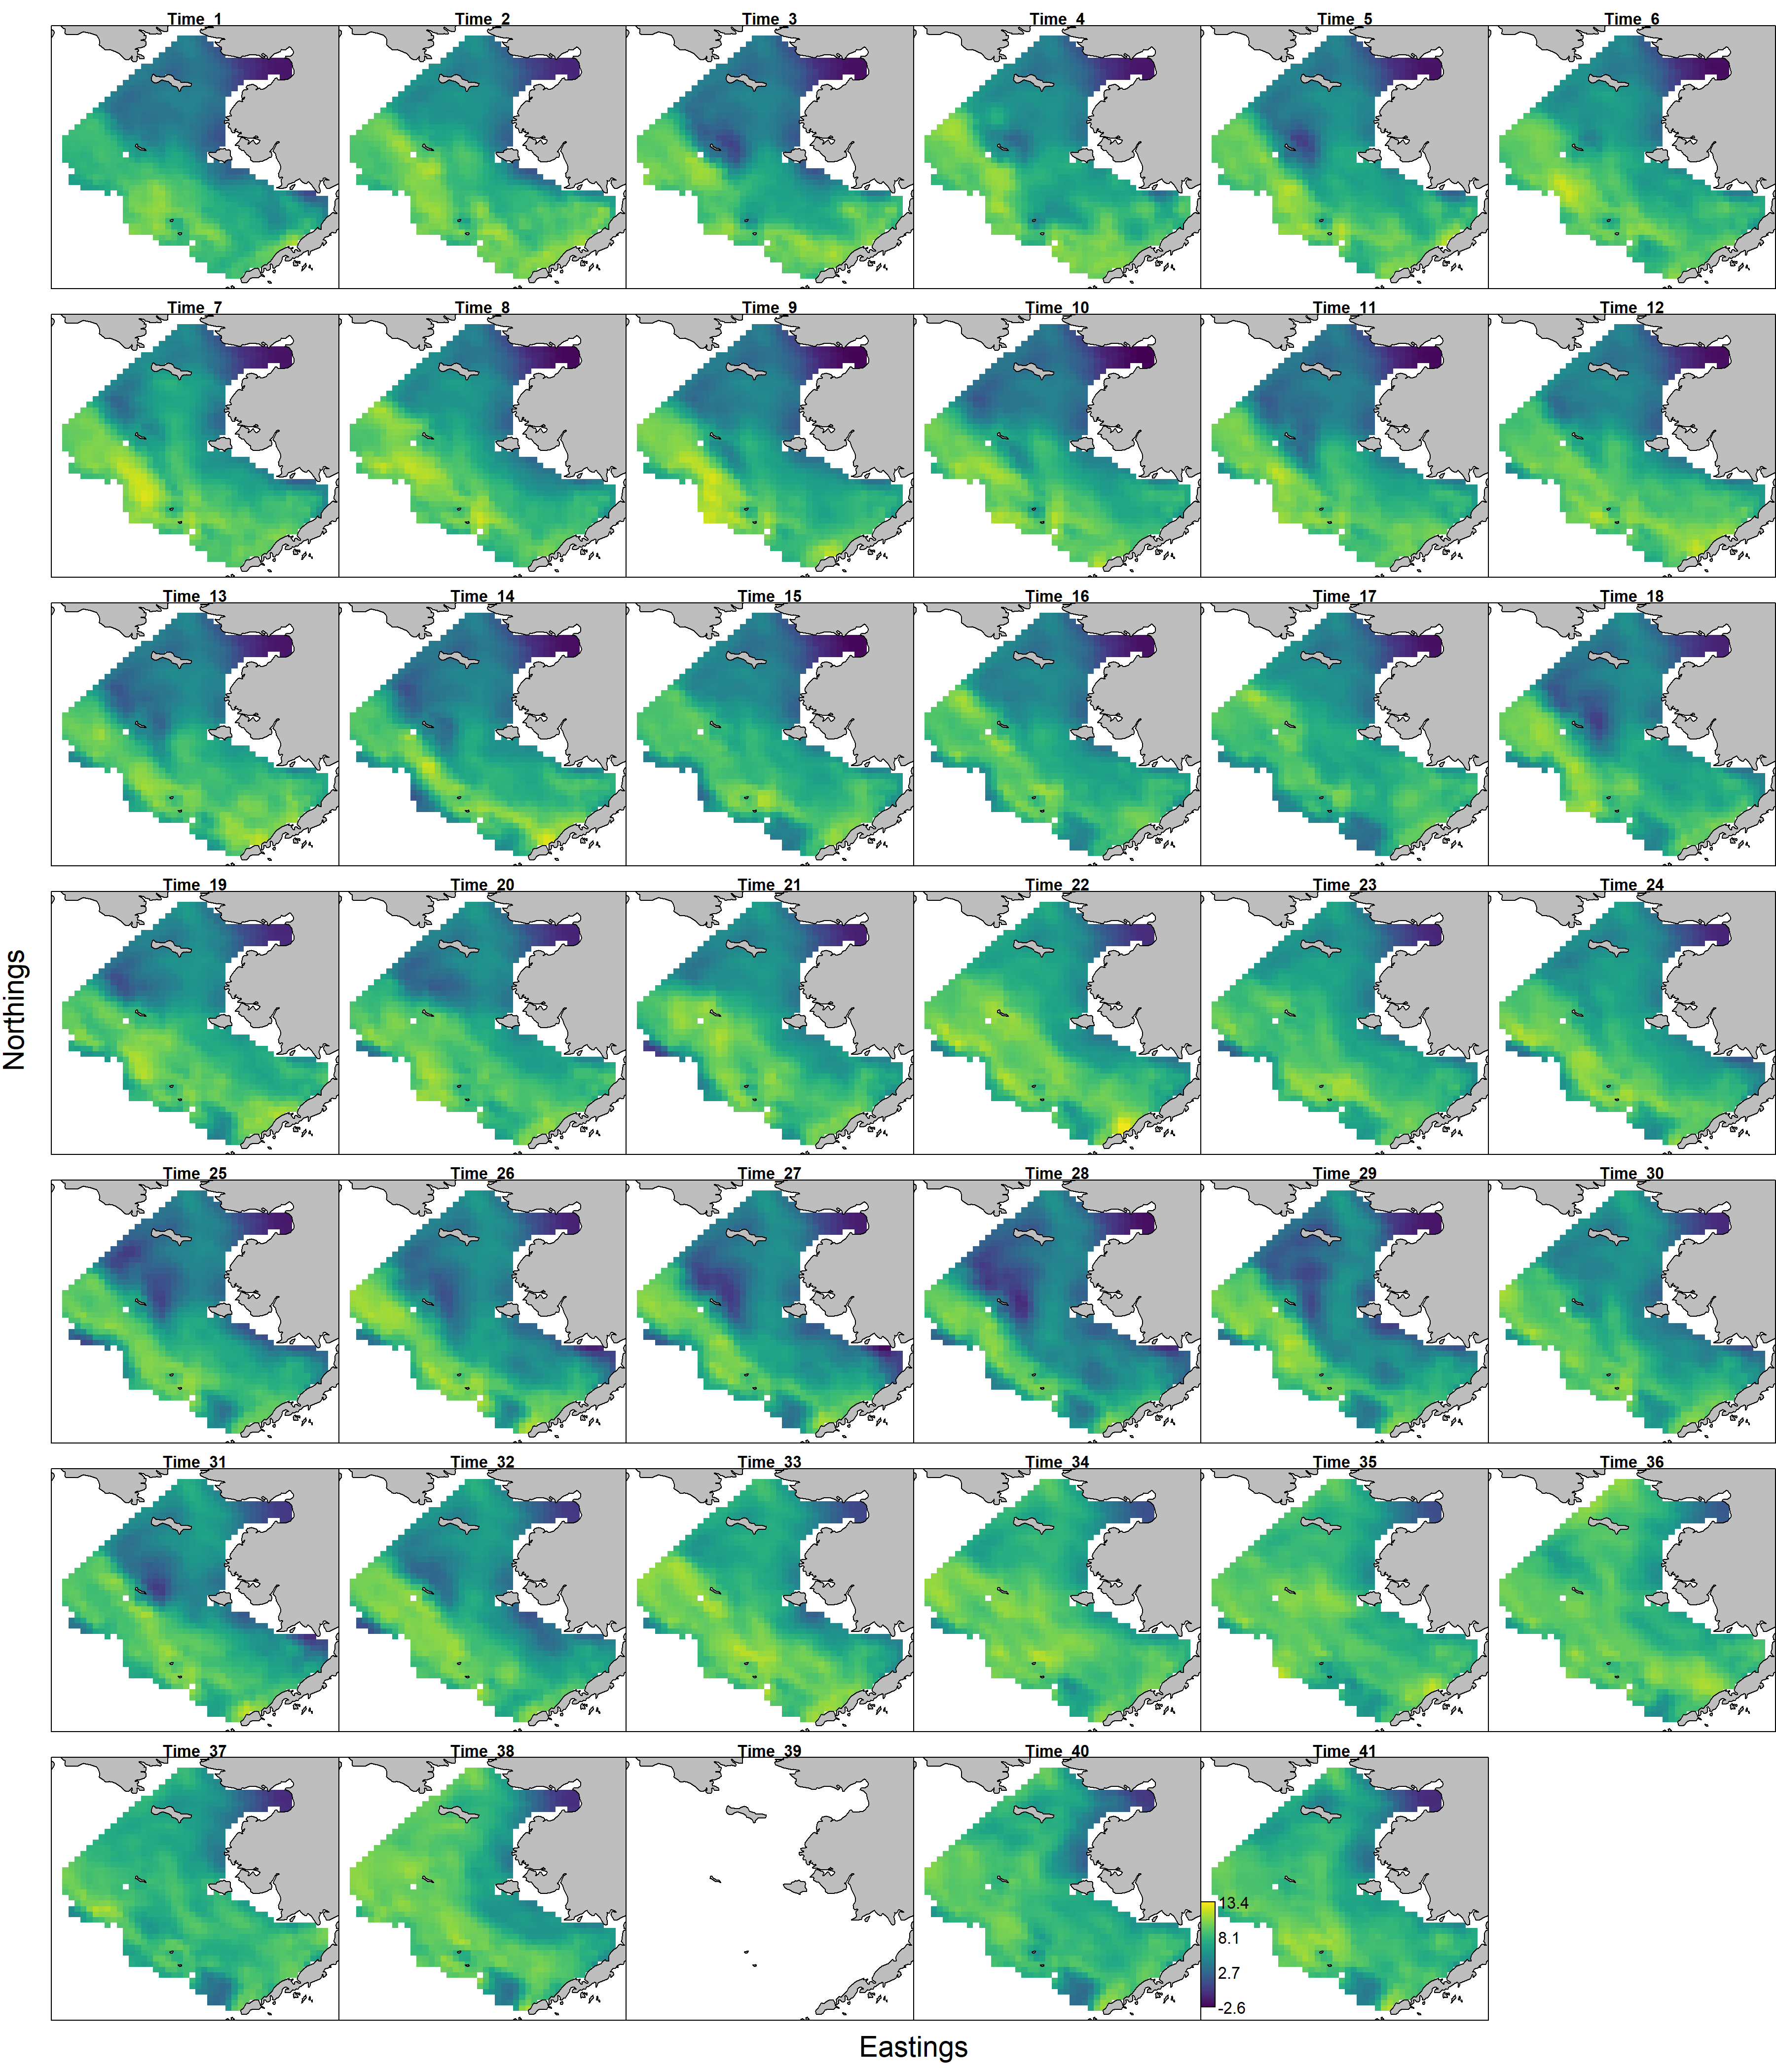

Pollock log density maps of the BTS data using the VAST model approach, 1982-2019,2021-2022.

Pollock index values for the standard survey region, the NBS, and combined based on the VAST application to density-dependent corrected CPUE values from the BTS data, 1982–2019, 2021-2022.

Pollock index values for the standard survey region, the NBS, and combined based on the VAST application to density-dependent corrected CPUE values from the BTS data, 1982–2019, 2021-2022.

## Additional references

References

Dunn, K.P., and Smyth, G.K. 1996. Randomized quantile residuals. Journal of Computational and Graphical Statistics 5, 1-10.

Hartig, F. 2021. DHARMa: Residual Diagnostics for Hierarchical (Multi-Level / Mixed) Regression Models. R package version 0.4.0. <http://florianhartig.github.io/DHARMa/>

O’Leary, C.A., Thorson, J.T., Ianelli, J.N. and Kotwicki, S., 2020. Adapting to climate‐driven distribution shifts using model‐based indices and age composition from multiple surveys in the walleye pollock (Gadus chalcogrammus) stock assessment. Fisheries Oceanography, 29(6), pp.541-557.

Rohan, SK, Barnett, LAK & N Charriere. Evaluating approaches to estimating mean temperatures and cold pool area from AFSC bottom trawl surveys of the eastern Bering Sea. In review. NOAA Technical Memorandum.

Thorson, J.T., 2019. Measuring the impact of oceanographic indices on species distribution shifts: The spatially varying effect of cold‐pool extent in the eastern Bering Sea. Limnology and Oceanography, 64(6), pp.2632-2645.

Thorson, J.T., and Kristensen, K., 2016. Implementing a generic method for bias correction in statistical models using random effects, with spatial and population dynamics examples. Fisheries Research, 175, pp.66-74.